### *3.11.6 Vendors Page Errors.*

#### 3.11.6.1 Register Form Errors.

##### 3.11.6.1.1 The vendor ID *vendor ID* already exists.

If you write in the “Vendor ID” field and the data match with a register of a vendor, it will show an error message, that says that exists a register with the vendor ID you are trying to register.

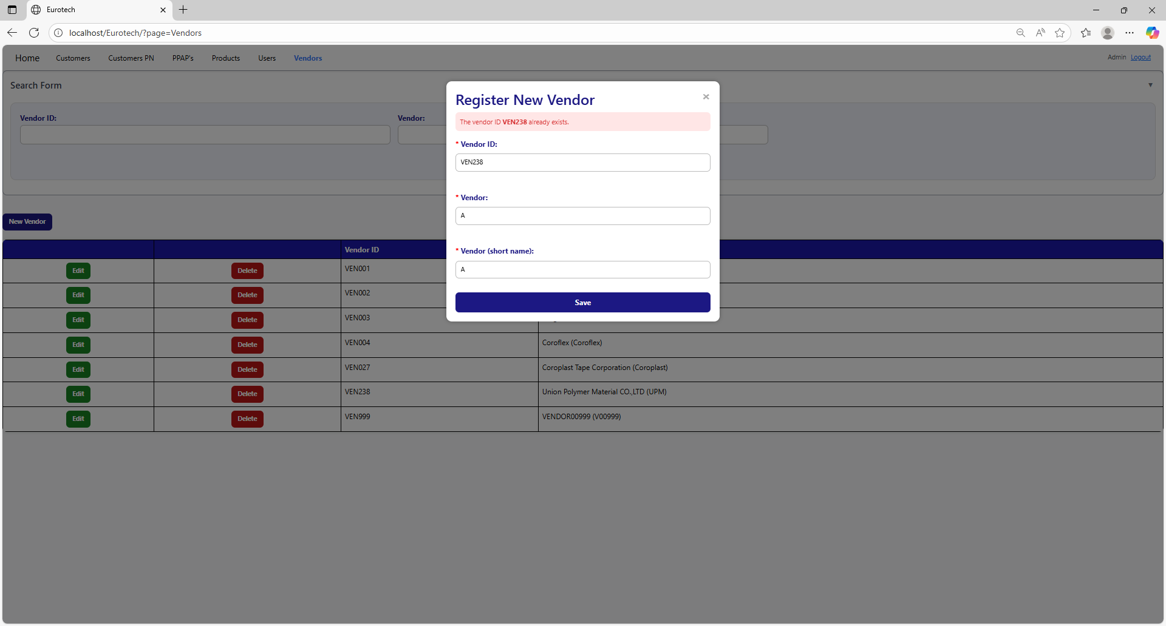

The error message prevents duplicate registers of vendors.

##### 3.11.6.1.2 The vendor *vendor’s name* already exists.

If you write in the “Vendor” field and the data match with a register of a vendor, it will show an error message, that says that exists a register with the vendor you are trying to register.

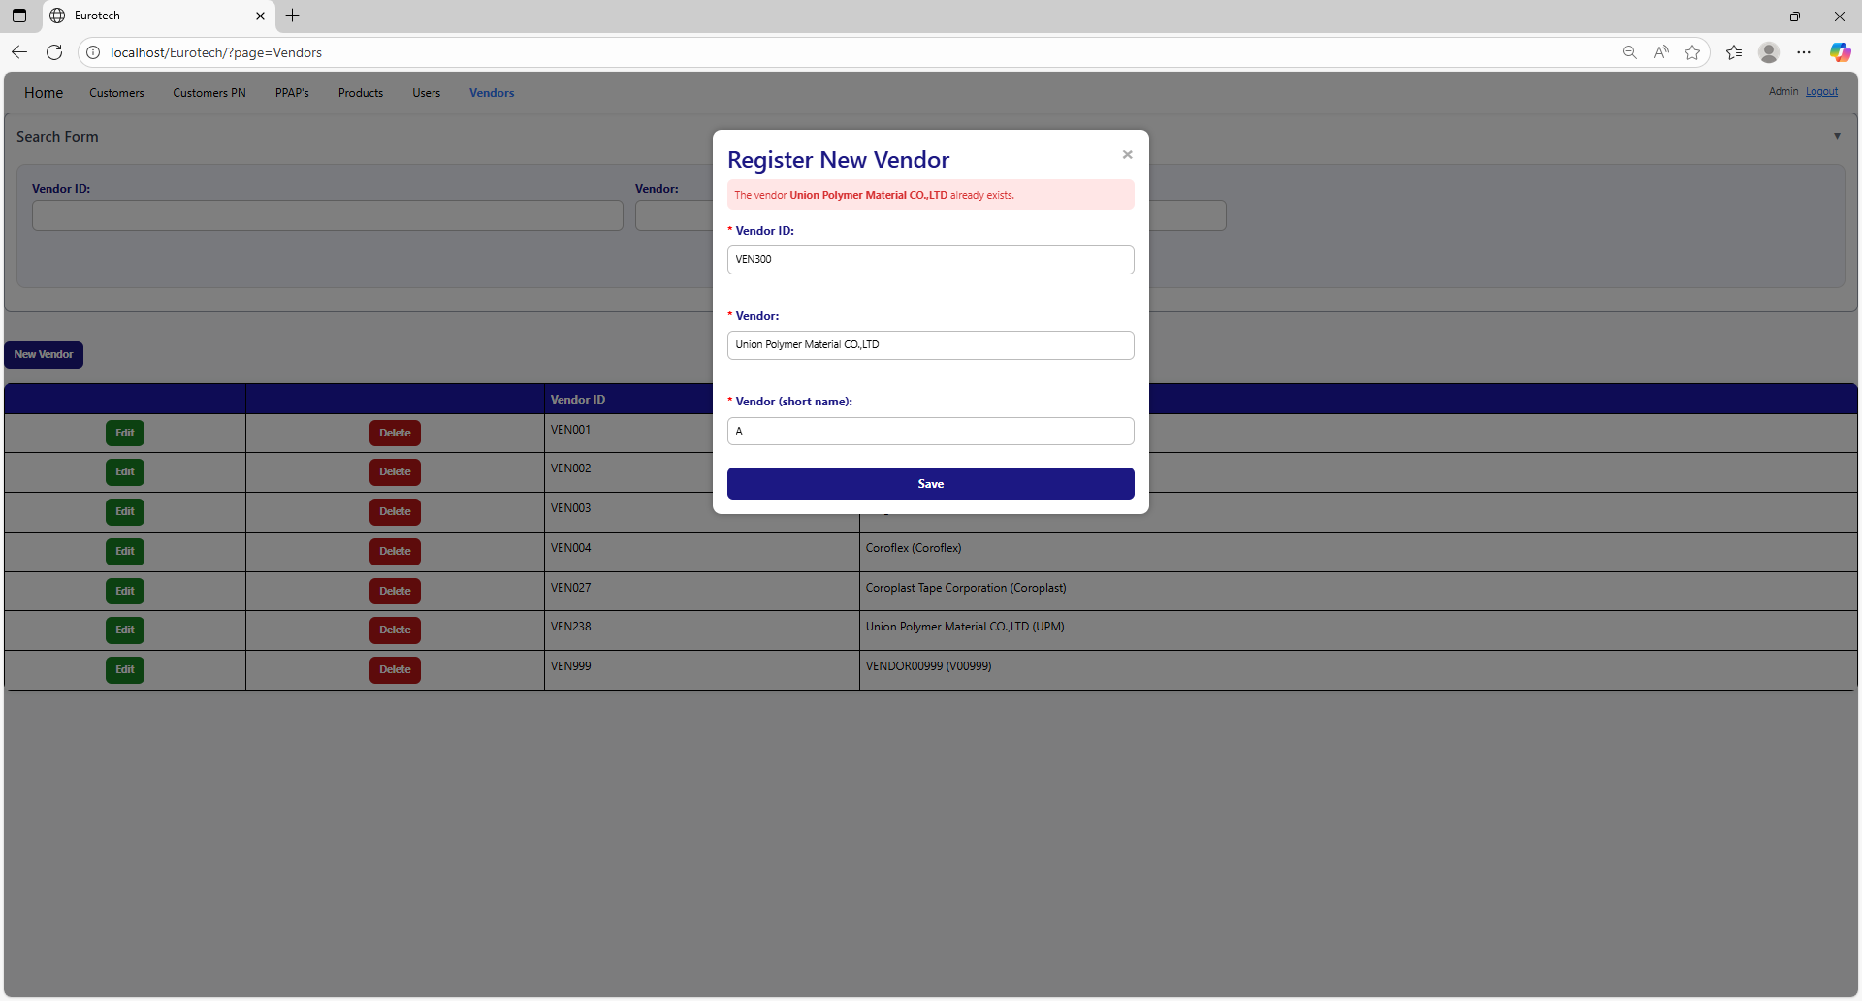

The error message prevents duplicate registers of vendors.

##### 3.11.6.1.3 The vendor with the short name *vendor’s short name* already exists.

If you write in the “Vendor (short name)” field and the data match with a register of a vendor, it will show an error message, that says that exists a register with the vendor’s short name you are trying to register.

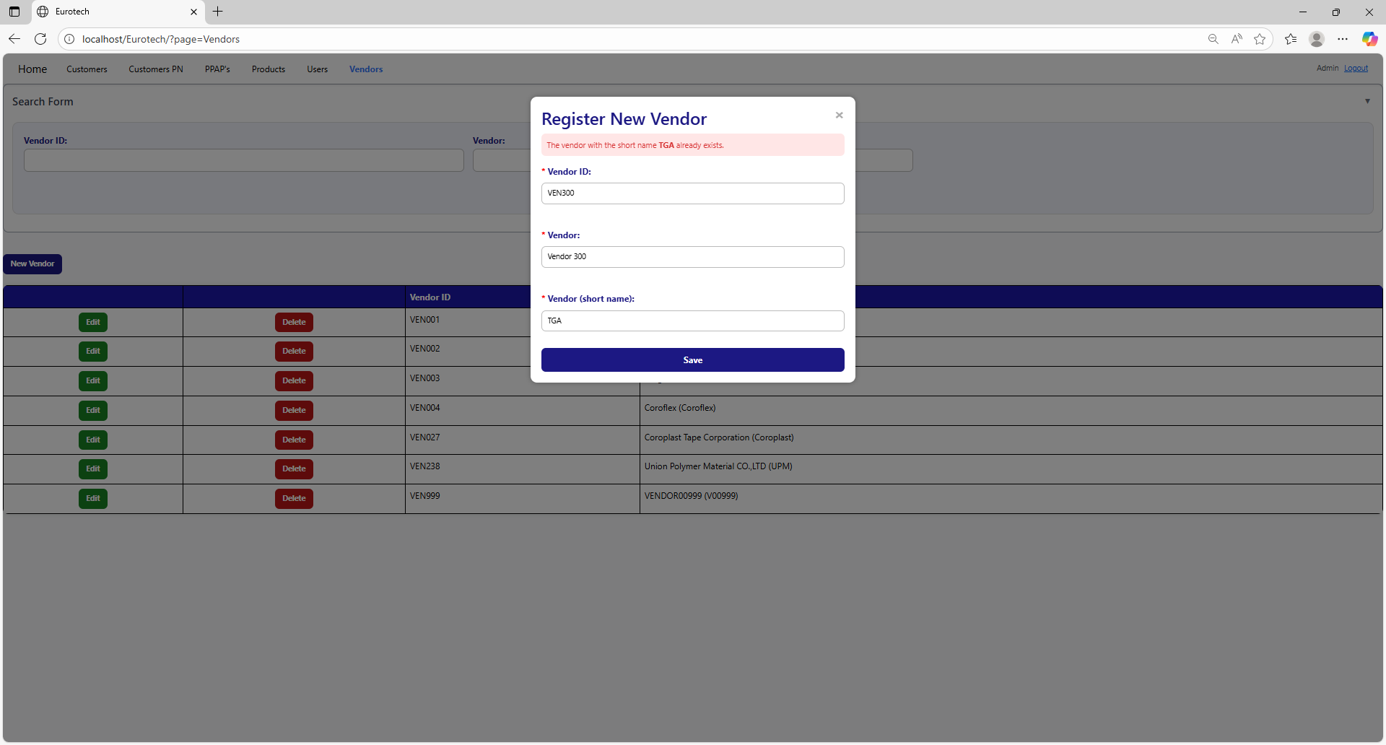

The error message prevents duplicate registers of vendors.

##### 3.11.6.1.4 The vendor ID *vendor ID* and the vendor *vendor’s name* already exist.

If you write in the “Vendor ID” and “Vendor” fields and the data match with a register of a vendor, it will show an error message, that says that exists a register with the vendor ID and vendor’s name you are trying to register.

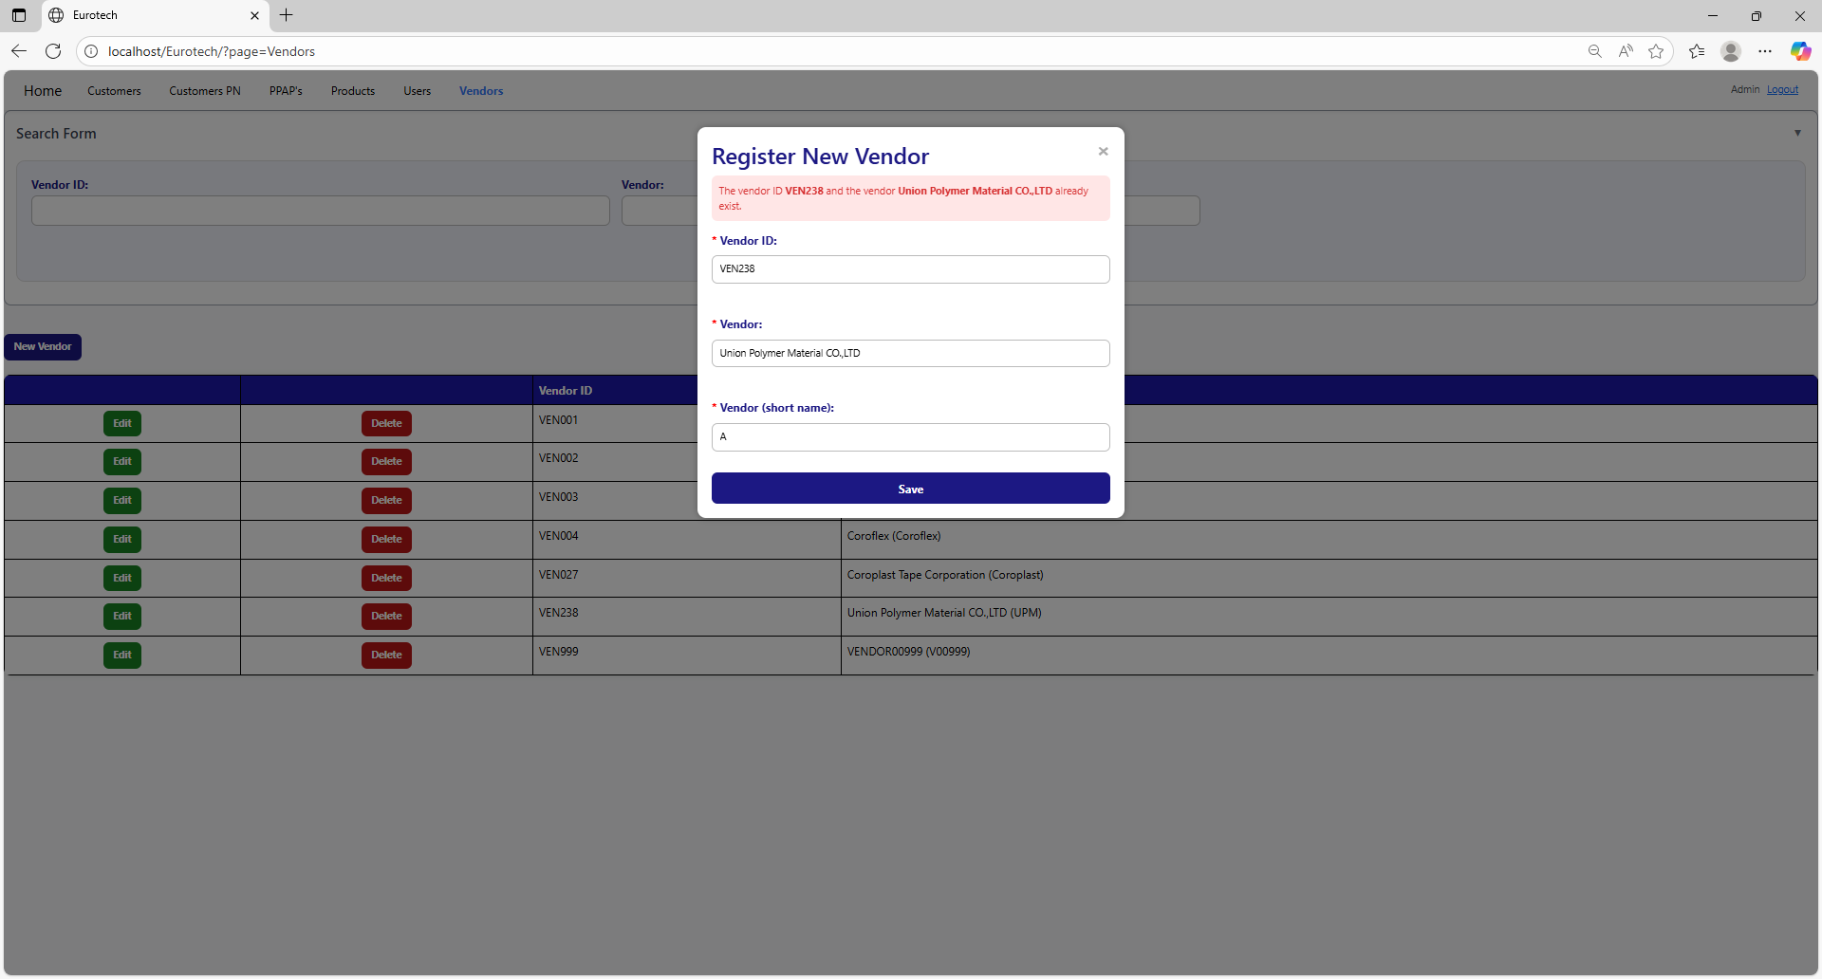

The error message prevents duplicate registers of vendors.

##### 3.11.6.1.5 The vendor ID *vendor ID* and the short name *vendor’s short name* already exist.

If you write in the “Vendor ID” and “Vendor (short name)” fields and the data match with a register of a vendor, it will show an error message, that says that exists a register with the vendor ID and vendor’s short name you are trying to register.

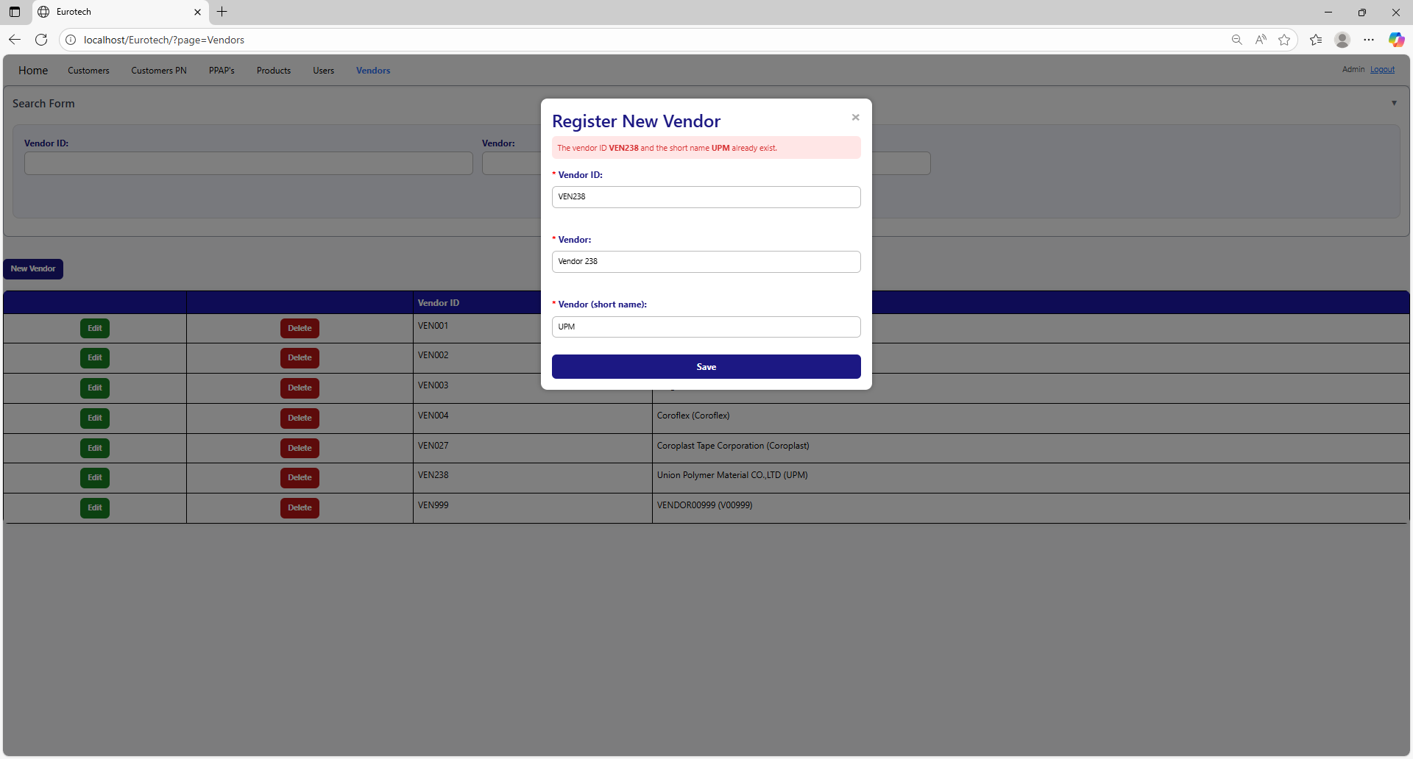

The error message prevents duplicate registers of vendors.

##### 3.11.6.1.6 The vendor *vendor’s name* and the short name *vendor’s short name* already exist.

If you write in the “Vendor” and “Vendor (short name)” fields and the data match with a register of a vendor, it will show an error message, that says that exists a register with the vendor’s name and vendor’s short name you are trying to register.

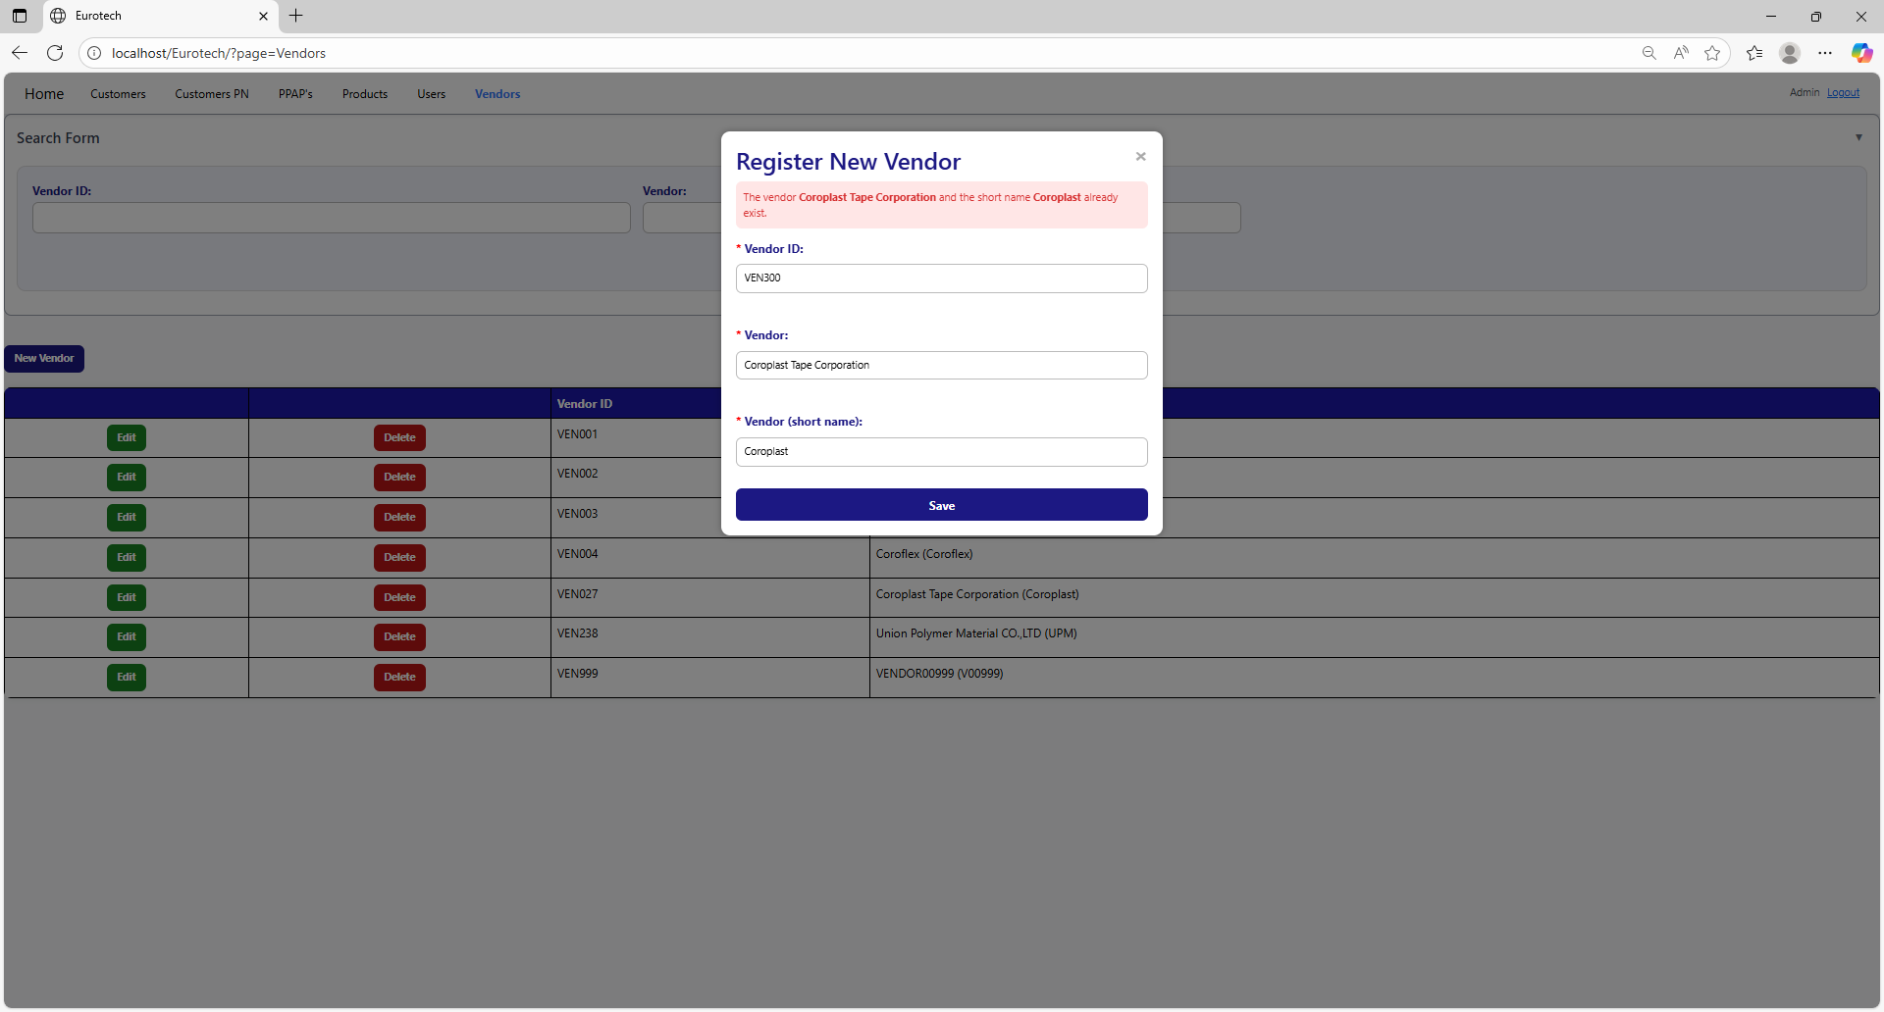

The error message prevents duplicate registers of vendors.

##### 3.11.6.1.7 The vendor ID *vendor ID*, the vendor *vendor’s name* and the short name *vendor’s short name* already exist.

If you write in the “Vendor ID”, “Vendor” and “Vendor (short name)” fields and the data match with a register of a vendor, it will show an error message, that says that exists a register with the vendor ID, vendor’s name and vendor’s short name you are trying to register.

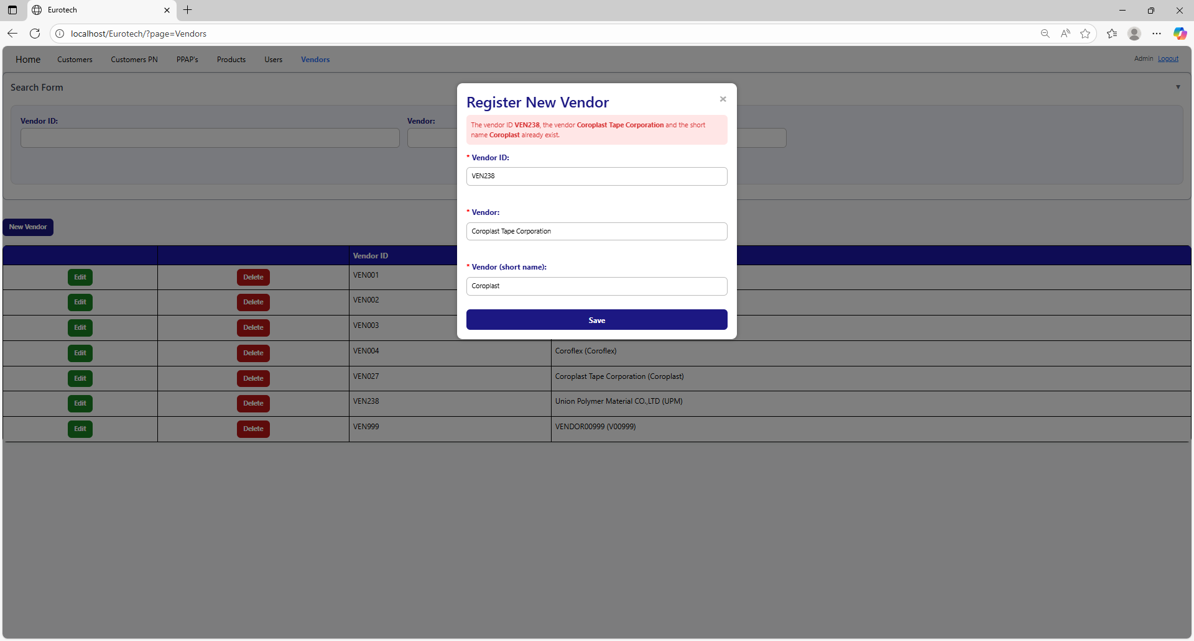

The error message prevents duplicate registers of vendors.

#### 3.11.6.2 Edit Form Errors.

##### 3.11.6.2.1 The vendor *vendor’s name* already exists.

If you write in the “Vendor” field and the data match with a register of a vendor, it will show an error message, that says that exists a register with the vendor you are trying to update.

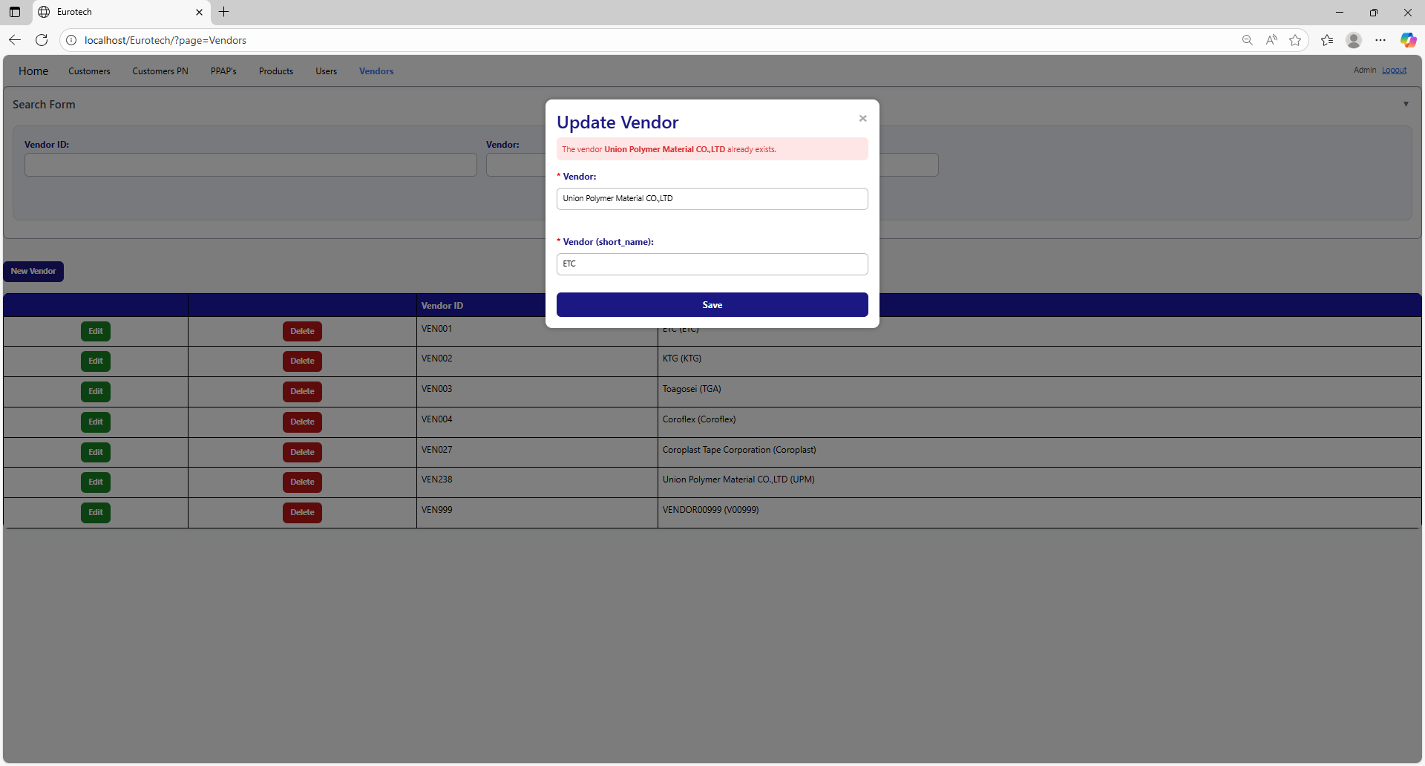

The error message prevents duplicate registers of vendors.

##### 3.11.6.2.2 The vendor with the short name *vendor’s short name* already exists.

If you write in the “Vendor (short name)” field and the data match with a register of a vendor, it will show an error message, that says that exists a register with the vendor’s short name you are trying to update.

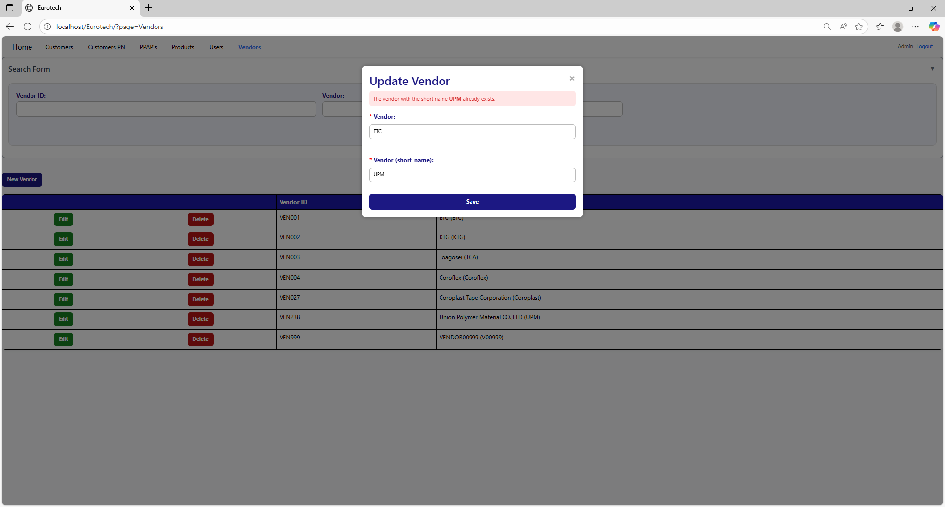

The error message prevents duplicate registers of vendors.

##### 3.11.6.2.3 The vendor *vendor’s name* and the short name *vendor’s short name* already exist.

If you write in the “Vendor” and “Vendor (short name)” fields and the data match with a register of a vendor, it will show an error message, that says that exists a register with the vendor’s name and vendor’s short name you are trying to update.

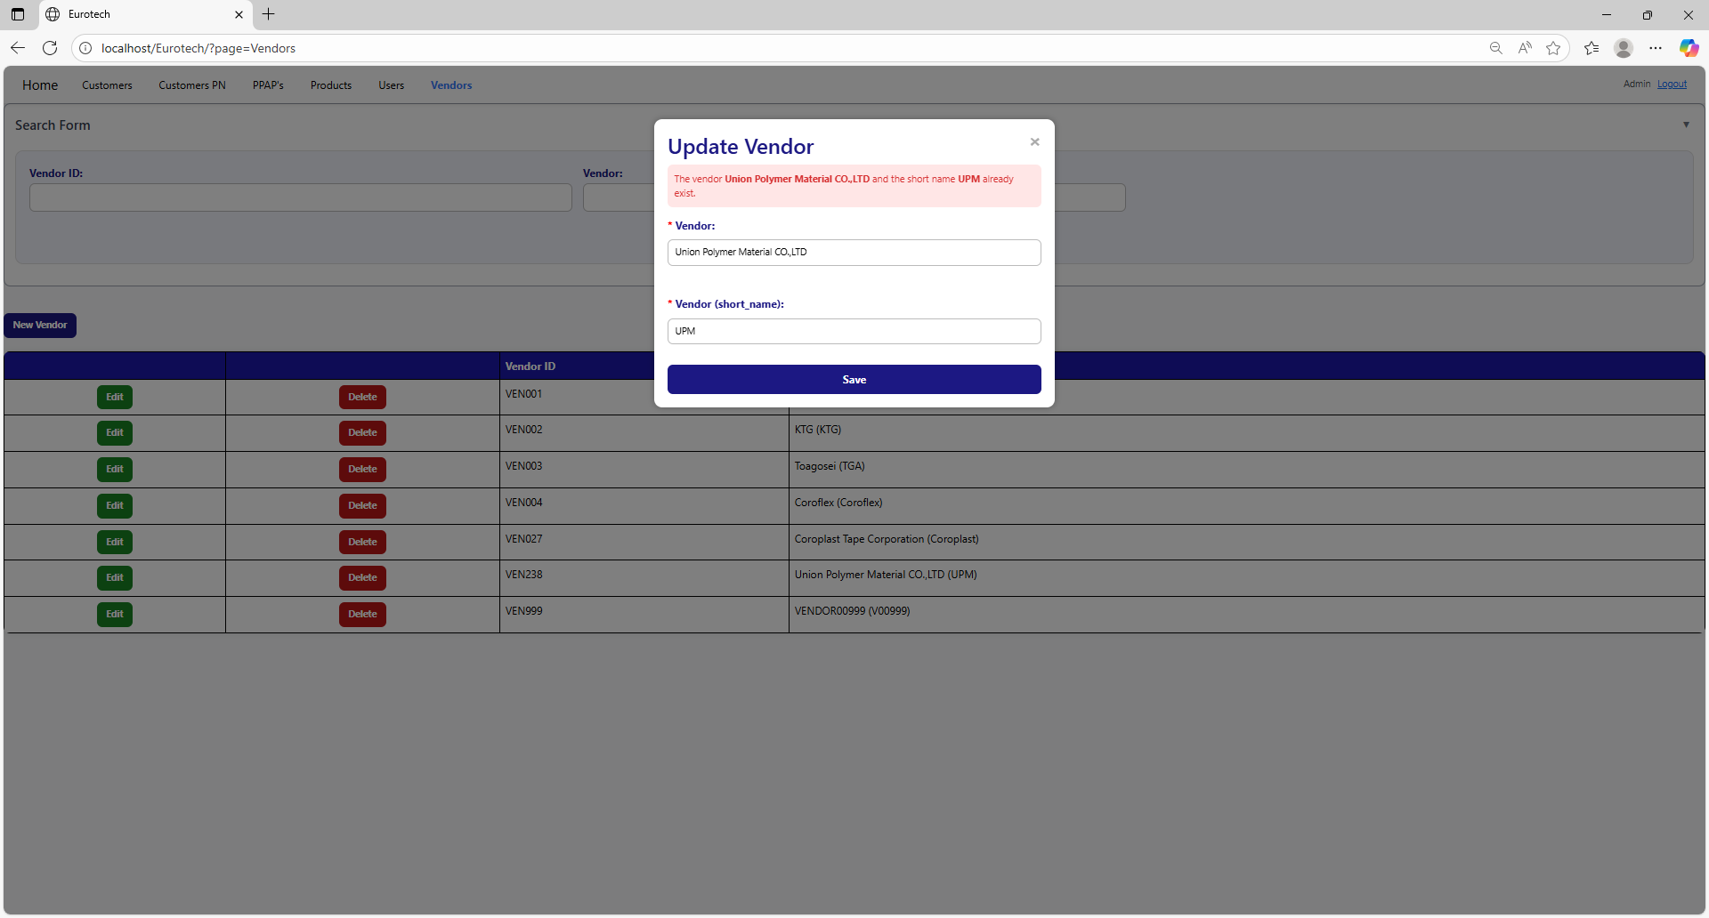

The error message prevents duplicate registers of vendors.

#### 3.11.6.3 Delete Form Errors.

##### 3.11.6.3.1 This vendor can’t be deleted, because it already has registers.

If you tried to delete a vendor, and it shows you an error message, that says that the vendor you are trying to delete can’t be deleted, because it already has registers, this means that the vendor has registers in the “Products” page and in the “PPAP’s” page.

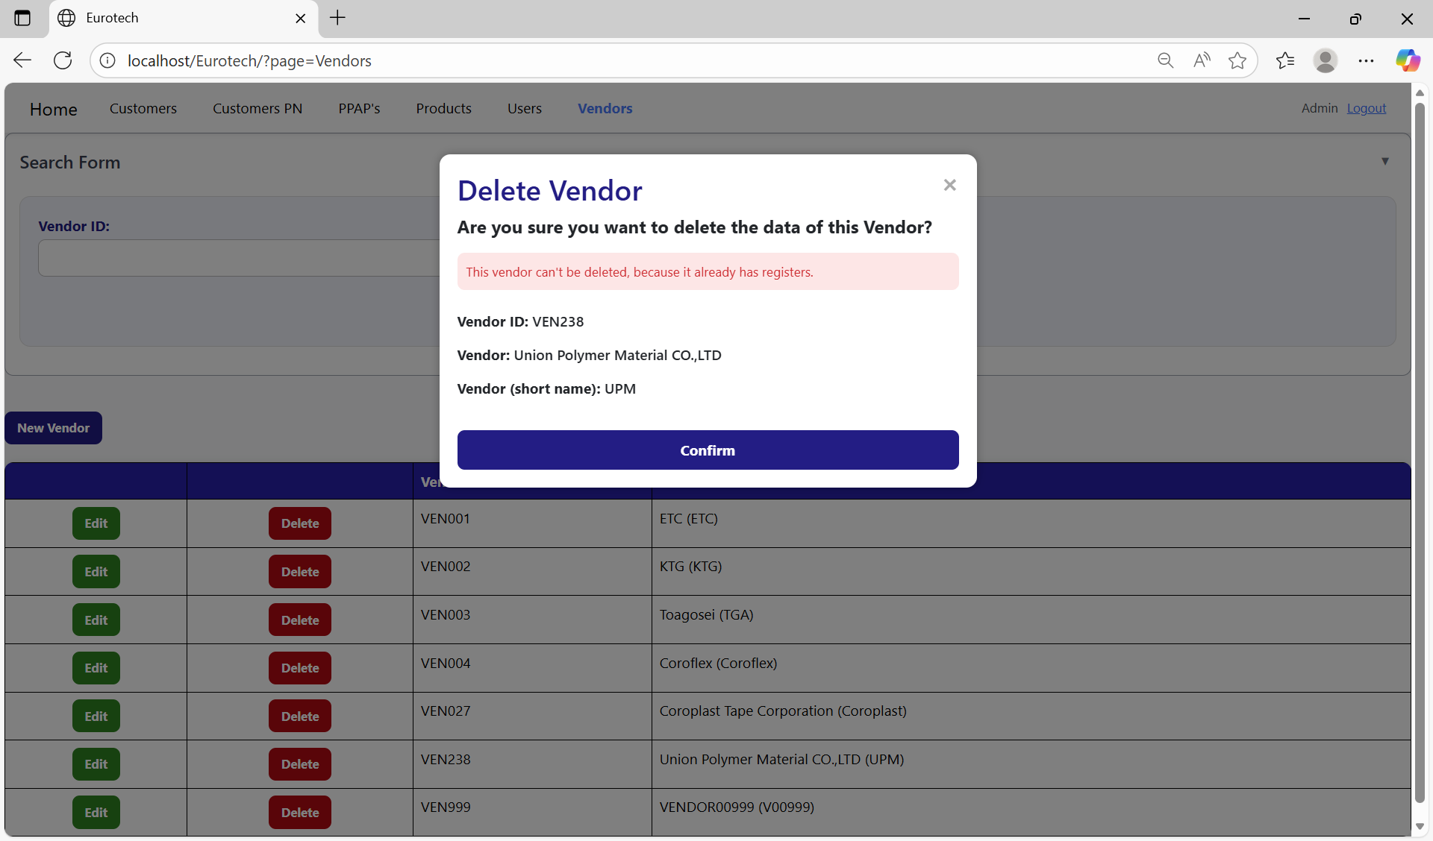

If you want to delete the vendor, you must delete all the registers of this vendor in the “Products” and “PPAP’s” pages.

## **3.12 Log out.**

### *3.12.1 How to log out from the web site.*

If you want to log out from the page, you must click the “Logout” button that is at the top right corner of the page, next to the user’s name.

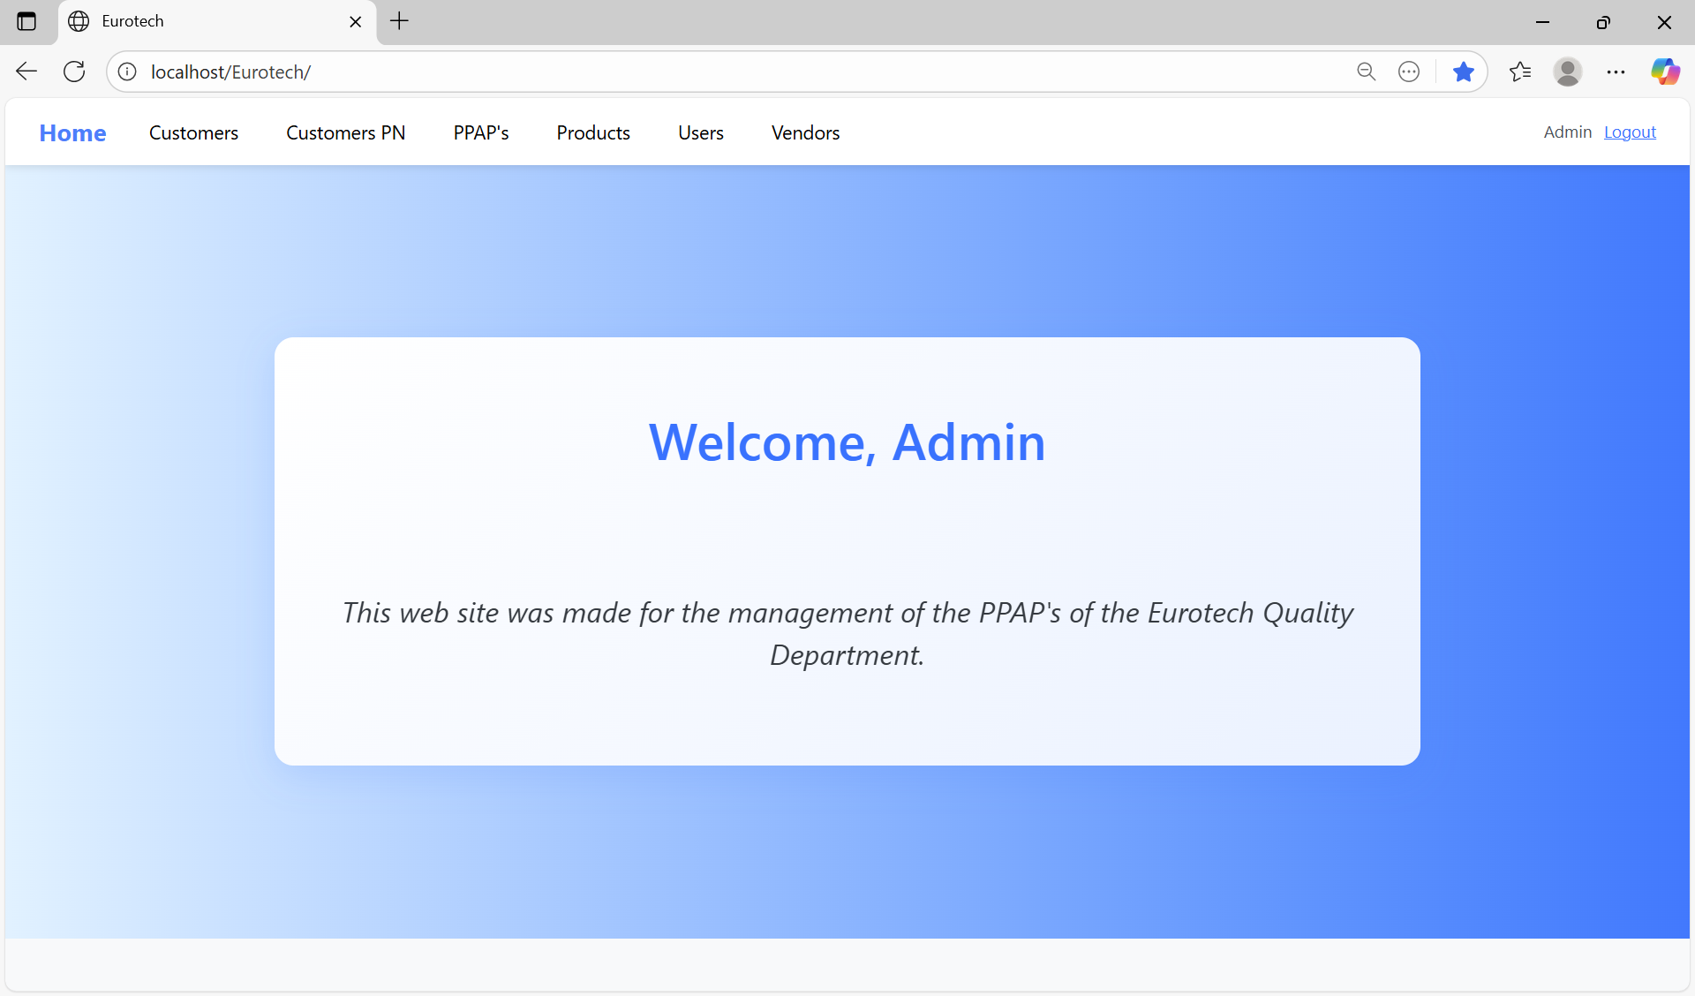

Once you click the “Logout” button, it will close the session of your user, and it will show you the “Login” page.

# **4. Users with the role “User”**

## ***4.1 PPAP’s Page***

### *4.1.1 How to Navigate to “PPAP’s” Page.*

On the navigation bar, you can navigate to the “PPAP’s” page.

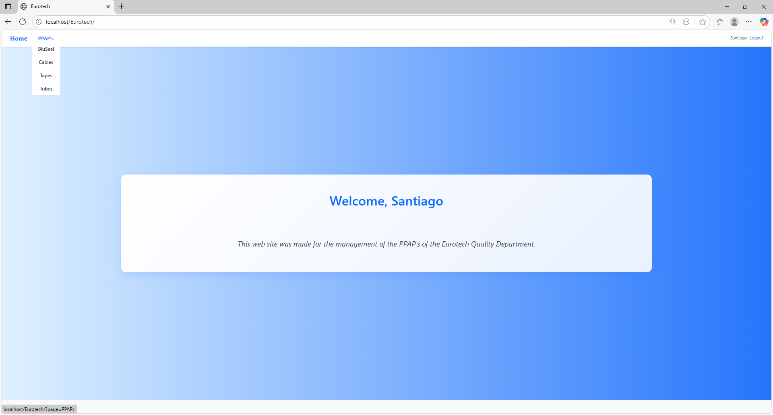

In this page you can manage the registers of all the PPAPs of all the products.

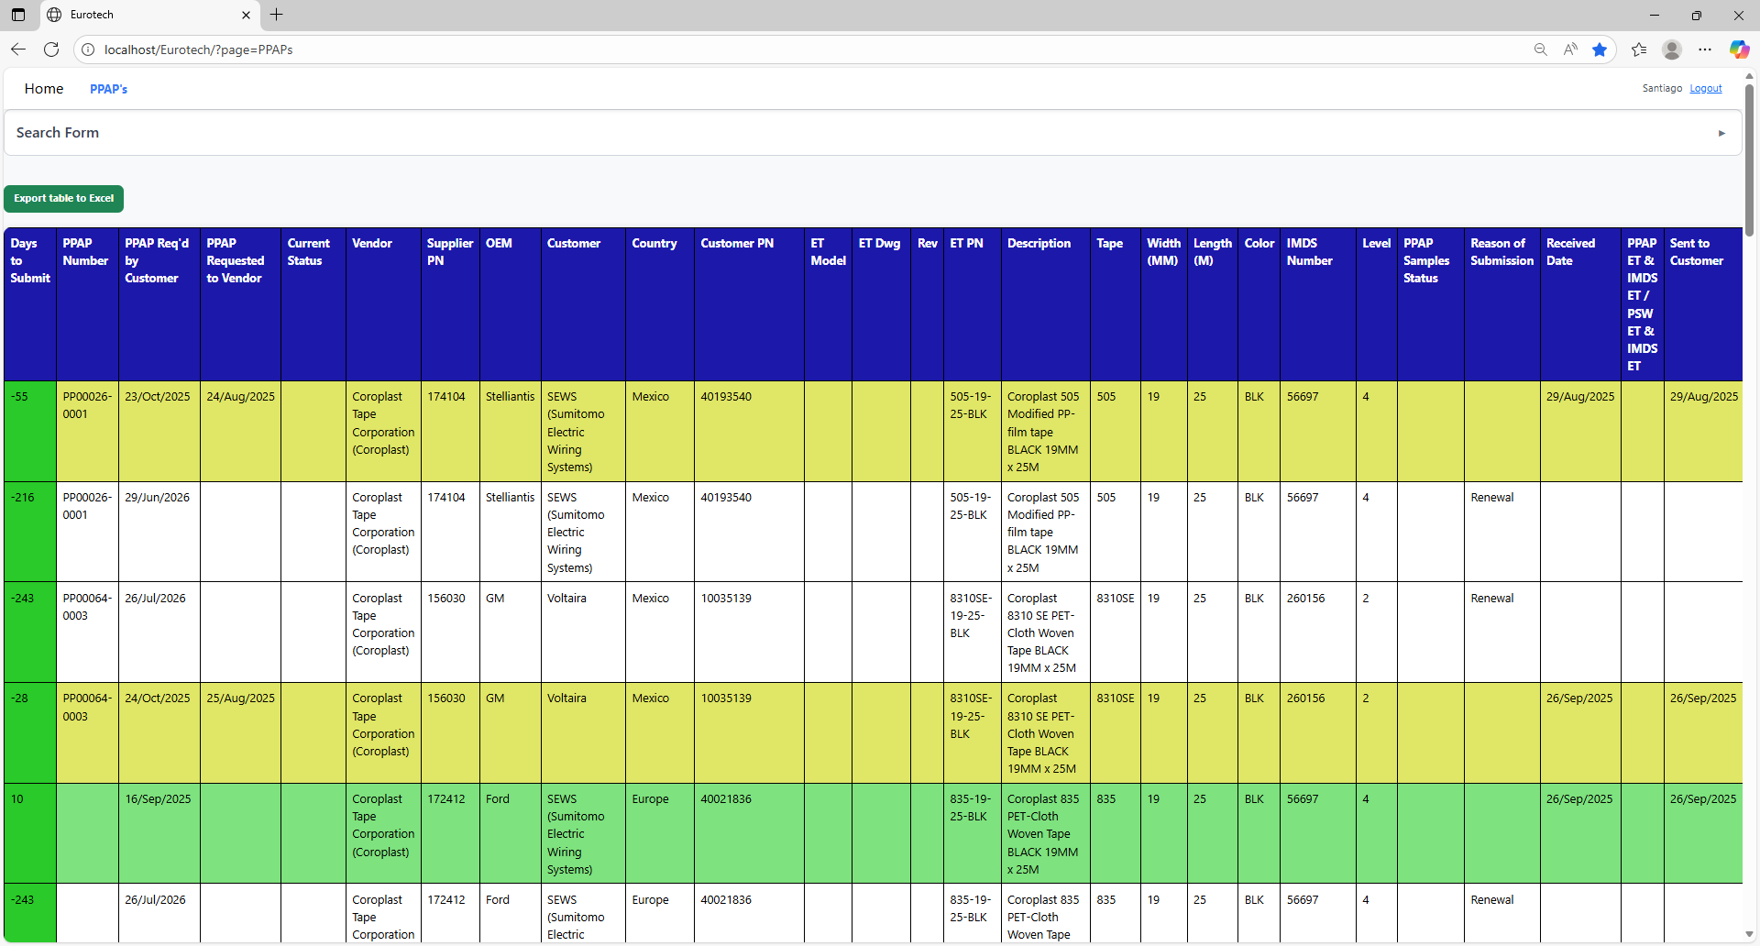

### *4.1.2 How to Search a PPAP.*

At the top of the page, it will be a dropdown “Search Form” that has all the fields of the table for querying registers.

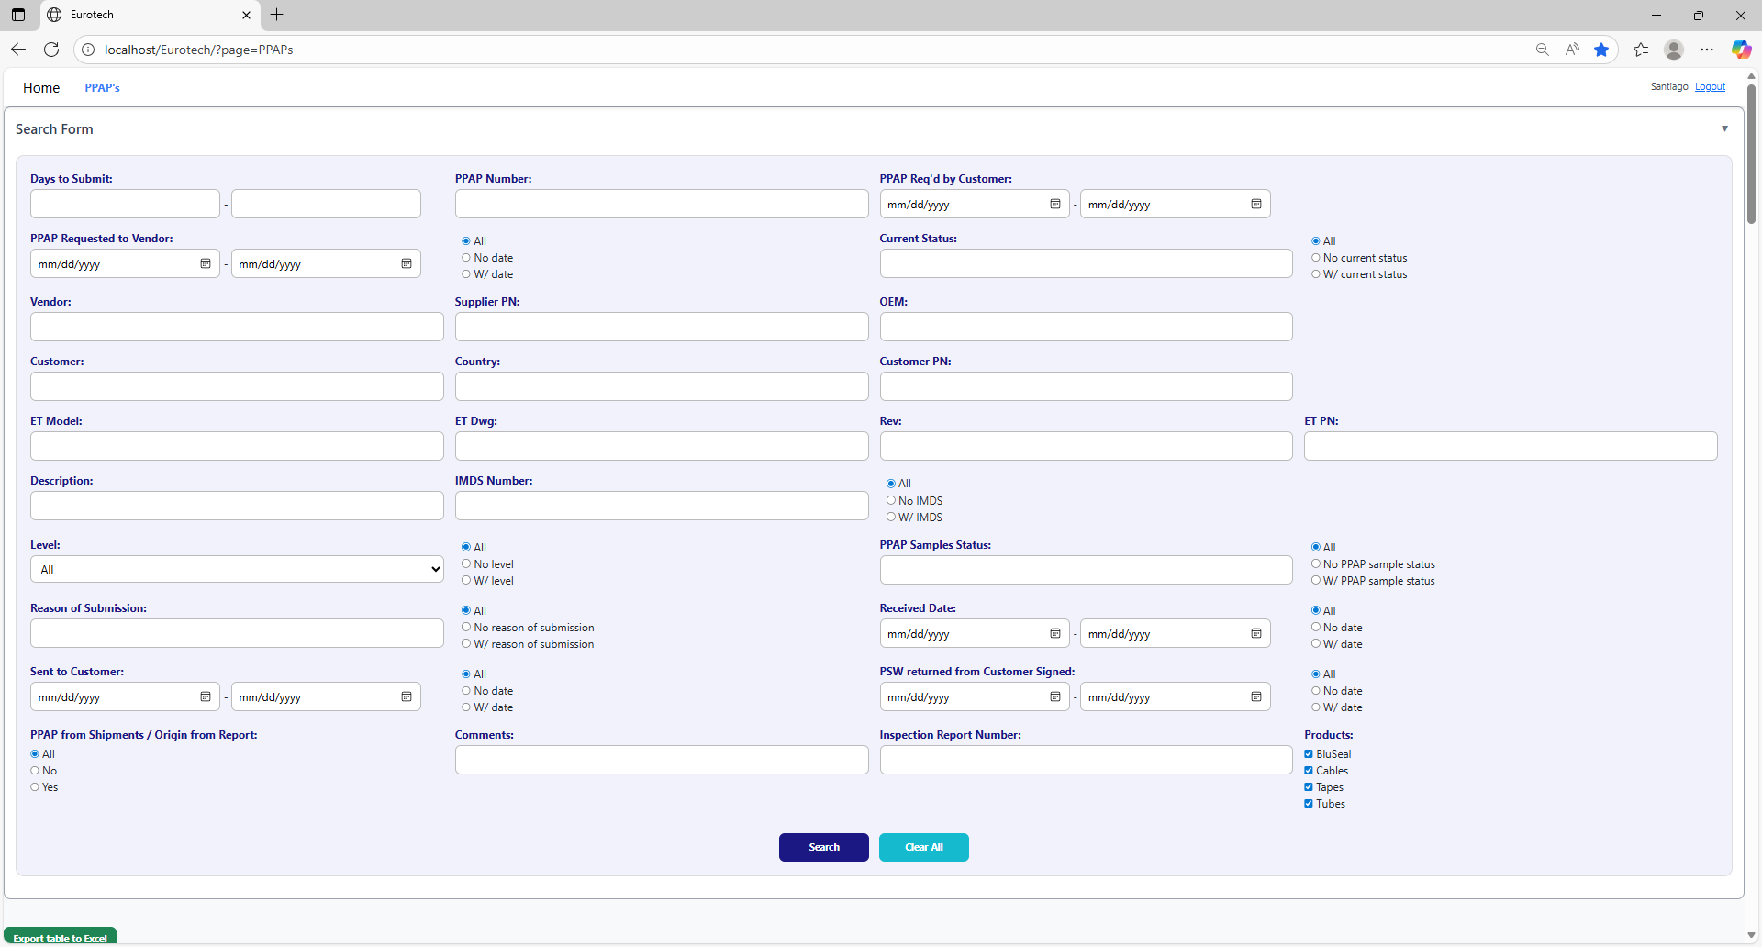

The search form allows you to perform searches by:

* Level
* PPAP Samples Status
* Reason of Submission
* Received Date
* Sent to Customer
* PSW returned from Customer Signed
* PPAP from Shipments / Origin from Report
* Comments
* Inspection Report Number
* Products
* Days to Submit
* PPAP Number
* PPAP Req’d by Customer
* PPAP Requested to Vendor
* Current Status
* Vendor
* Supplier PN
* OEM
* Customer
* Country
* Customer PN
* ET Model
* ET Dwg
* Rev
* Eurotech PN
* Description
* IMDS Number

You can search by “Days to Submit”, writing the range of days.

You can search by “PPAP Number”.

You can search by “PPAP Req’d by Customer”, writing the range of dates.

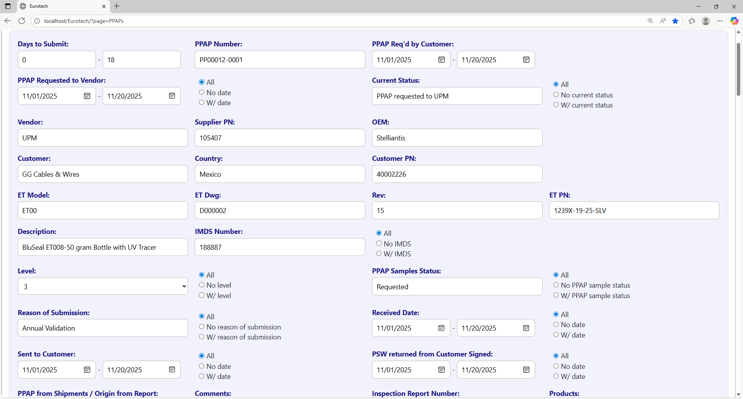

You can search registers that either have or don’t have the “Current Status” field filled in, or all the registers.

You can search by “Current Status”.

You can search registers that either have or don’t have a date on “PPAP Requested to Vendor”, or all the registers.

You can search by “PPAP Requested to Vendor”, writing the range of dates.

You can search by “OEM”.

You can search by “Vendor”.

You can search by “Supplier PN”.



You can search by “Customer PN”.

You can search by “Customer”.

You can search by “Country”.

You can search by “ET PN”.

You can search by “Rev”.

You can search by “ET Dwg”.

You can search by “ET Model”.



You can search registers that either have or don’t have the “IMDS Number” field filled in, or all the registers.

You can search by “IMDS Number”.

You can search by “Description”.

You can search by “PPAP Samples Status”.

You can search by “Level”.

You can search registers that either have or don’t have the “PPAP Samples Status” field filled in, or all the registers.

You can search registers that either have or don’t have the “Level” field filled in, or all the registers.



You can search registers that either have or don’t have a date on “Received Date”, or all the registers.

You can search by “Received Date”, writing the range of dates.

You can search registers that either have or don’t have the “Reason of Submission” field filled in, or all the registers.

You can search by “Reason of Submission”.

You can search registers that either have or don’t have a date on “PSW returned from Customer Signed”, or all the registers.

You can search registers that either have or don’t have a date on “Sent to Customer”, or all the registers.

You can search by “PSW returned from Customer Signed”, writing the range of dates.

You can search by “Sent to Customer”, writing the range of dates.

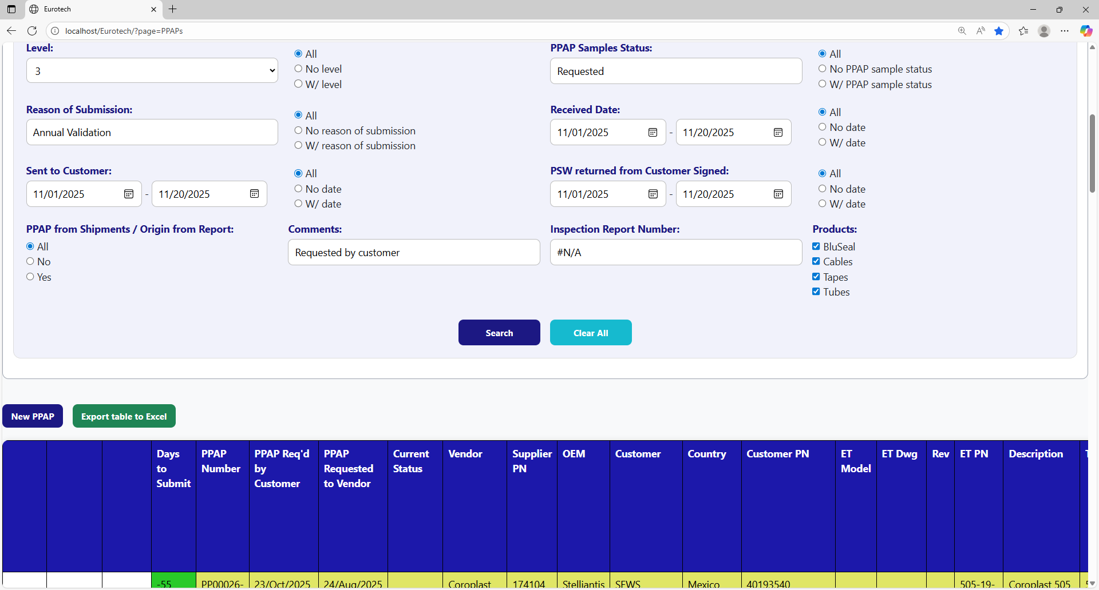

You can search by “Products”.

You can search by “Inspection Report Number”.

You can search by “Comments”.

You can search by “PPAP from Shipments / Origin from Report”.

You must click the “Search” button after you fill any of the fields of the “Search Form” to make the search.

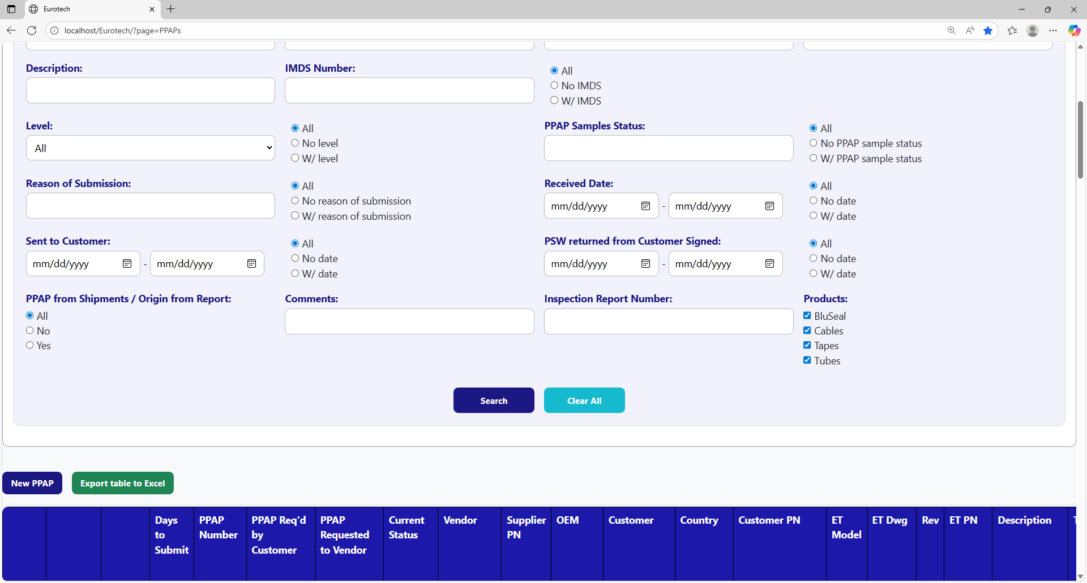

This is an example of how the table would look like after a search (the meaning of the colors of the registers will be explained later).

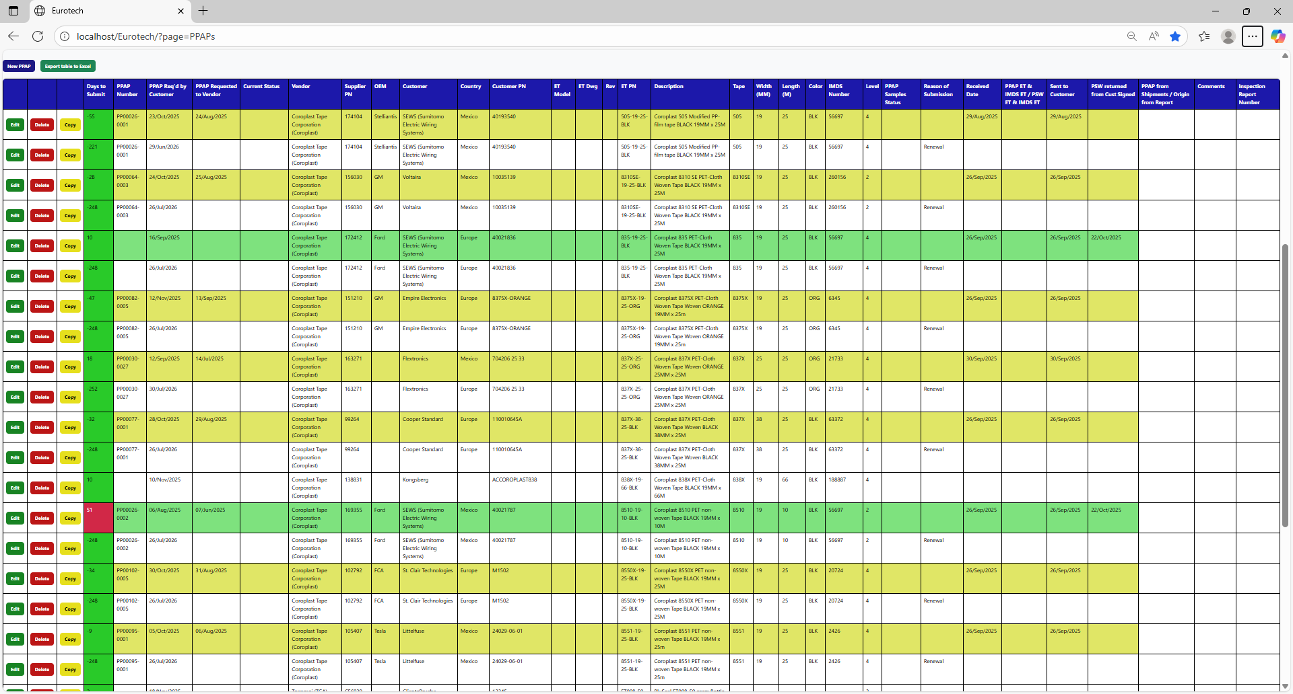

And with the “Clear All” button, you can clean the querying and see all the registers of the PPAPs.



Once you click the “Clear All” button, the fields of the “Search Form” will be empty, and in the table will be shown all the PPAPs.

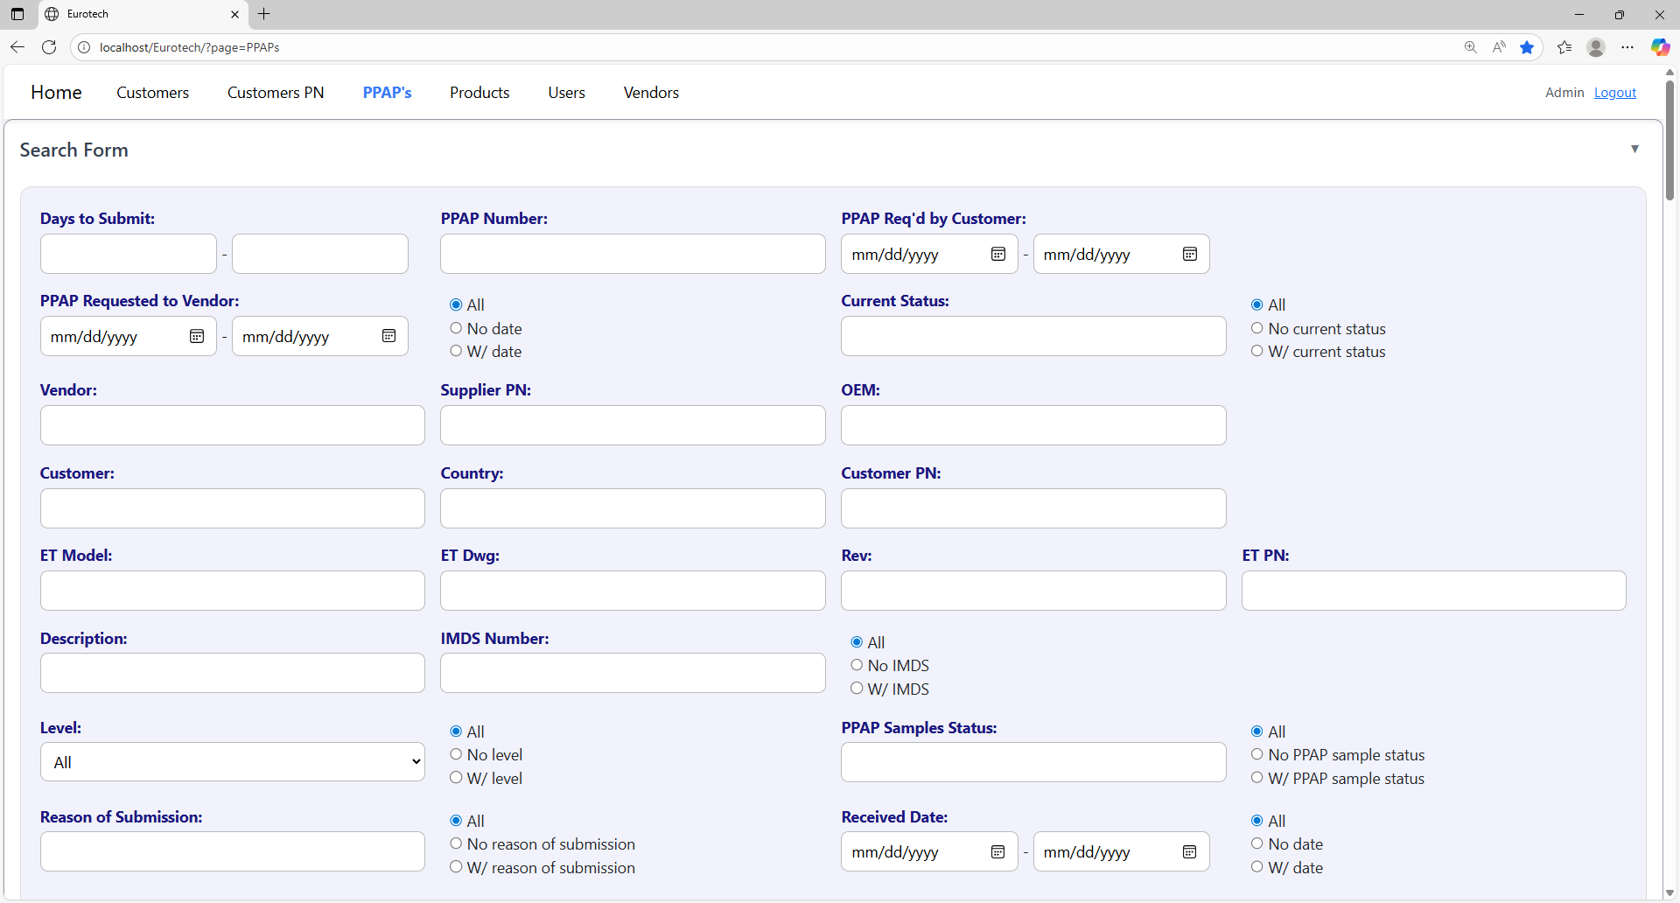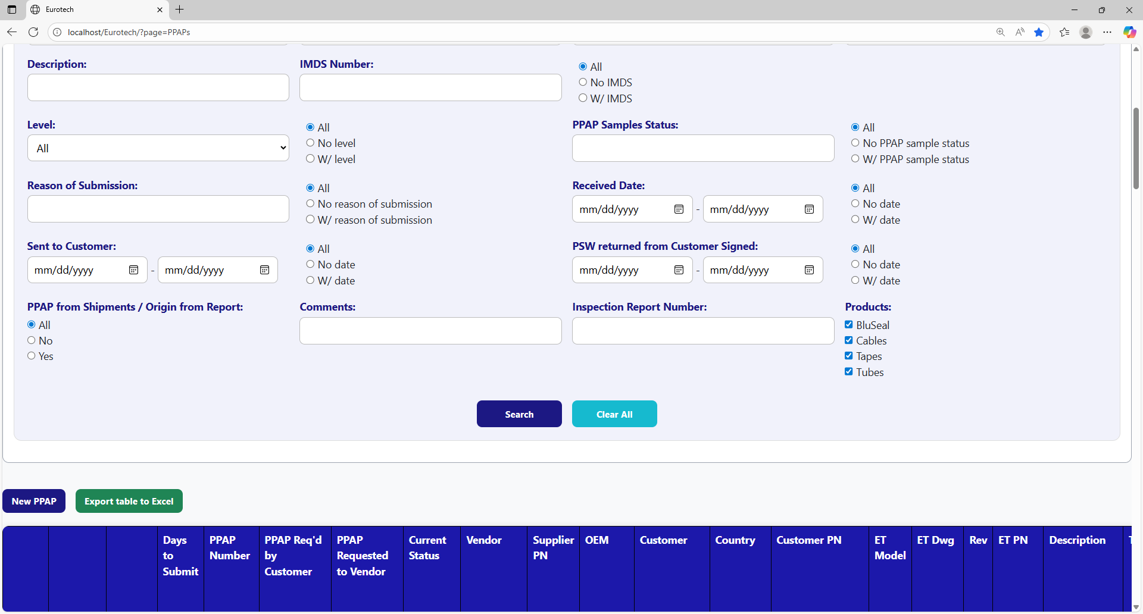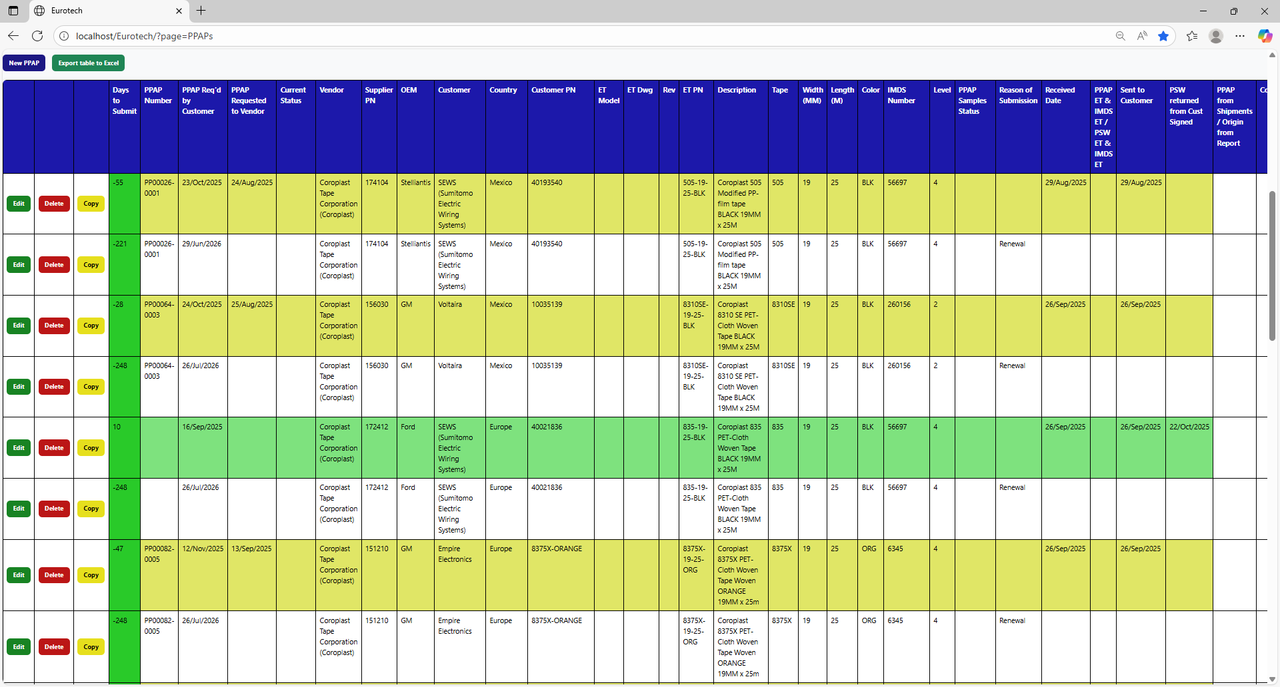

### *4.1.3 Meaning of the Colors of the Registers.*

1.- In the “Days to Submit” column there will be:

* Registers with green field indicate that the difference between the “PPAP Req’d by Customer” date and the “Sent to Customer” date is less than 19 days (if there is no “Sent to Customer” date yet, it is compared with the current date).

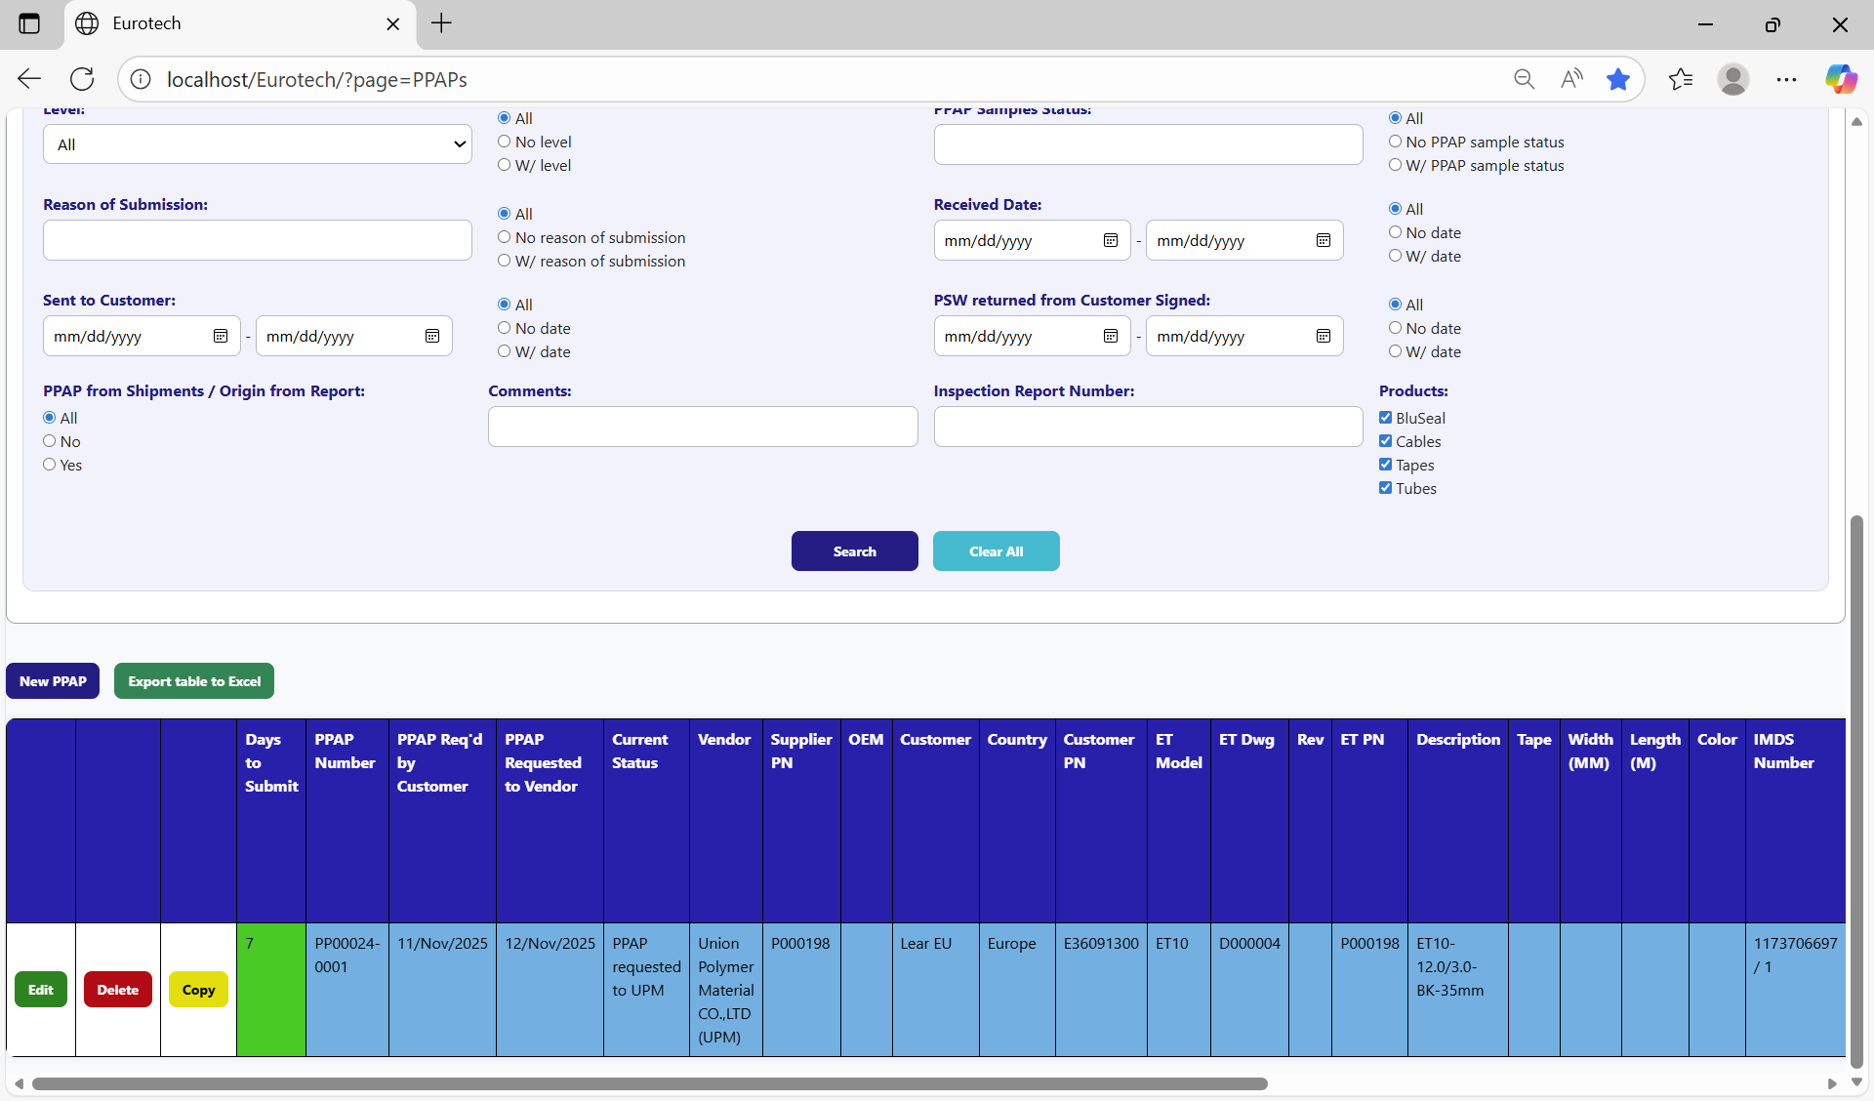

* Registers with yellow field indicate that the difference between the “PPAP Req’d by Customer” date and the “Sent to Customer” date is between 19 and 29 days (if there is no “Sent to Customer” date yet, it is compared with the current date).

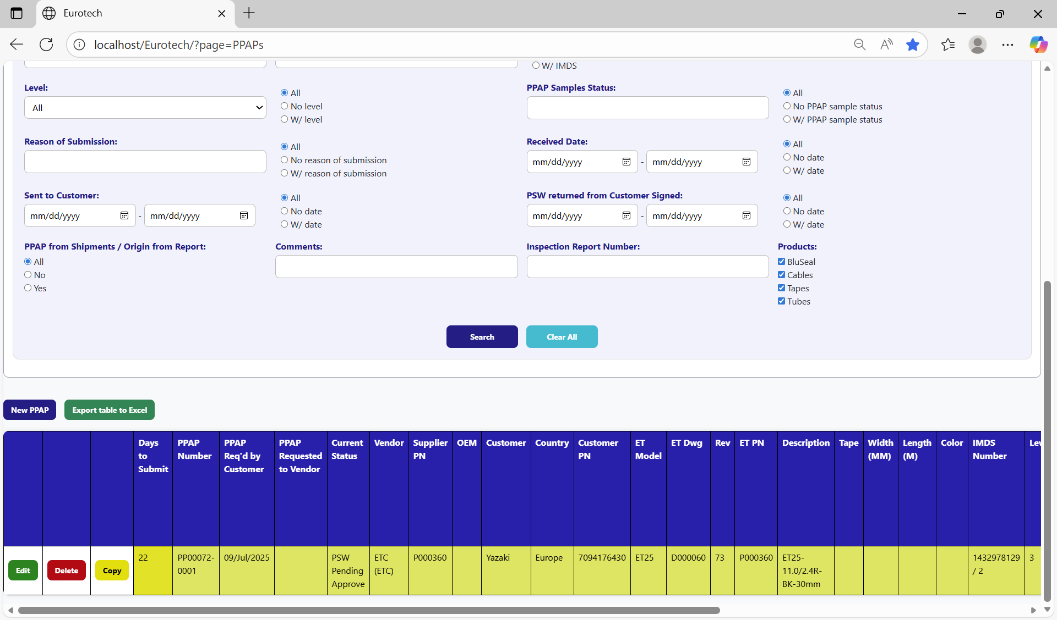

* Registers with red field indicate that the difference between the “PPAP Req’d by Customer” date and the “Sent to Customer” date is greater than 29 days (if there is no “Sent to Customer” date yet, it is compared with the current date).

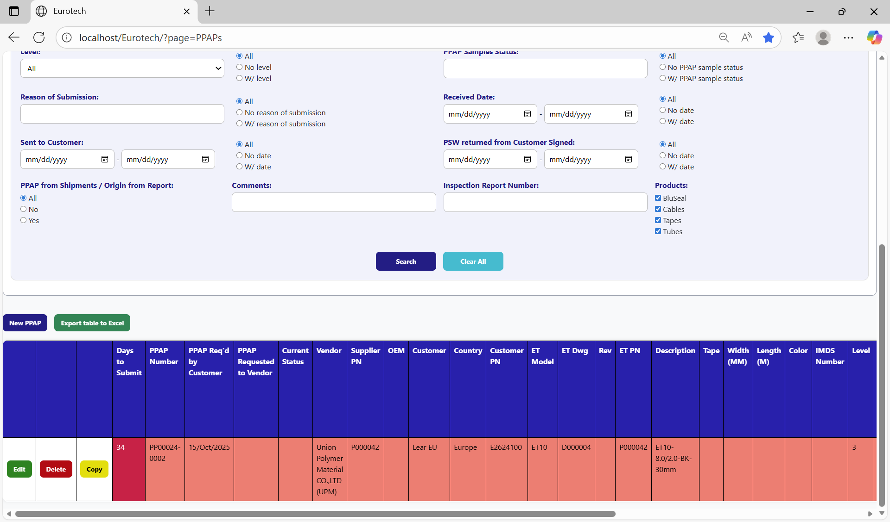

2.- In the rest of the columns of the registers will be:

* Registers with white background indicate that the PPAP has been requested by the customer, the request has not been sent to the vendor, and 30 days have not passed without the documentation being sent to the customer.

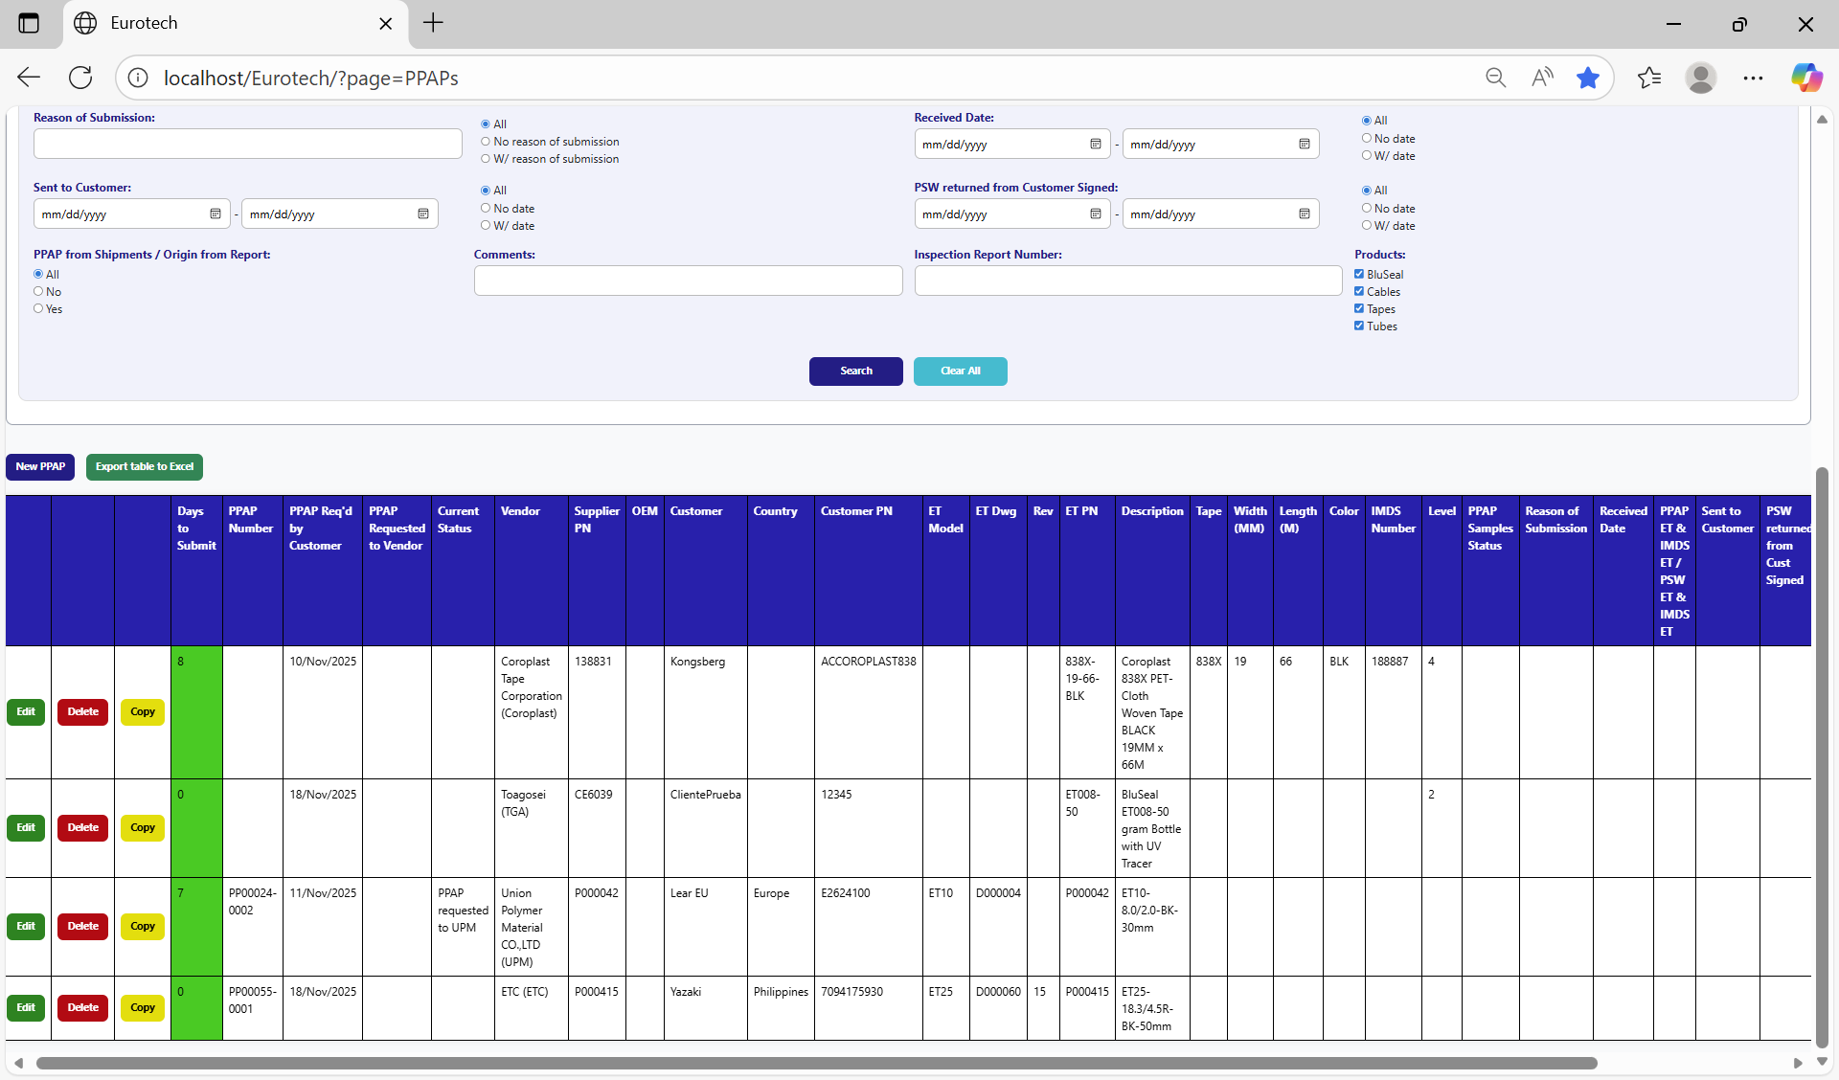

* Registers with blue background indicate that the PPAP has been requested by the customer, the request has been sent to the vendor, and 30 days have not passed without the documentation being sent to the customer.

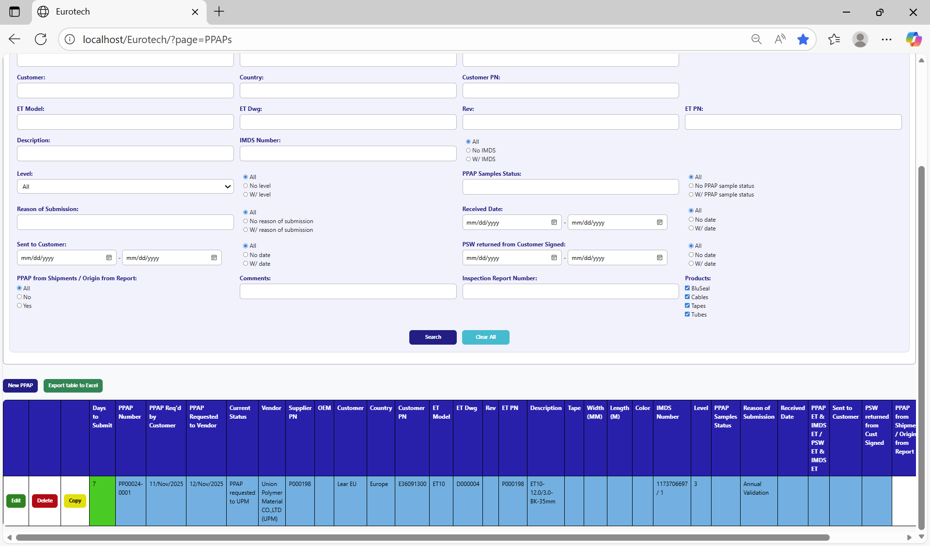

* Registers with red background indicate that the PPAP has been requested by the customer, and the 30-day limit has passed without the documentation being sent to the customer.

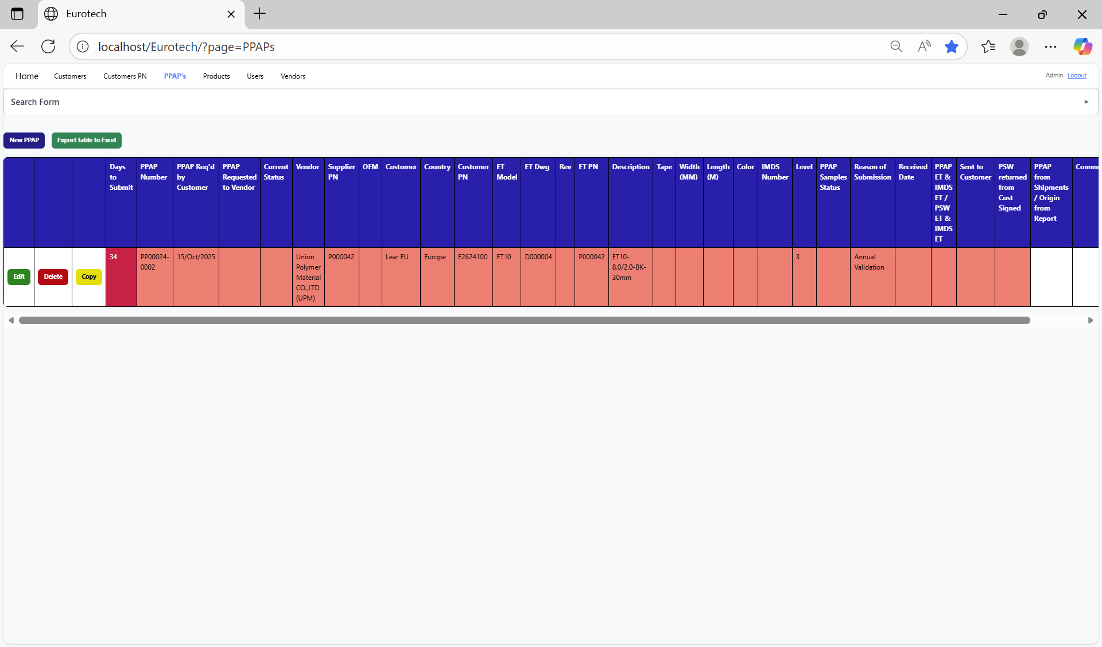

* Registers with yellow background indicate that the PPAP has been sent to the customer, and the PSW has not been returned signed by the customer.

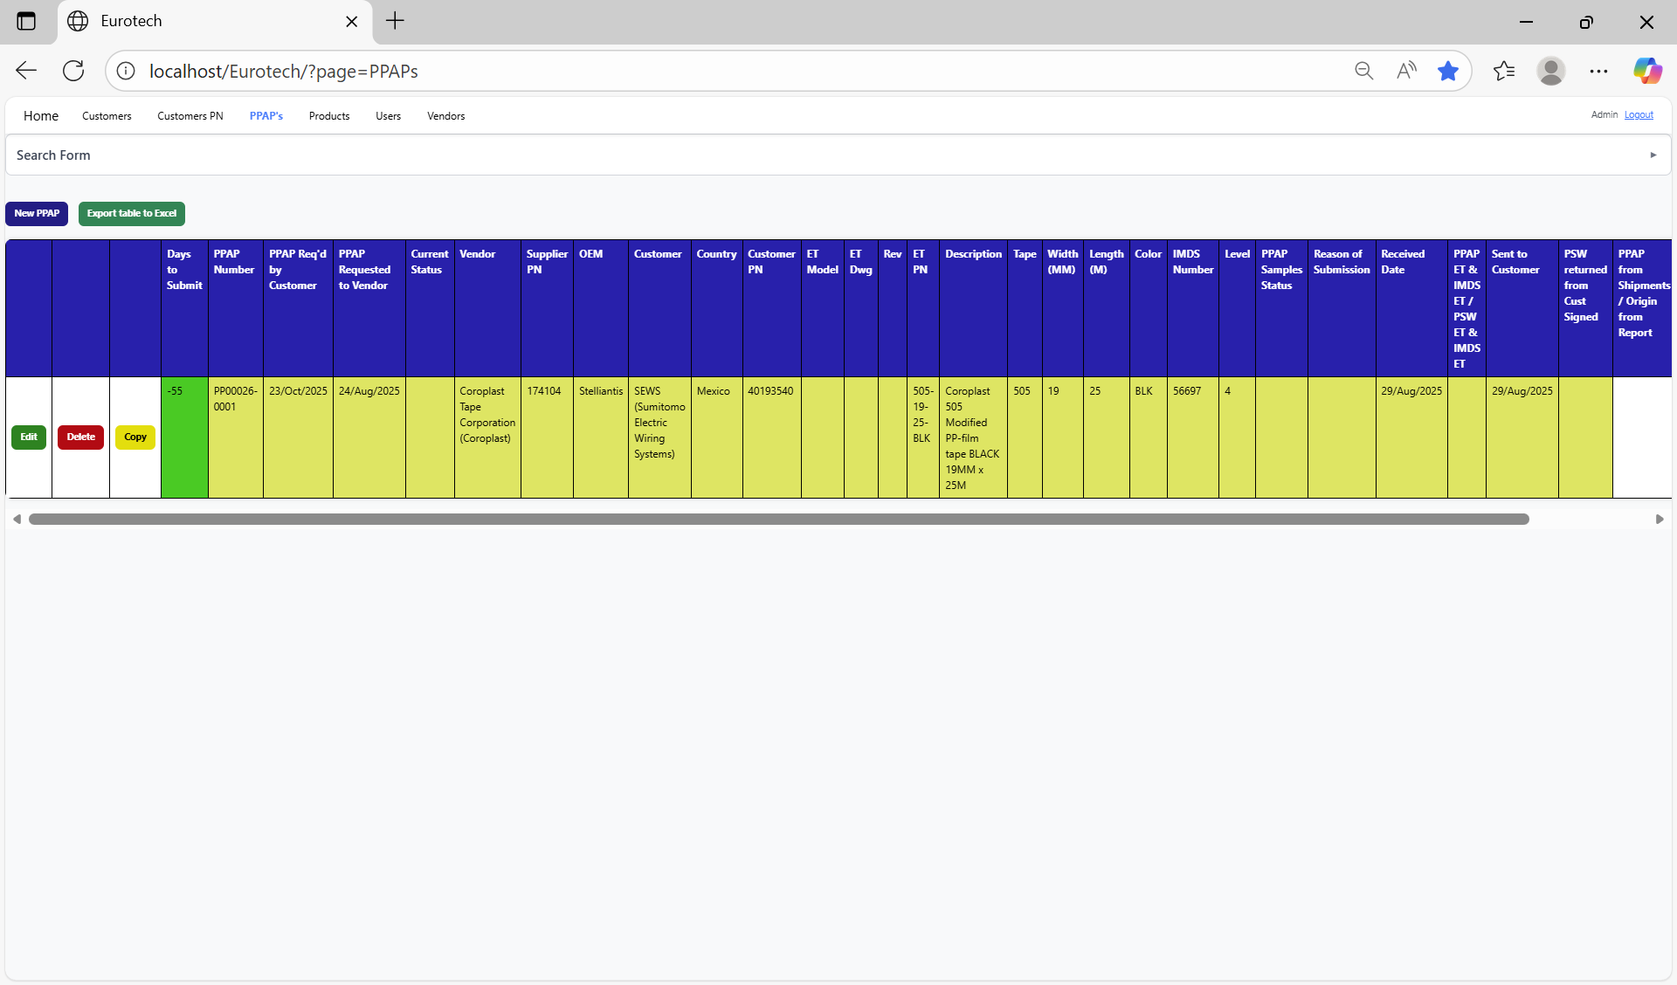

* Registers with green background indicate that the PSW has been returned signed by the customer.

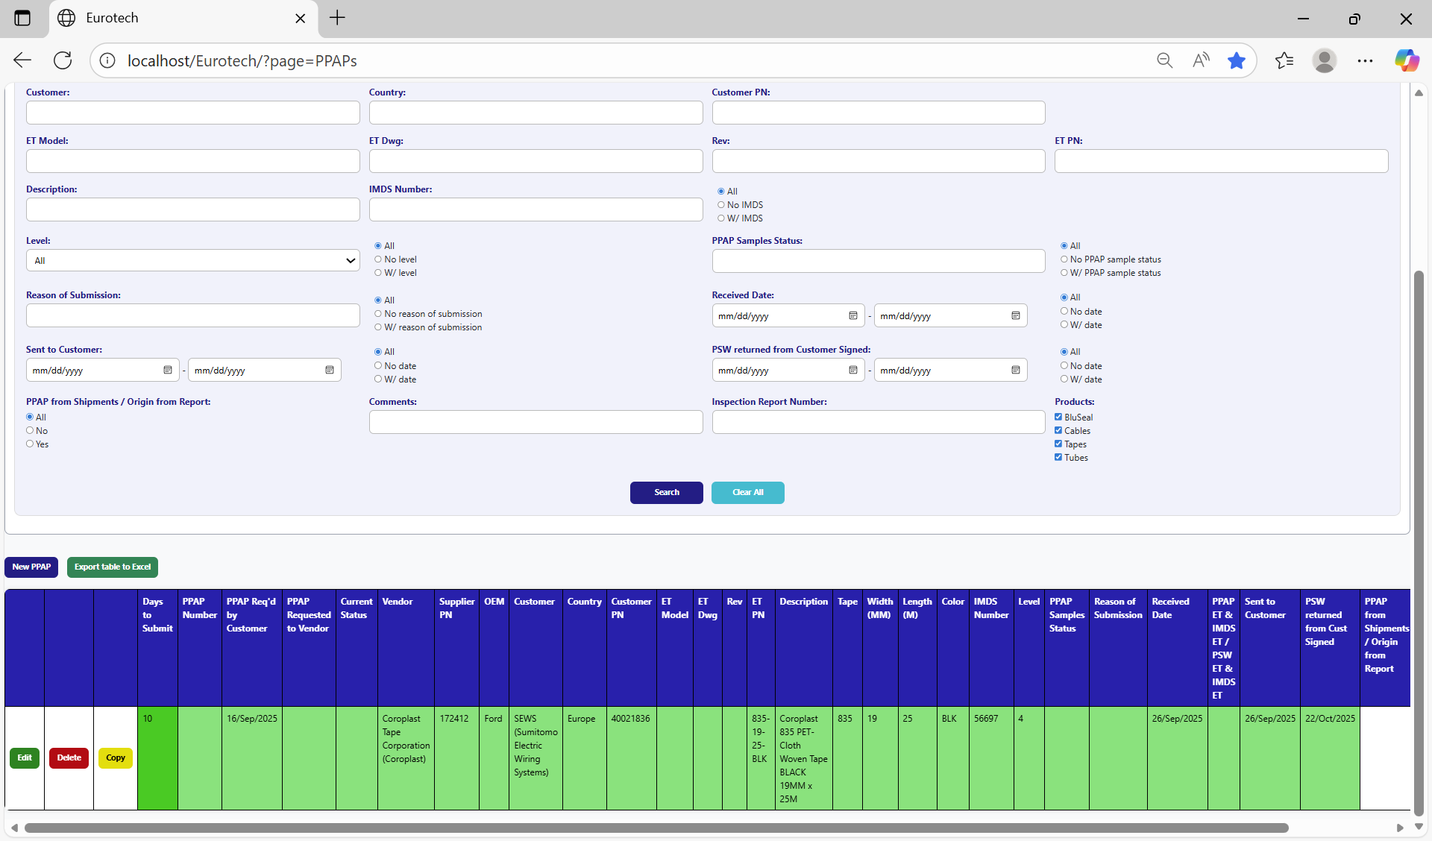

### *4.1.4 How to Export the Information of the Table to an Excel Document.*

To export the table to an Excel document, you must click the “Export table to Excel” button.

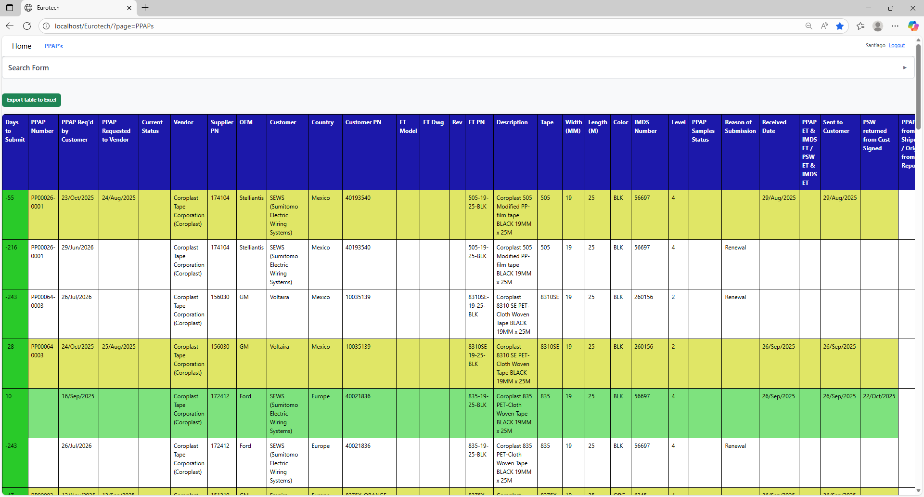

Once you click the “Export table to Excel” button, it will start to download the Excel document with the name “PPAPs_Report.xls”.

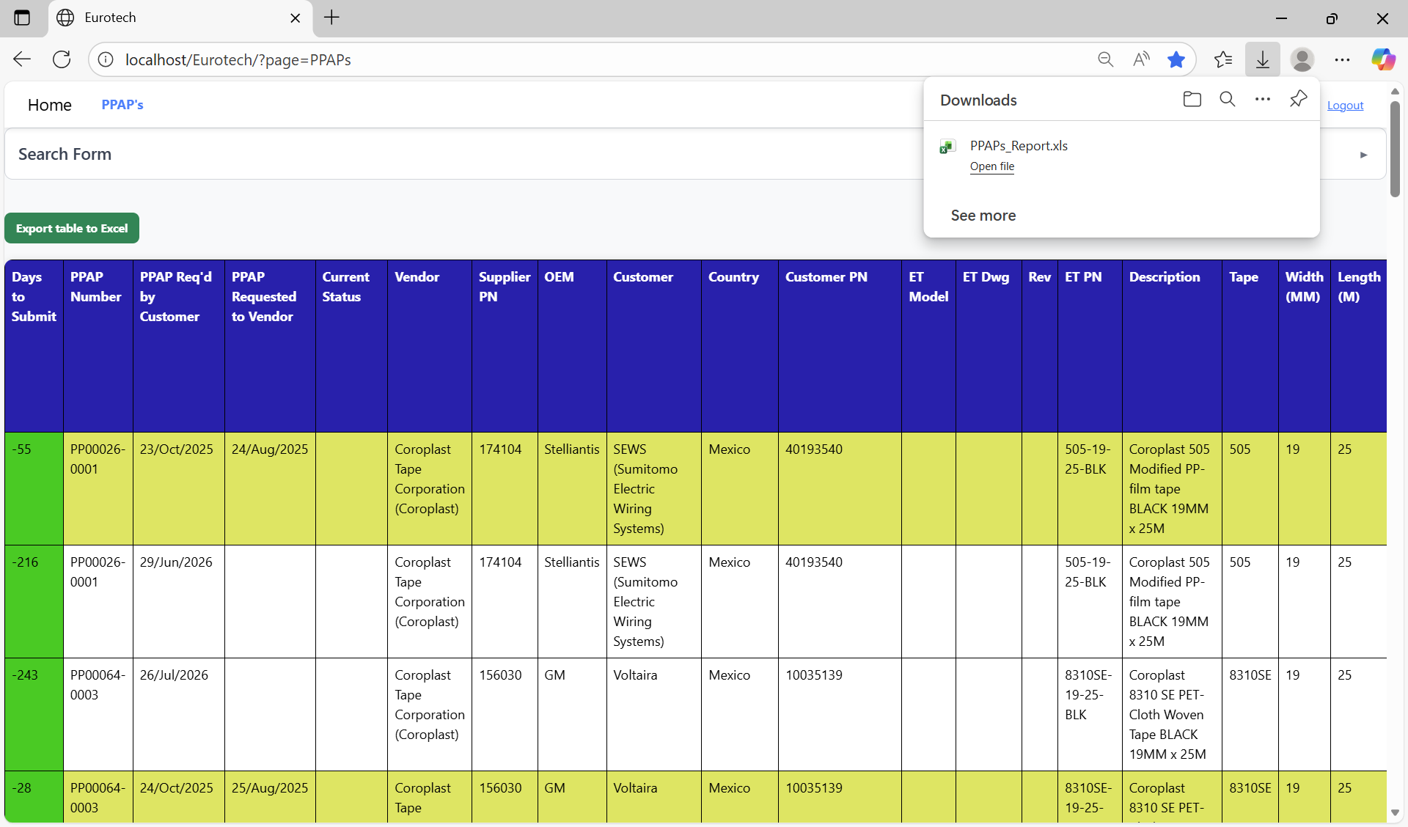

Once the download is finished, you can go to the folder it was downloaded and open the Excel document.

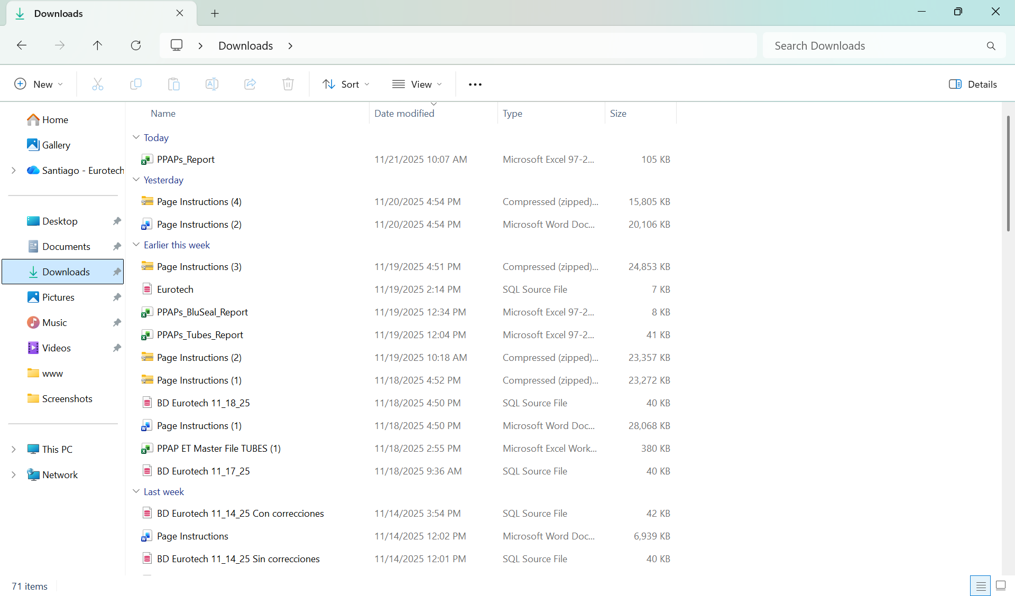

This is an example of how the document would look like:

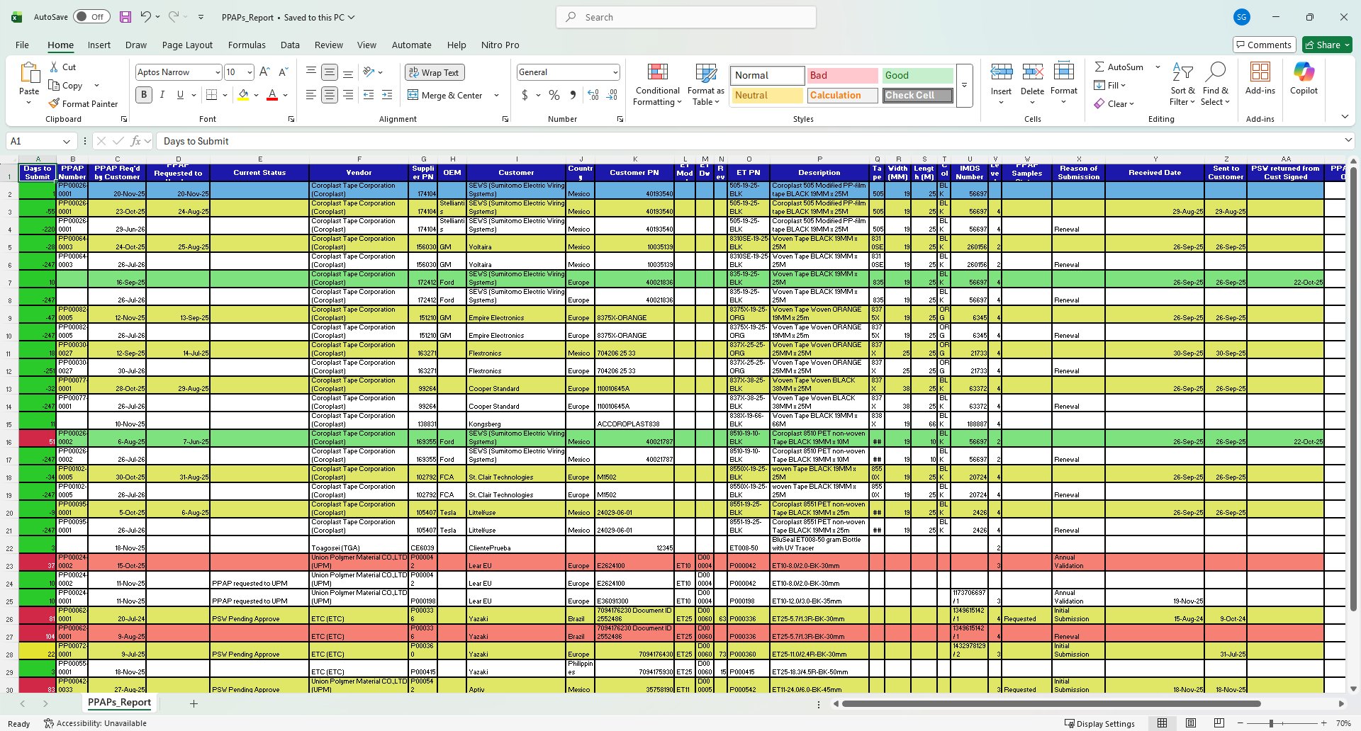

## ***4.2 BluSeal Page***

### *4.2.1 How to Navigate to “BluSeal” Page.*

On the navigation bar, you can navigate to the “BluSeal” page.

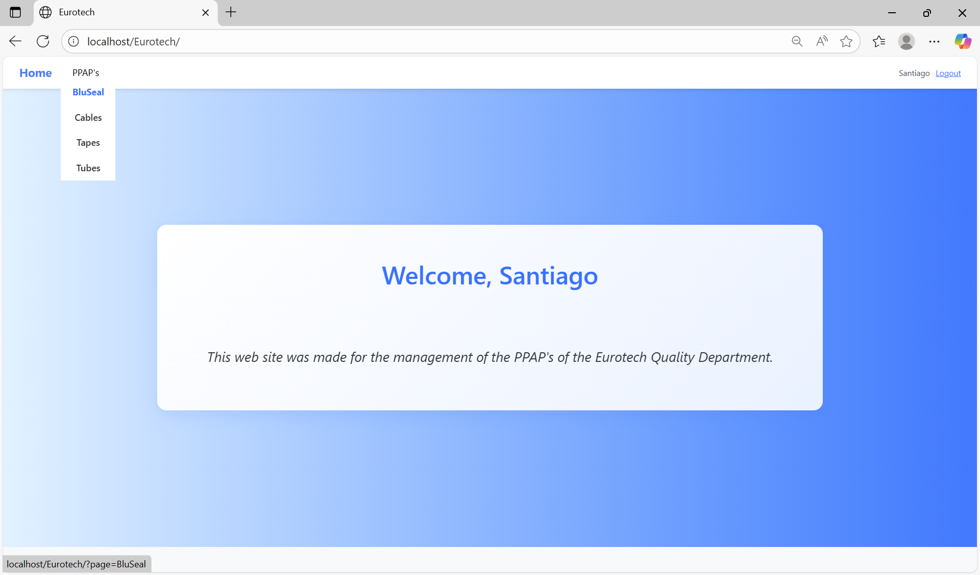

In this page you can manage the registers of all the PPAPs of BluSeal.

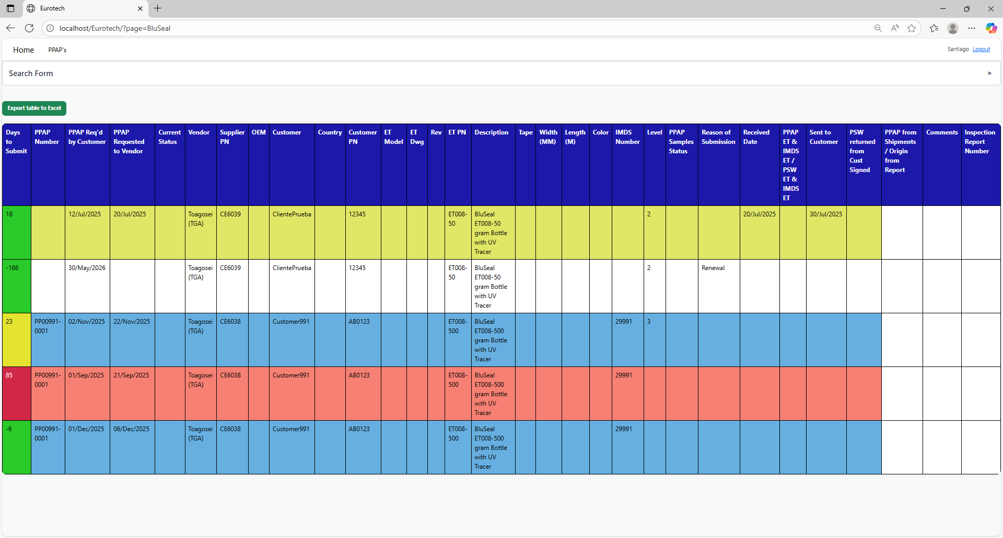

### *4.2.2 How to Search a PPAP.*

At the top of the page, it will be a dropdown “Search Form” that has all the fields of the table for querying registers.

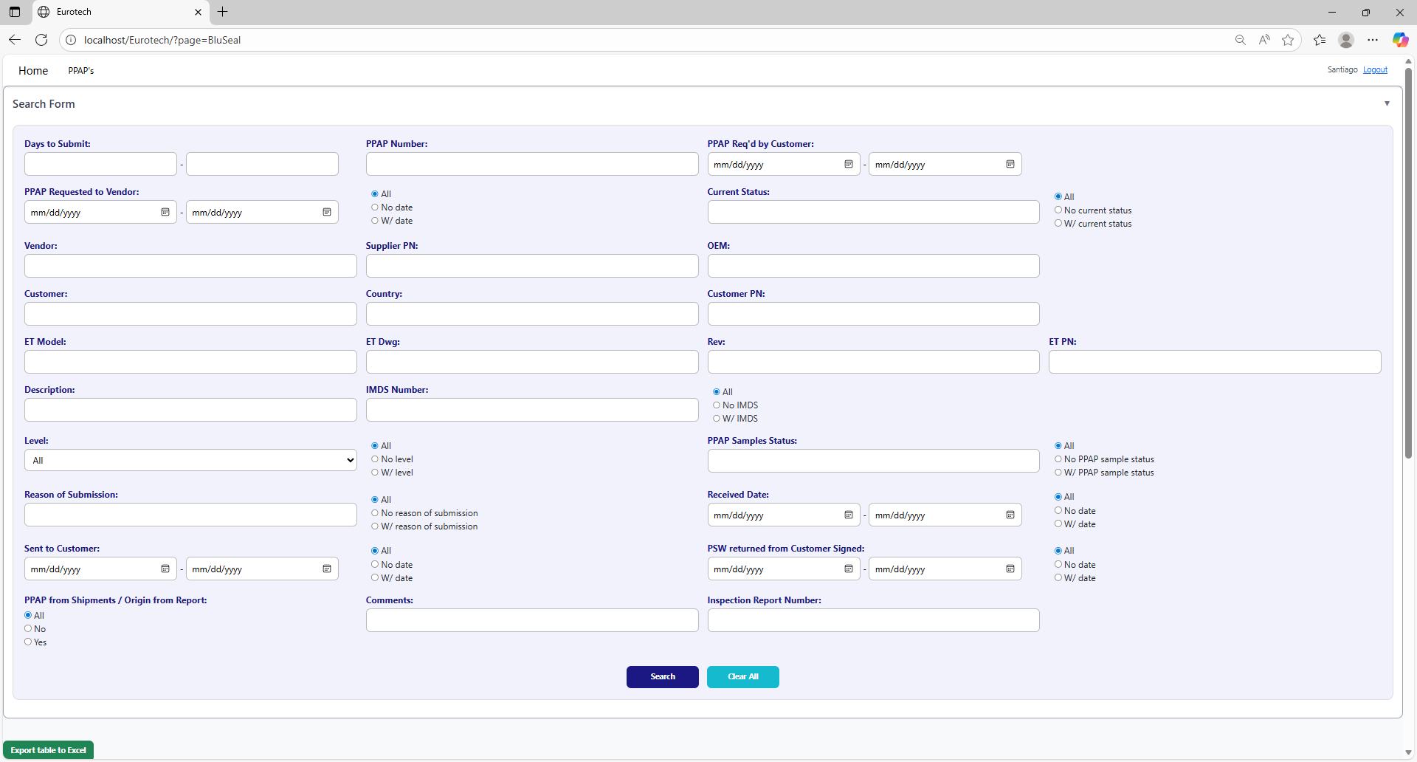

The search form allows you to perform searches by:

* Level
* PPAP Samples Status
* Reason of Submission
* Received Date
* Sent to Customer
* PSW returned from Customer Signed
* PPAP from Shipments / Origin from Report
* Comments
* Inspection Report Number
* Days to Submit
* PPAP Number
* PPAP Req’d by Customer
* PPAP Requested to Vendor
* Current Status
* Vendor
* Supplier PN
* OEM
* Customer
* Country
* Customer PN
* ET Model
* ET Dwg
* Rev
* Eurotech PN
* Description
* IMDS Number

You can search by “Days to Submit”, writing the range of days.

You can search by “PPAP Number”.

You can search by “PPAP Req’d by Customer”, writing the range of dates.



You can search registers that either have or don’t have the “Current Status” field filled in, or all the registers.

You can search by “Current Status”.

You can search registers that either have or don’t have a date on “PPAP Requested to Vendor”, or all the registers.

You can search by “PPAP Requested to Vendor”, writing the range of dates.

You can search by “OEM”.

You can search by “Vendor”.

You can search by “Supplier PN”.



You can search by “Customer PN”.

You can search by “Customer”.

You can search by “Country”.

You can search by “ET PN”.

You can search by “Rev”.

You can search by “ET Dwg”.

You can search by “ET Model”.



You can search registers that either have or don’t have the “IMDS Number” field filled in, or all the registers.

You can search by “IMDS Number”.

You can search by “Description”.

You can search by “PPAP Samples Status”.

You can search by “Level”.

You can search registers that either have or don’t have the “PPAP Samples Status” field filled in, or all the registers.

You can search registers that either have or don’t have the “Level” field filled in, or all the registers.



You can search registers that either have or don’t have a date on “Received Date”, or all the registers.

You can search by “Received Date”, writing the range of dates.

You can search registers that either have or don’t have the “Reason of Submission” field filled in, or all the registers.

You can search by “Reason of Submission”.

You can search registers that either have or don’t have a date on “PSW returned from Customer Signed”, or all the registers.

You can search registers that either have or don’t have a date on “Sent to Customer”, or all the registers.

You can search by “PSW returned from Customer Signed”, writing the range of dates.

You can search by “Sent to Customer”, writing the range of dates.



You can search by “Inspection Report Number”.

You can search by “Comments”.

You can search by “PPAP from Shipments / Origin from Report”.

You must click the “Search” button after you fill any of the fields of the “Search Form” to make the search.



This is an example of how the table would look like after a search (the meaning of the colors of the registers will be explained later).

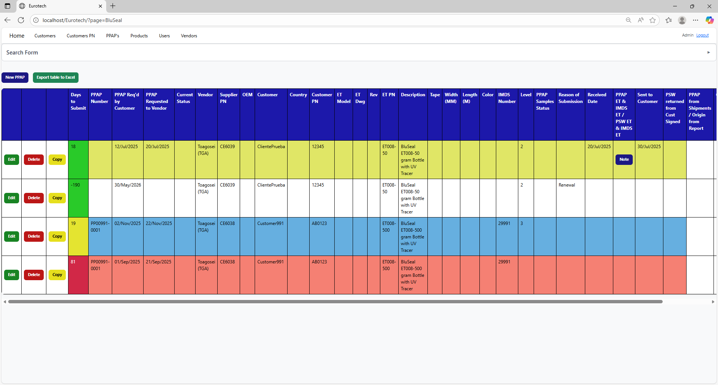

And with the “Clear All” button, you can clean the querying and see all the registers of the PPAPs.



Once you click the “Clear All” button, the fields of the “Search Form” will be empty, and in the table will be shown all the PPAPs.





### *4.2.3 Meaning of the Colors of the Registers.*

1.- In the “Days to Submit” column there will be:

* Registers with green field indicate that the difference between the “PPAP Req’d by Customer” date and the “Sent to Customer” date is less than 19 days (if there is no “Sent to Customer” date yet, it is compared with the current date).



* Registers with yellow field indicate that the difference between the “PPAP Req’d by Customer” date and the “Sent to Customer” date is between 19 and 29 days (if there is no “Sent to Customer” date yet, it is compared with the current date).

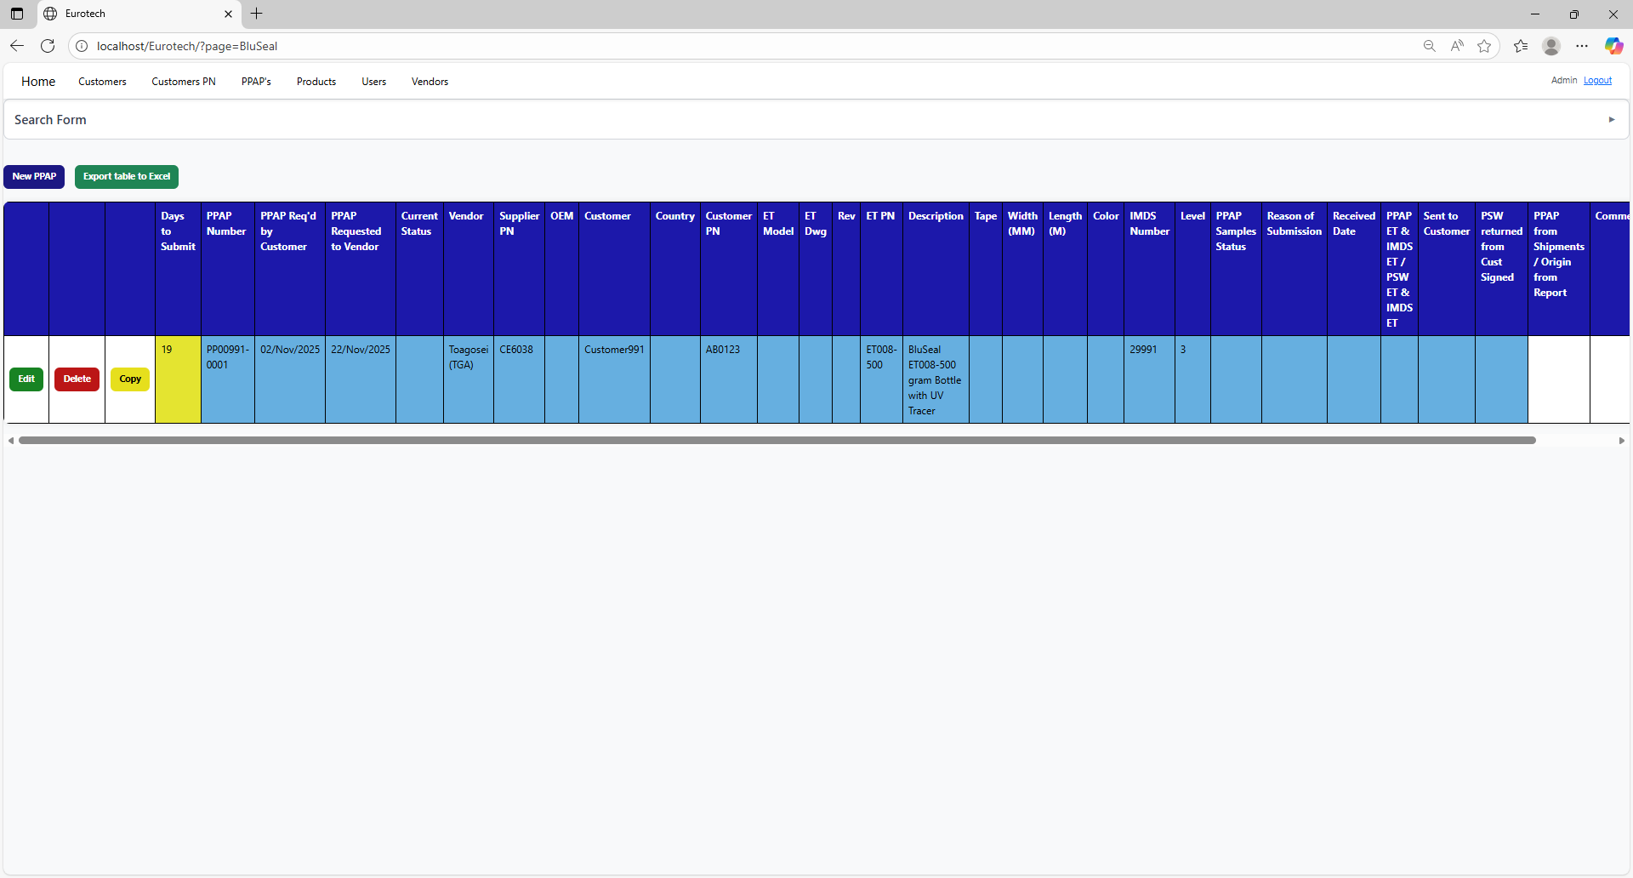

* Registers with red field indicate that the difference between the “PPAP Req’d by Customer” date and the “Sent to Customer” date is greater than 29 days (if there is no “Sent to Customer” date yet, it is compared with the current date).

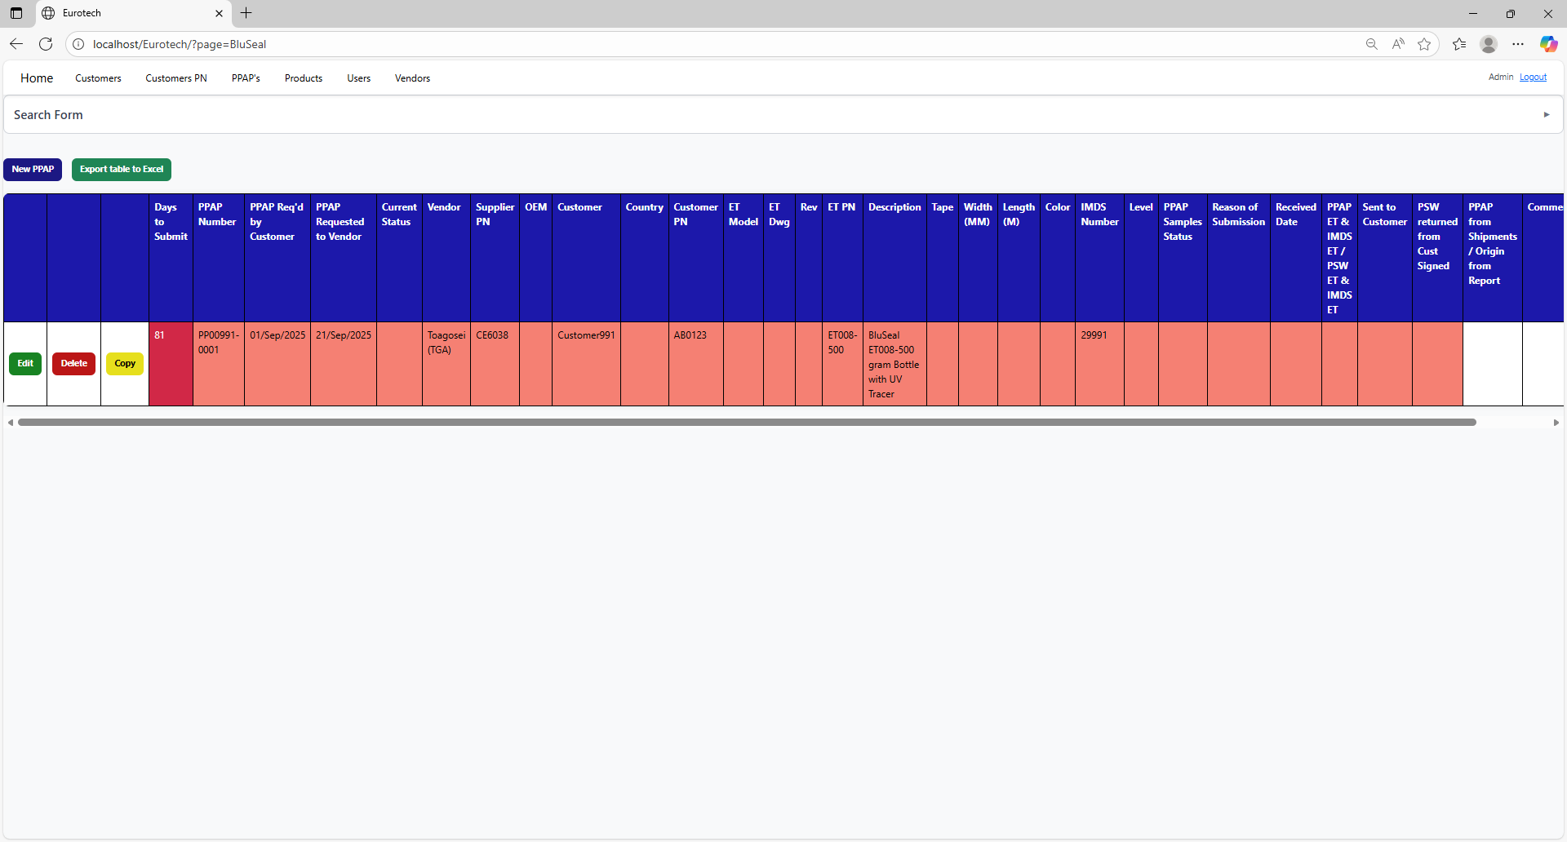

2.- In the rest of the columns of the registers will be:

* Registers with white background indicate that the PPAP has been requested by the customer, the request has not been sent to the vendor, and 30 days have not passed without the documentation being sent to the customer.

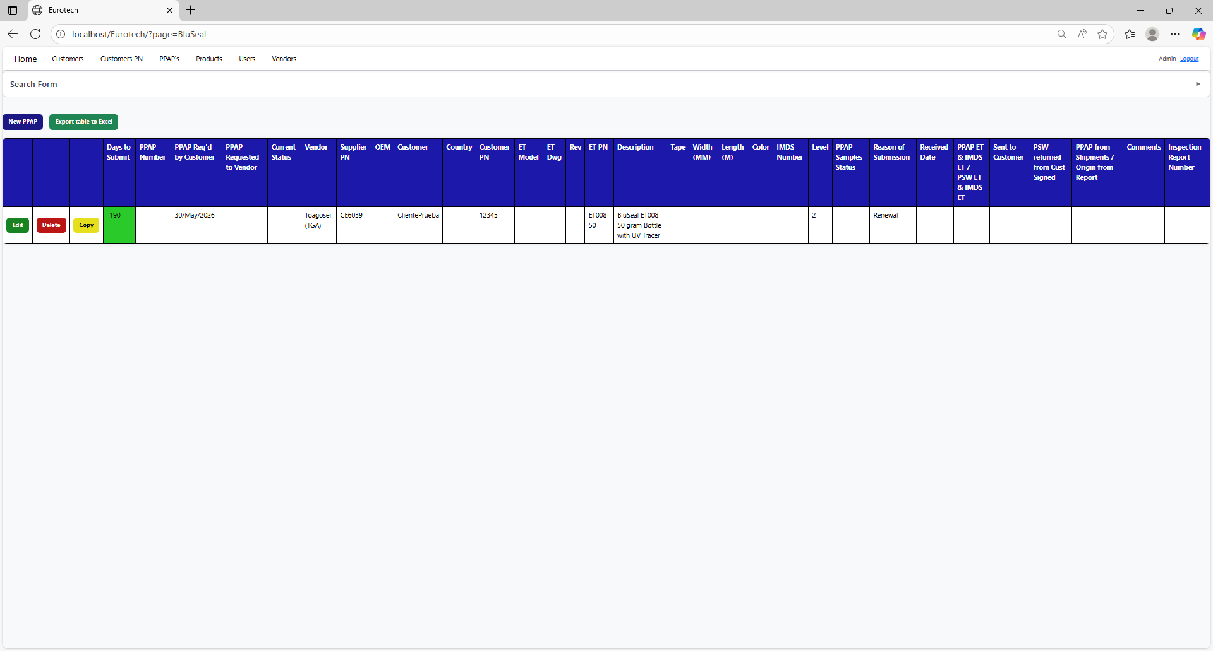

* Registers with blue background indicate that the PPAP has been requested by the customer, the request has been sent to the vendor, and 30 days have not passed without the documentation being sent to the customer.

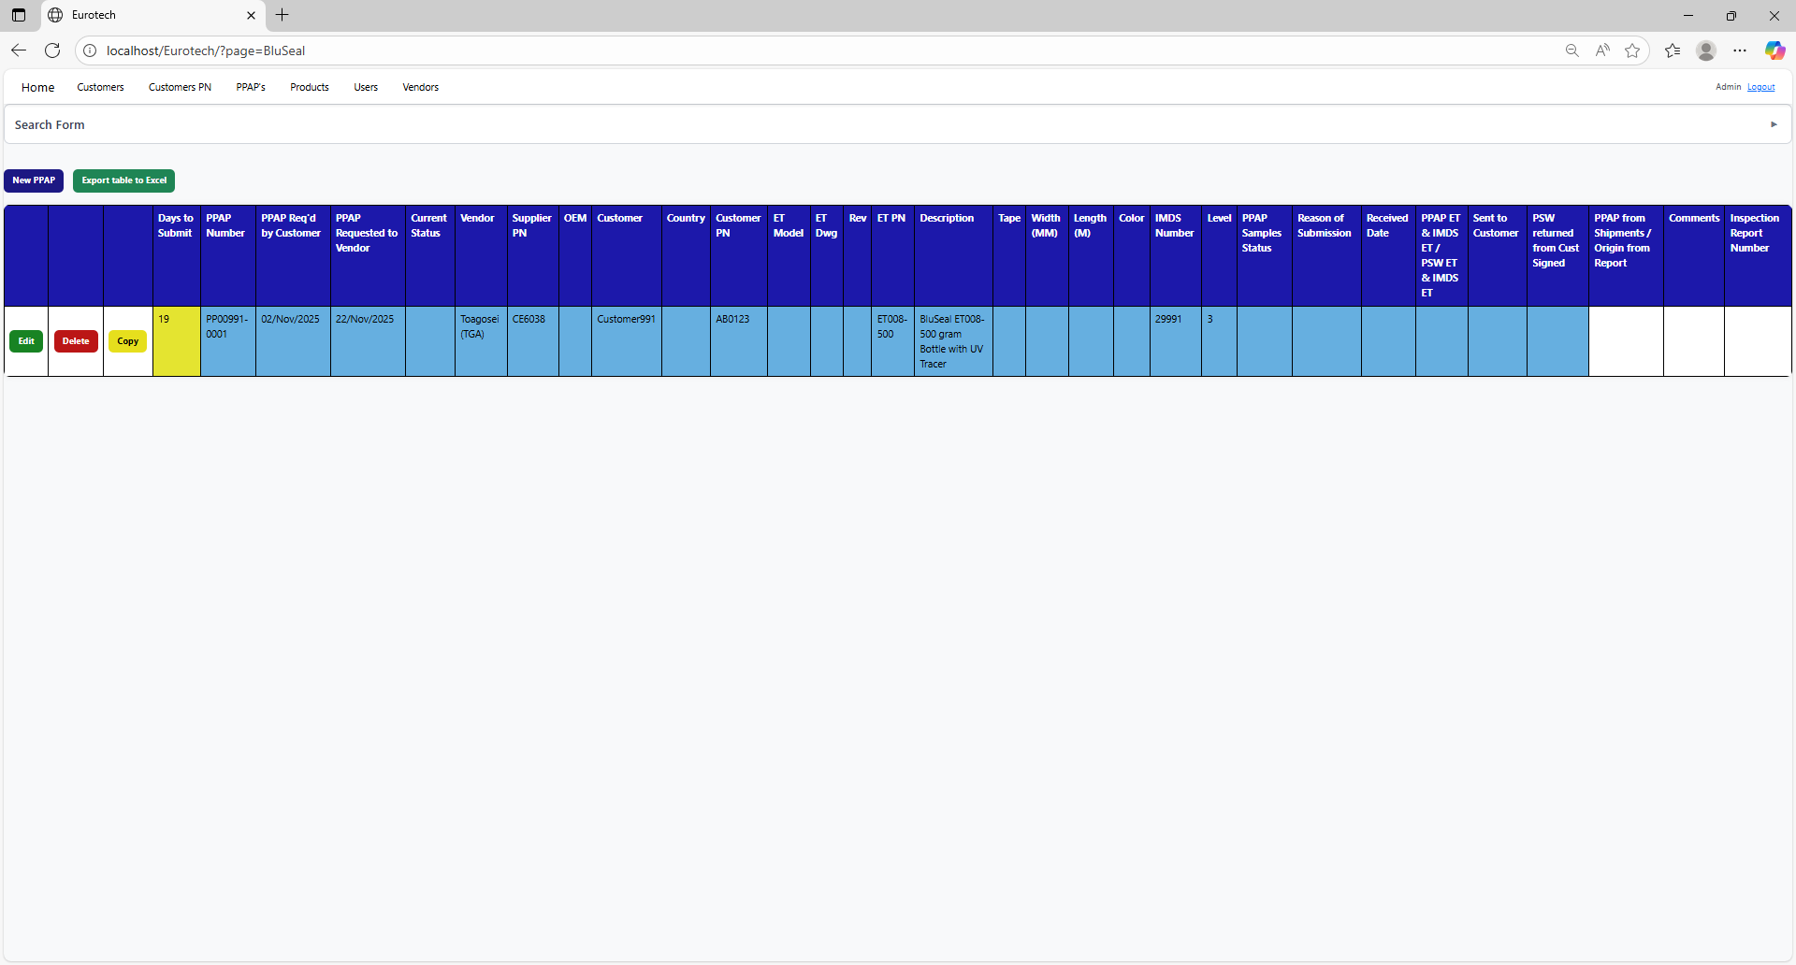

* Registers with red background indicate that the PPAP has been requested by the customer, and the 30-day limit has passed without the documentation being sent to the customer.

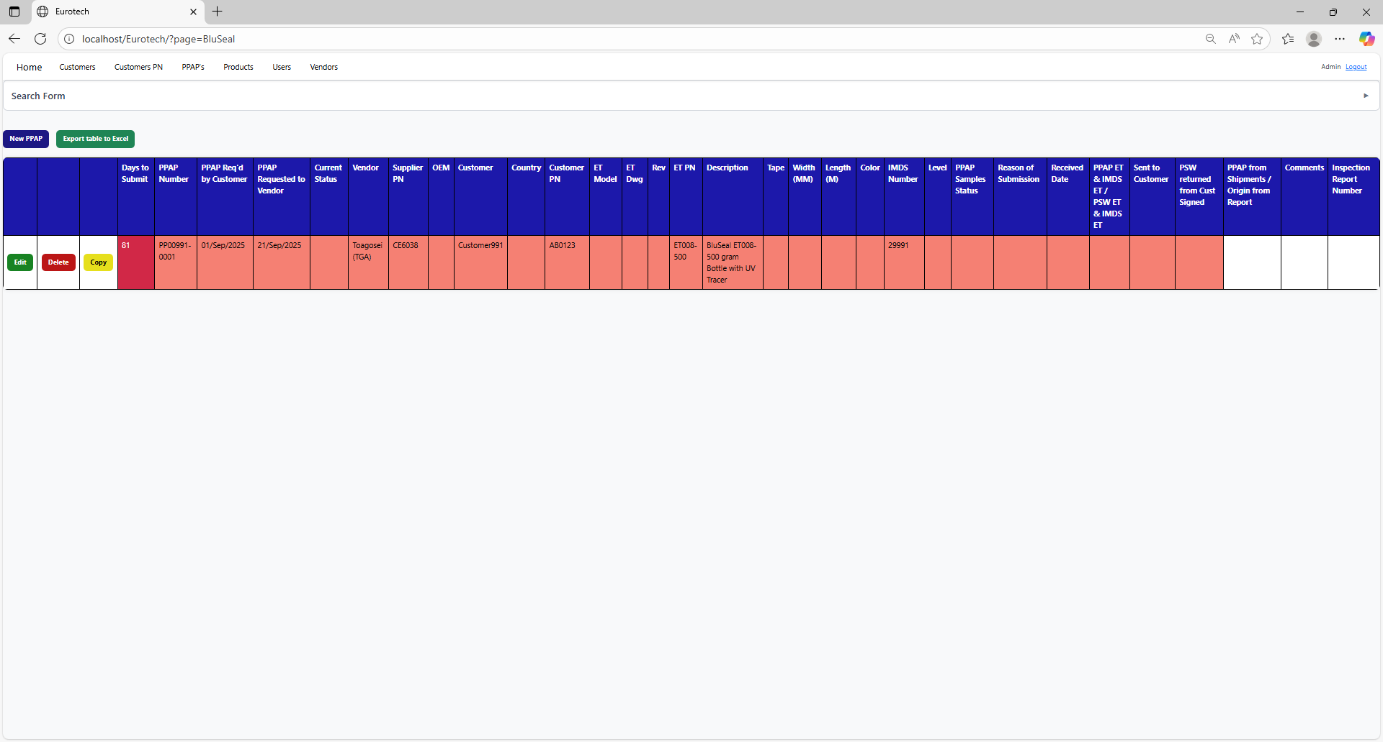

* Registers with yellow background indicate that the PPAP has been sent to the customer, and the PSW has not been returned signed by the customer.



* Registers with green background indicate that the PSW has been returned signed by the customer.

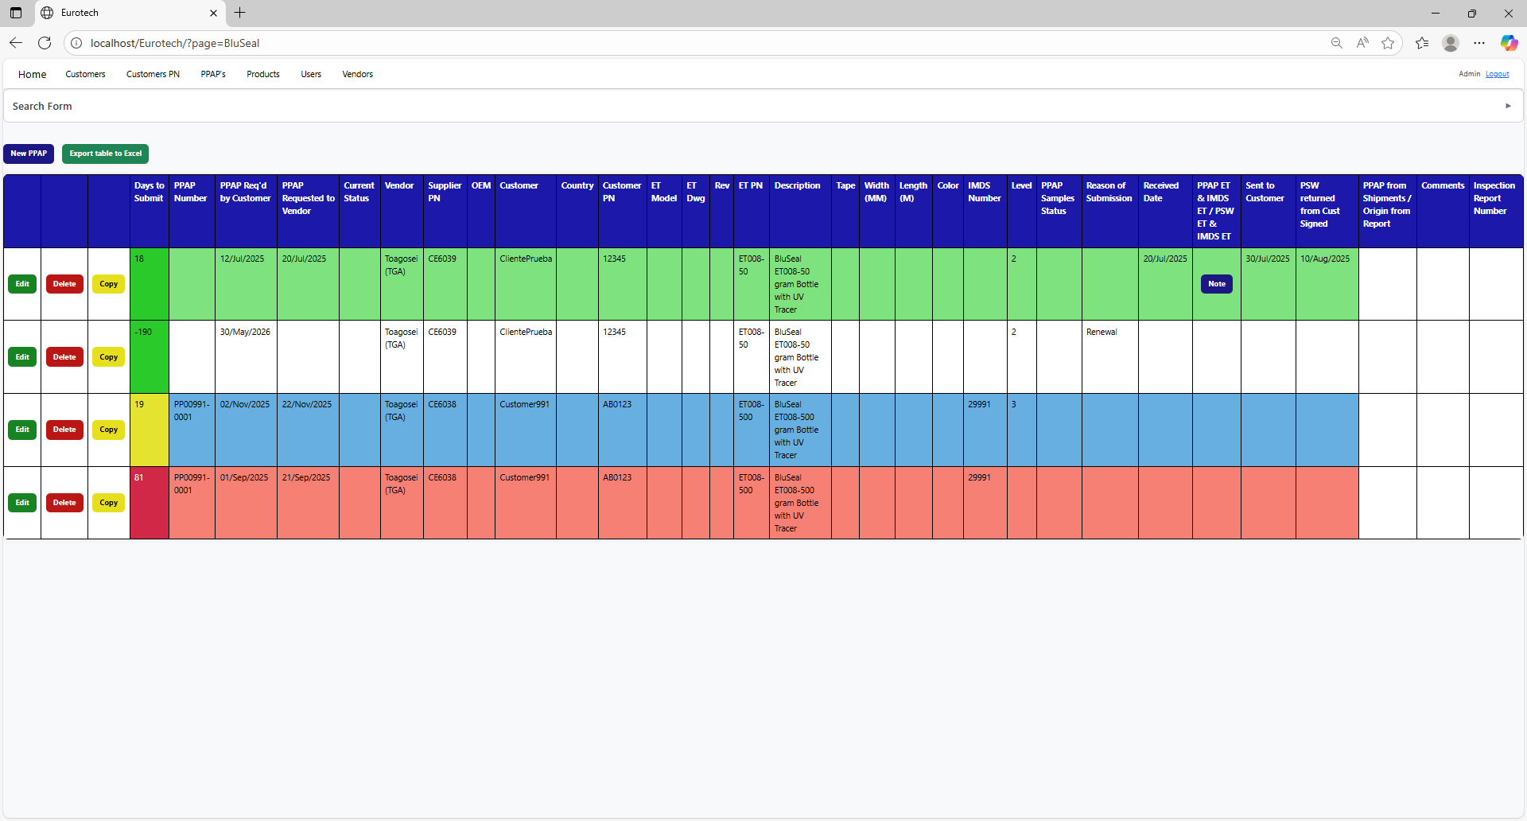

### *4.2.4 How to Export the Information of the Table to an Excel Document.*

To export the table to an Excel document, you must click the “Export table to Excel” button.



Once you click the “Export table to Excel” button, it will start to download the Excel document with the name “PPAPs_BluSeal_Report.xls”.

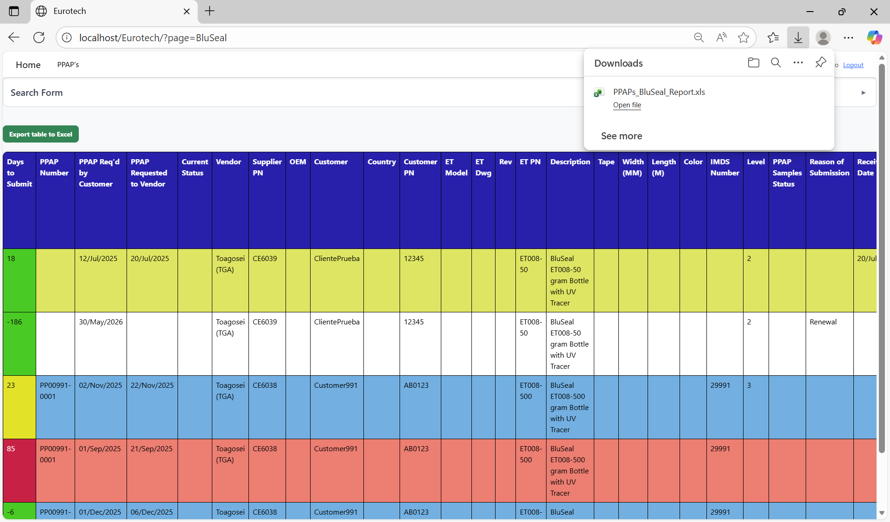

Once the download is finished, you can go to the folder it was downloaded and open the Excel document.

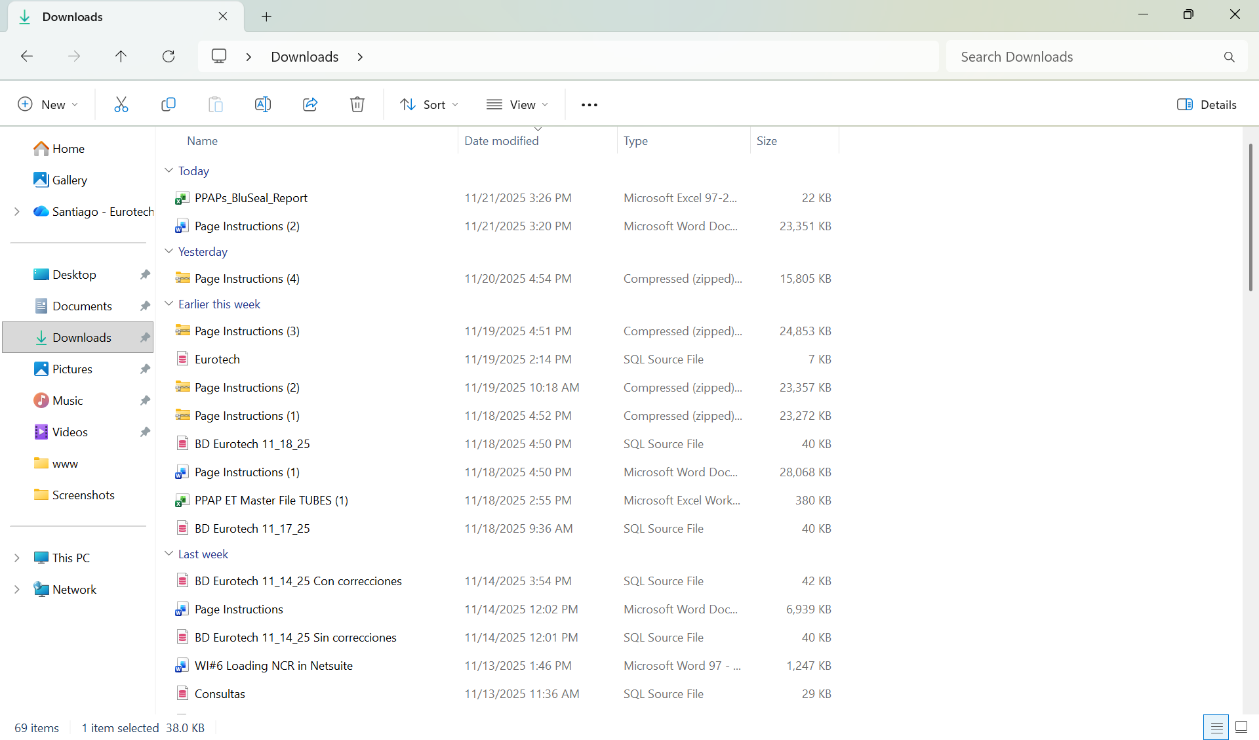

This is an example of how the document would look like:

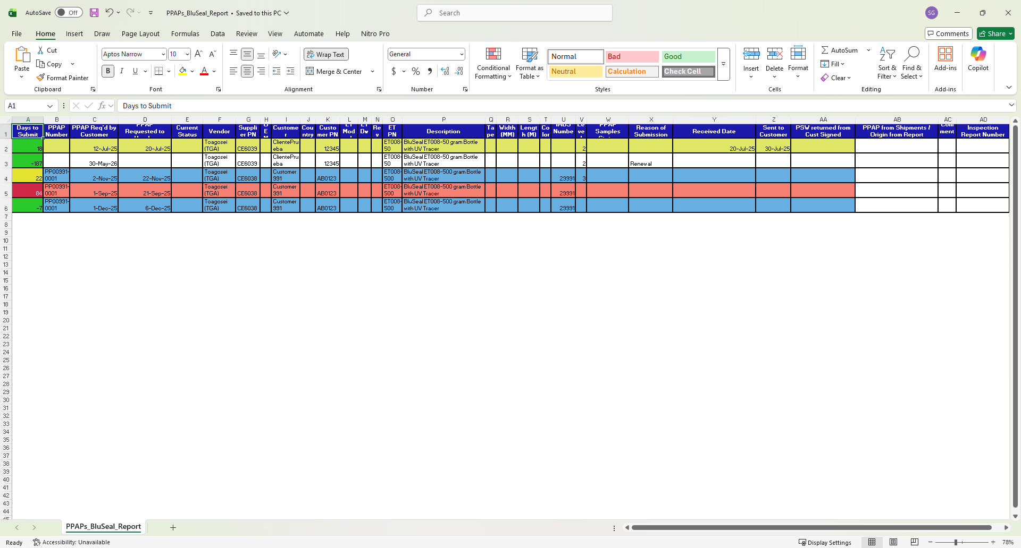

## ***4.3 Cables Page***

### *4.3.1 How to Navigate to “Cables” Page.*

On the navigation bar, you can navigate to the “Cables” page.

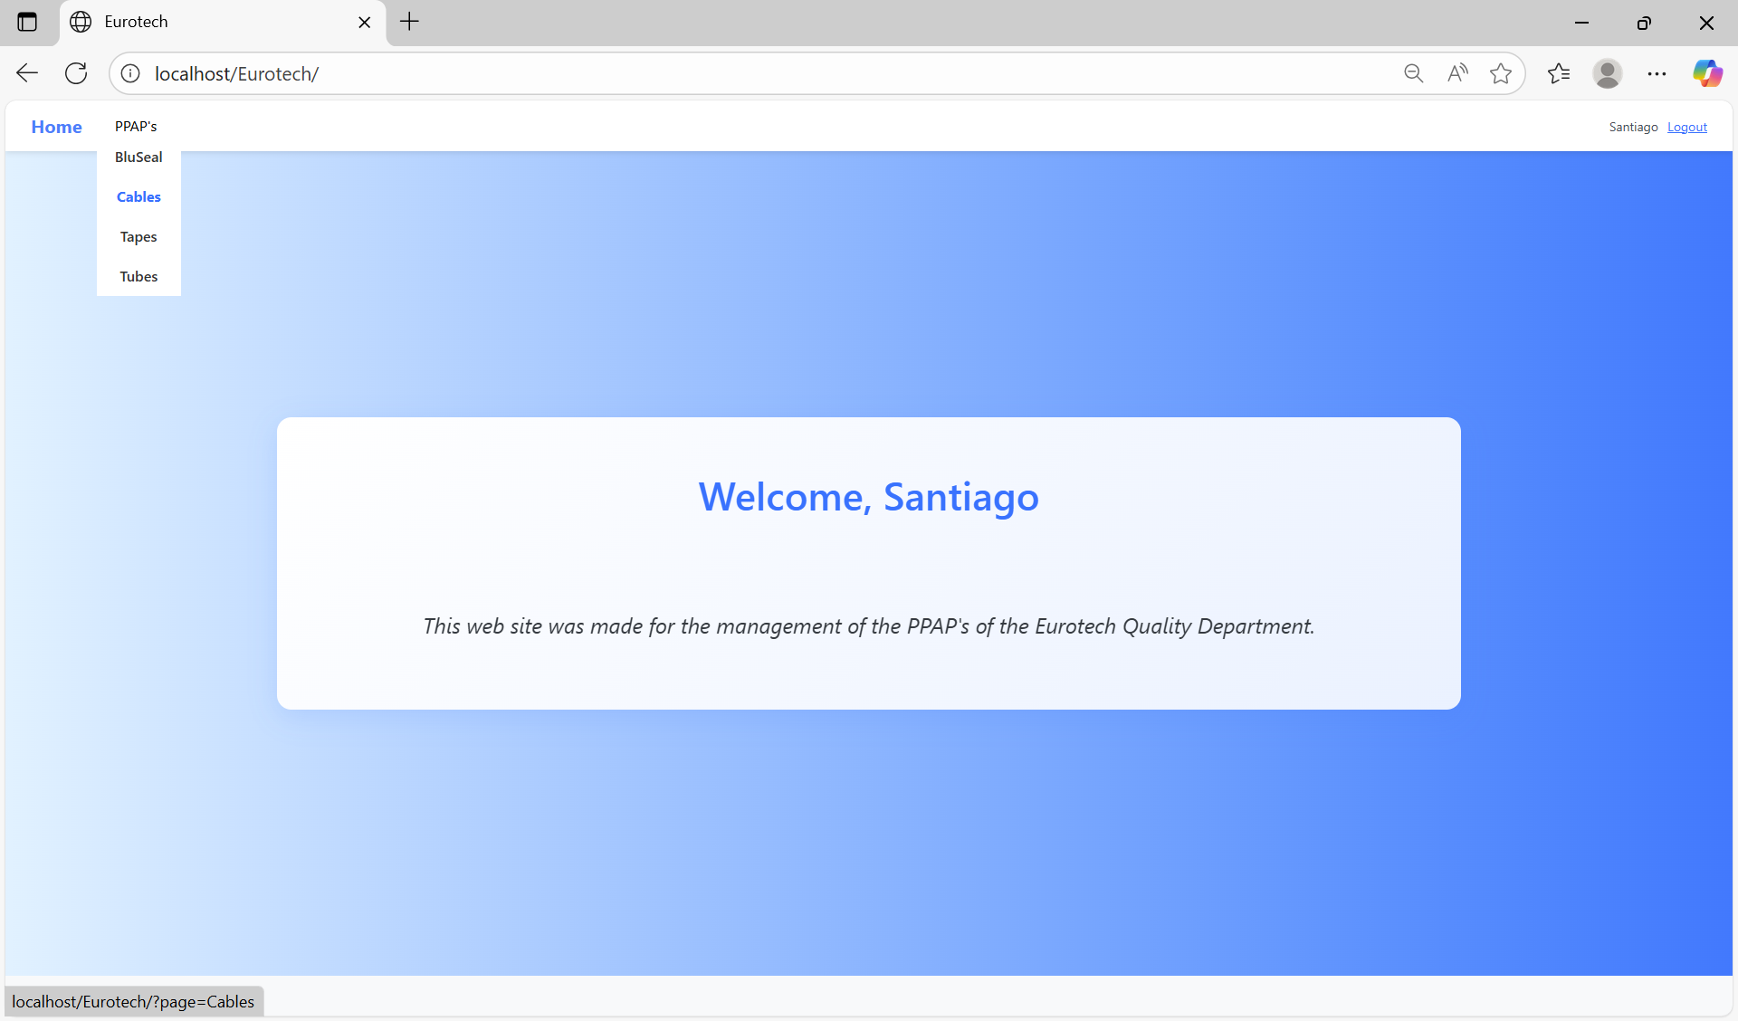

In this page you can manage the registers of all the PPAPs of Cables.

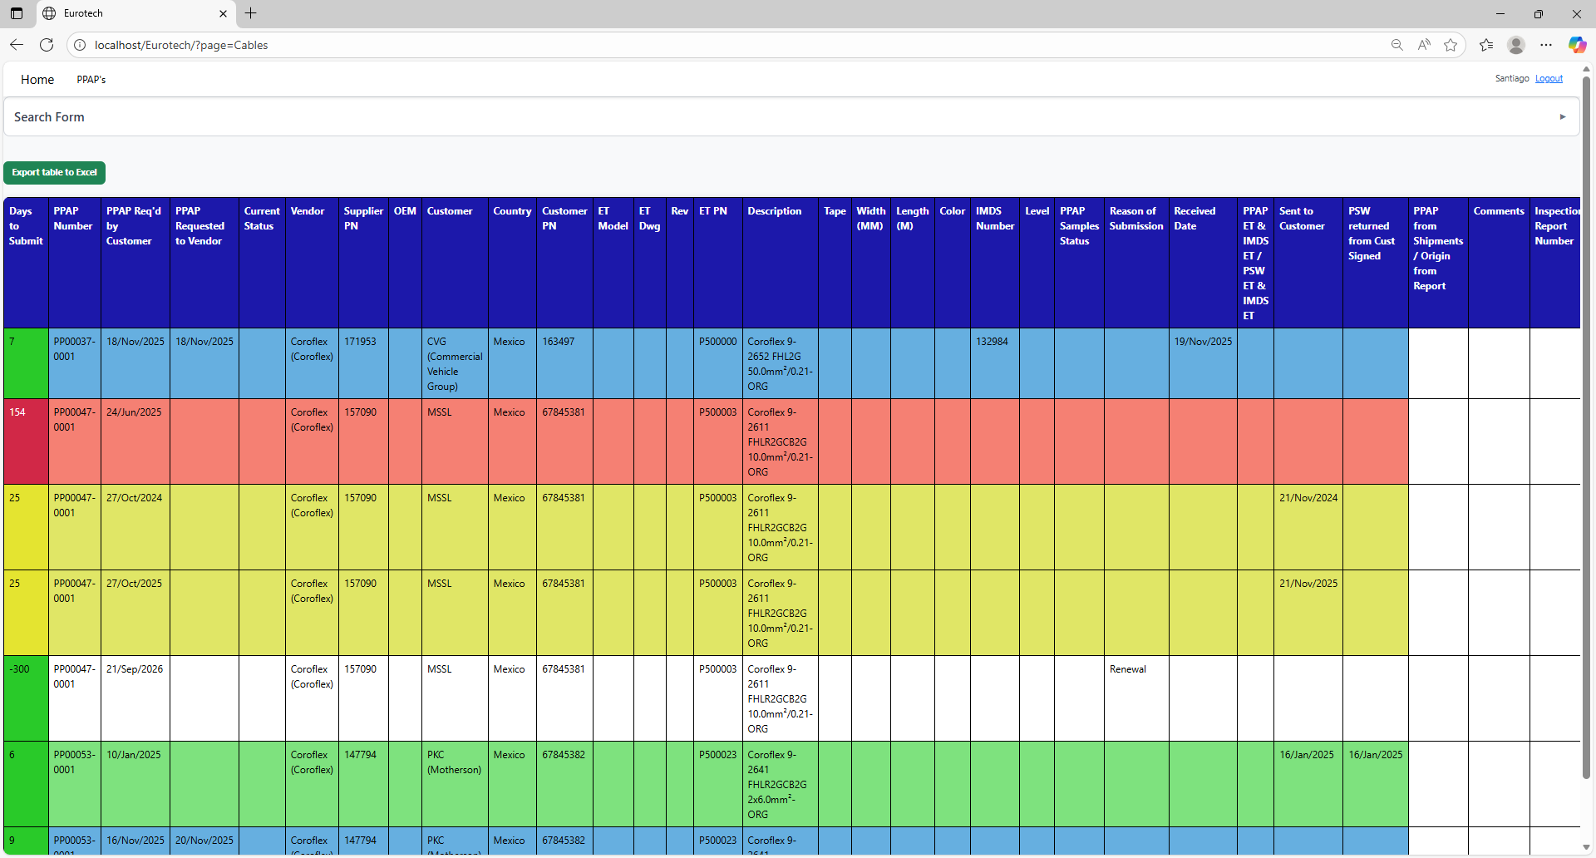

### *4.3.2 How to Search a PPAP.*

At the top of the page, it will be a dropdown “Search Form” that has all the fields of the table for querying registers.

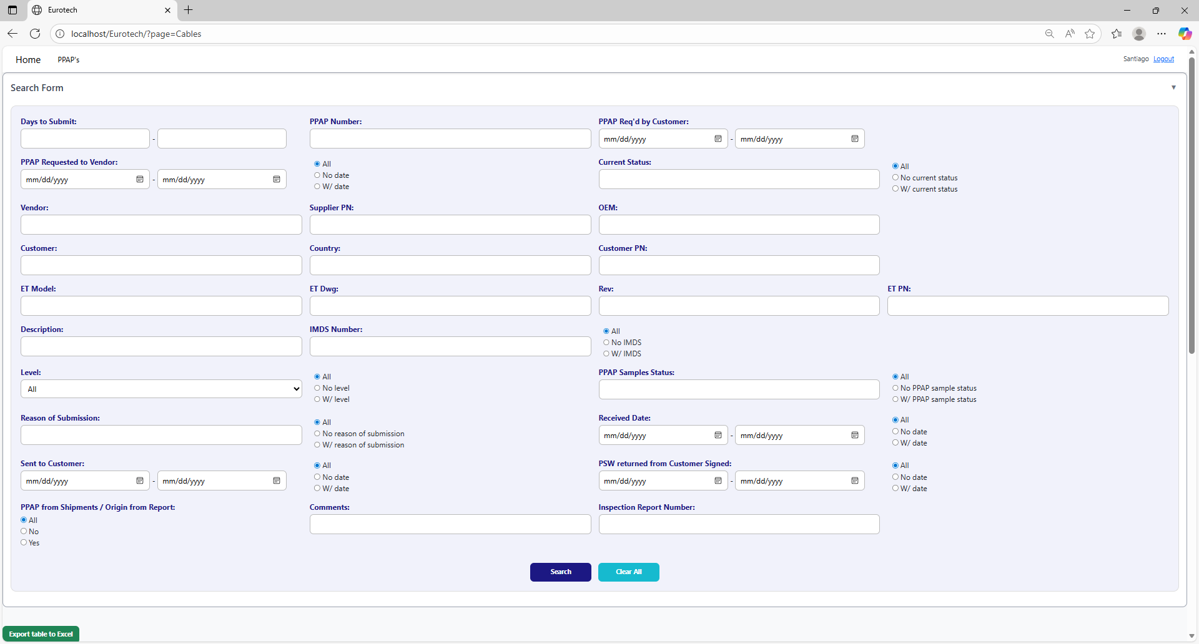

The search form allows you to perform searches by:

* Level
* PPAP Samples Status
* Reason of Submission
* Received Date
* Sent to Customer
* PSW returned from Customer Signed
* PPAP from Shipments / Origin from Report
* Comments
* Inspection Report Number
* Days to Submit
* PPAP Number
* PPAP Req’d by Customer
* PPAP Requested to Vendor
* Current Status
* Vendor
* Supplier PN
* OEM
* Customer
* Country
* Customer PN
* ET Model
* ET Dwg
* Rev
* Eurotech PN
* Description
* IMDS Number

You can search by “Days to Submit”, writing the range of days.

You can search by “PPAP Number”.

You can search by “PPAP Req’d by Customer”, writing the range of dates.



You can search registers that either have or don’t have the “Current Status” field filled in, or all the registers.

You can search by “Current Status”.

You can search registers that either have or don’t have a date on “PPAP Requested to Vendor”, or all the registers.

You can search by “PPAP Requested to Vendor”, writing the range of dates.

You can search by “OEM”.

You can search by “Vendor”.

You can search by “Supplier PN”.



You can search by “Customer PN”.

You can search by “Customer”.

You can search by “Country”.

You can search by “ET PN”.

You can search by “Rev”.

You can search by “ET Dwg”.

You can search by “ET Model”.



You can search registers that either have or don’t have the “IMDS Number” field filled in, or all the registers.

You can search by “IMDS Number”.

You can search by “Description”.

You can search by “PPAP Samples Status”.

You can search by “Level”.

You can search registers that either have or don’t have the “PPAP Samples Status” field filled in, or all the registers.

You can search registers that either have or don’t have the “Level” field filled in, or all the registers.



You can search registers that either have or don’t have a date on “Received Date”, or all the registers.

You can search by “Received Date”, writing the range of dates.

You can search registers that either have or don’t have the “Reason of Submission” field filled in, or all the registers.

You can search by “Reason of Submission”.

You can search registers that either have or don’t have a date on “PSW returned from Customer Signed”, or all the registers.

You can search registers that either have or don’t have a date on “Sent to Customer”, or all the registers.

You can search by “PSW returned from Customer Signed”, writing the range of dates.

You can search by “Sent to Customer”, writing the range of dates.



You can search by “Inspection Report Number”.

You can search by “Comments”.

You can search by “PPAP from Shipments / Origin from Report”.

You must click the “Search” button after you fill any of the fields of the “Search Form” to make the search.



This is an example of how the table would look like after a search (the meaning of the colors of the registers will be explained later).

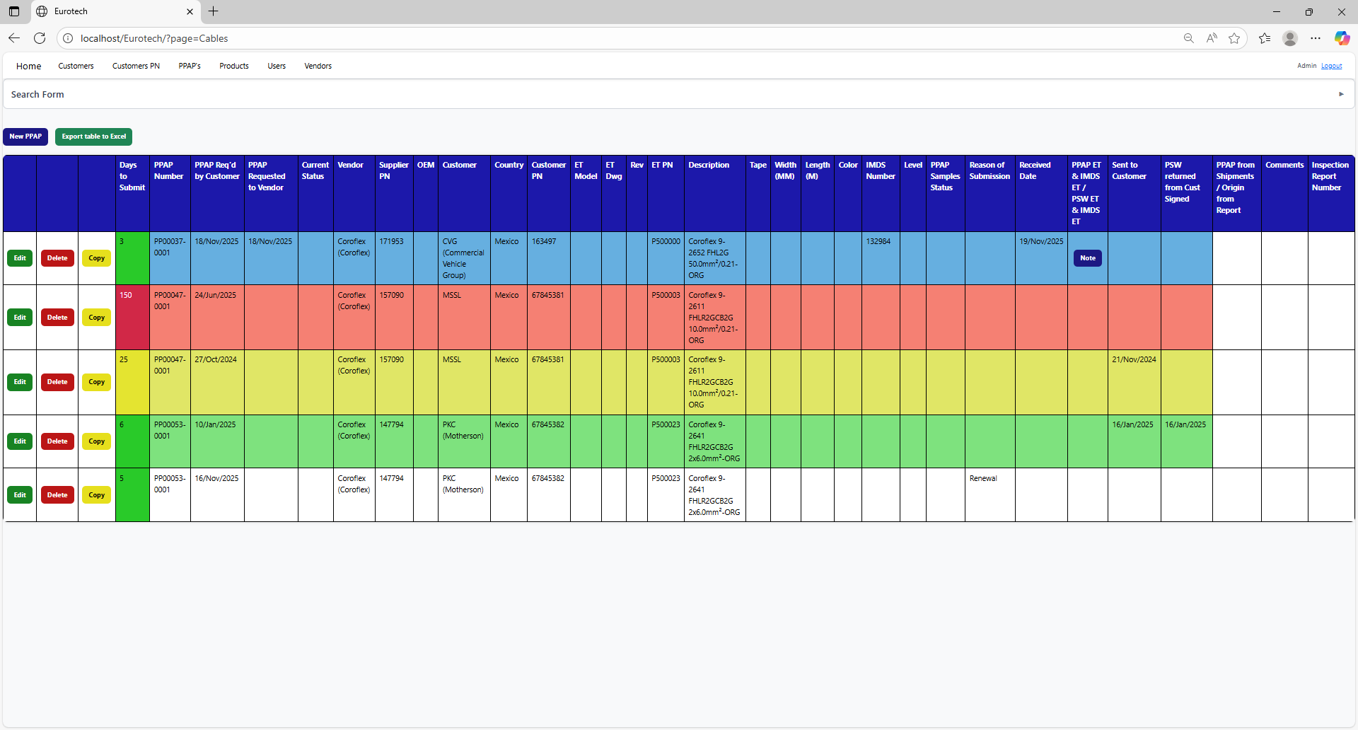

And with the “Clear All” button, you can clean the querying and see all the registers of the PPAPs.



Once you click the “Clear All” button, the fields of the “Search Form” will be empty, and in the table will be shown all the PPAPs.





### *4.3.3 Meaning of the Colors of the Registers.*

1.- In the “Days to Submit” column there will be:

* Registers with green field indicate that the difference between the “PPAP Req’d by Customer” date and the “Sent to Customer” date is less than 19 days (if there is no “Sent to Customer” date yet, it is compared with the current date).

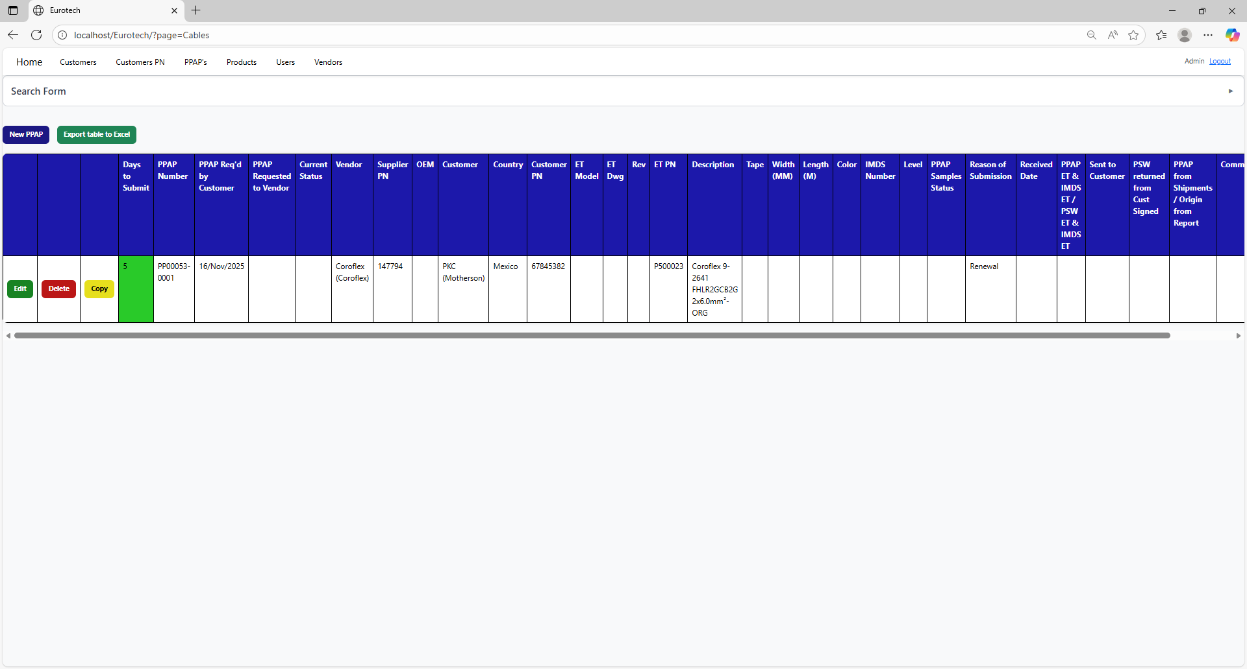

* Registers with yellow field indicate that the difference between the “PPAP Req’d by Customer” date and the “Sent to Customer” date is between 19 and 29 days (if there is no “Sent to Customer” date yet, it is compared with the current date).

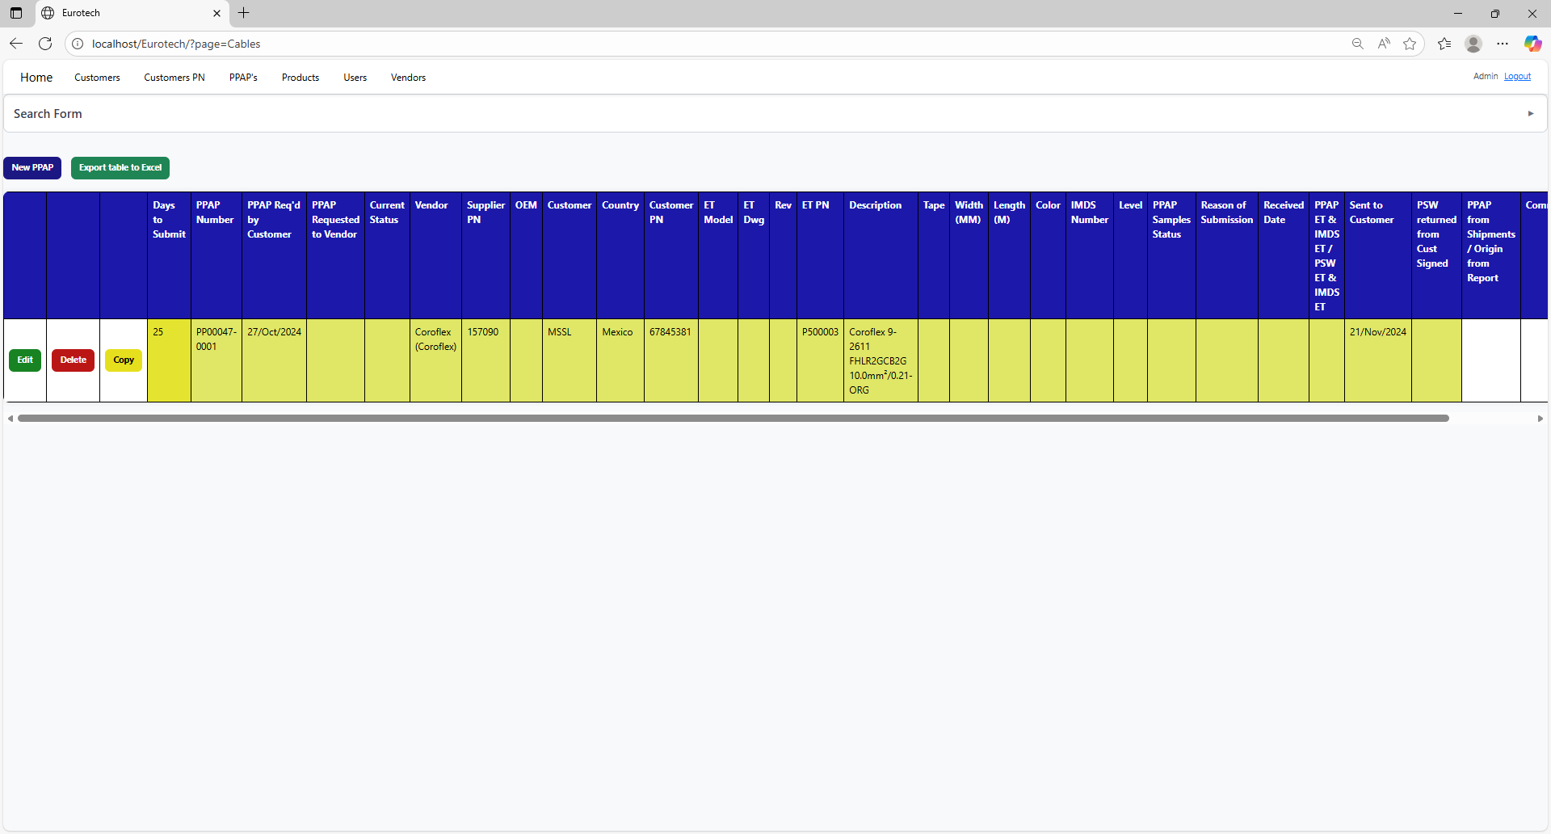

* Registers with red field indicate that the difference between the “PPAP Req’d by Customer” date and the “Sent to Customer” date is greater than 29 days (if there is no “Sent to Customer” date yet, it is compared with the current date).

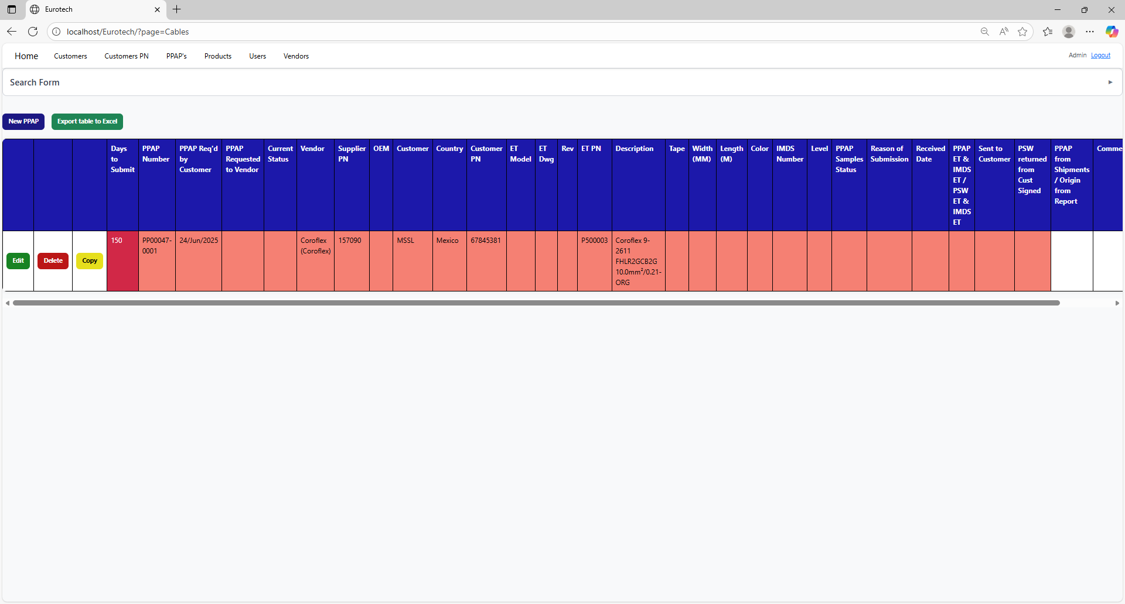

2.- In the rest of the columns of the registers will be:

* Registers with white background indicate that the PPAP has been requested by the customer, the request has not been sent to the vendor, and 30 days have not passed without the documentation being sent to the customer.



* Registers with blue background indicate that the PPAP has been requested by the customer, the request has been sent to the vendor, and 30 days have not passed without the documentation being sent to the customer.

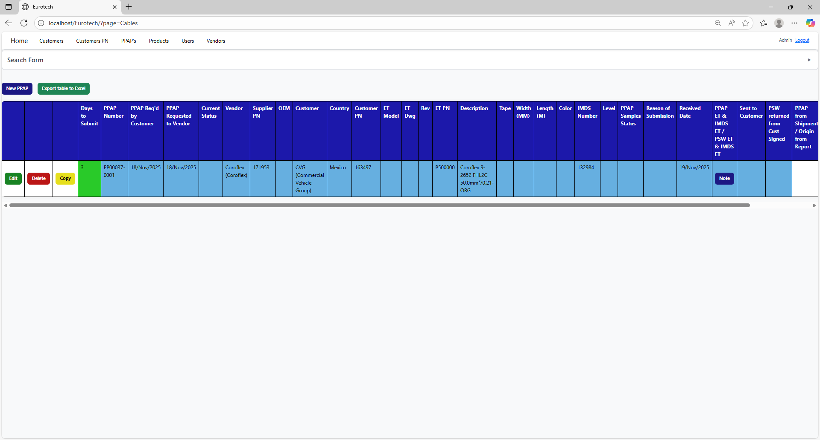

* Registers with red background indicate that the PPAP has been requested by the customer, and the 30-day limit has passed without the documentation being sent to the customer.



* Registers with yellow background indicate that the PPAP has been sent to the customer, and the PSW has not been returned signed by the customer.



* Registers with green background indicate that the PSW has been returned signed by the customer.

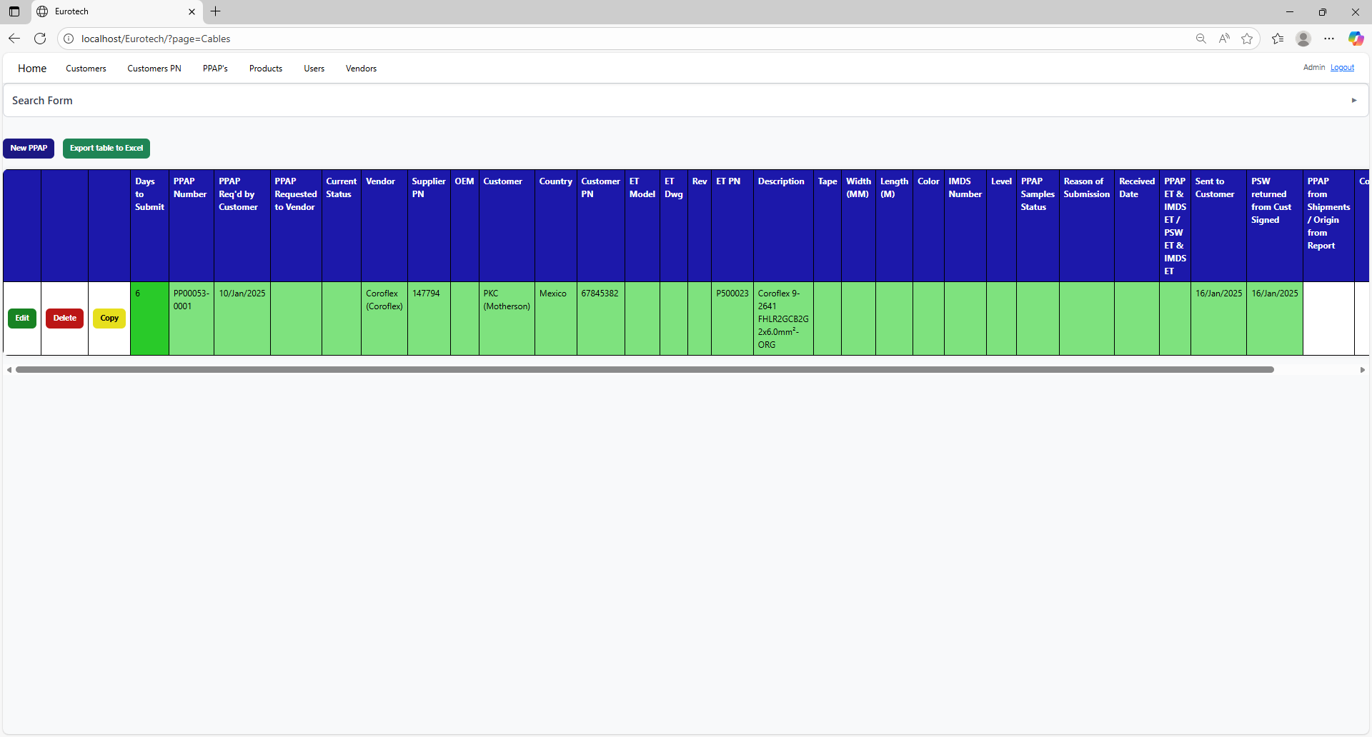

### *4.3.4 How to Export the Information of the Table to an Excel Document.*

To export the table to an Excel document, you must click the “Export table to Excel” button.



Once you click the “Export table to Excel” button, it will start to download the Excel document with the name “PPAPs_Cables_Report.xls”.

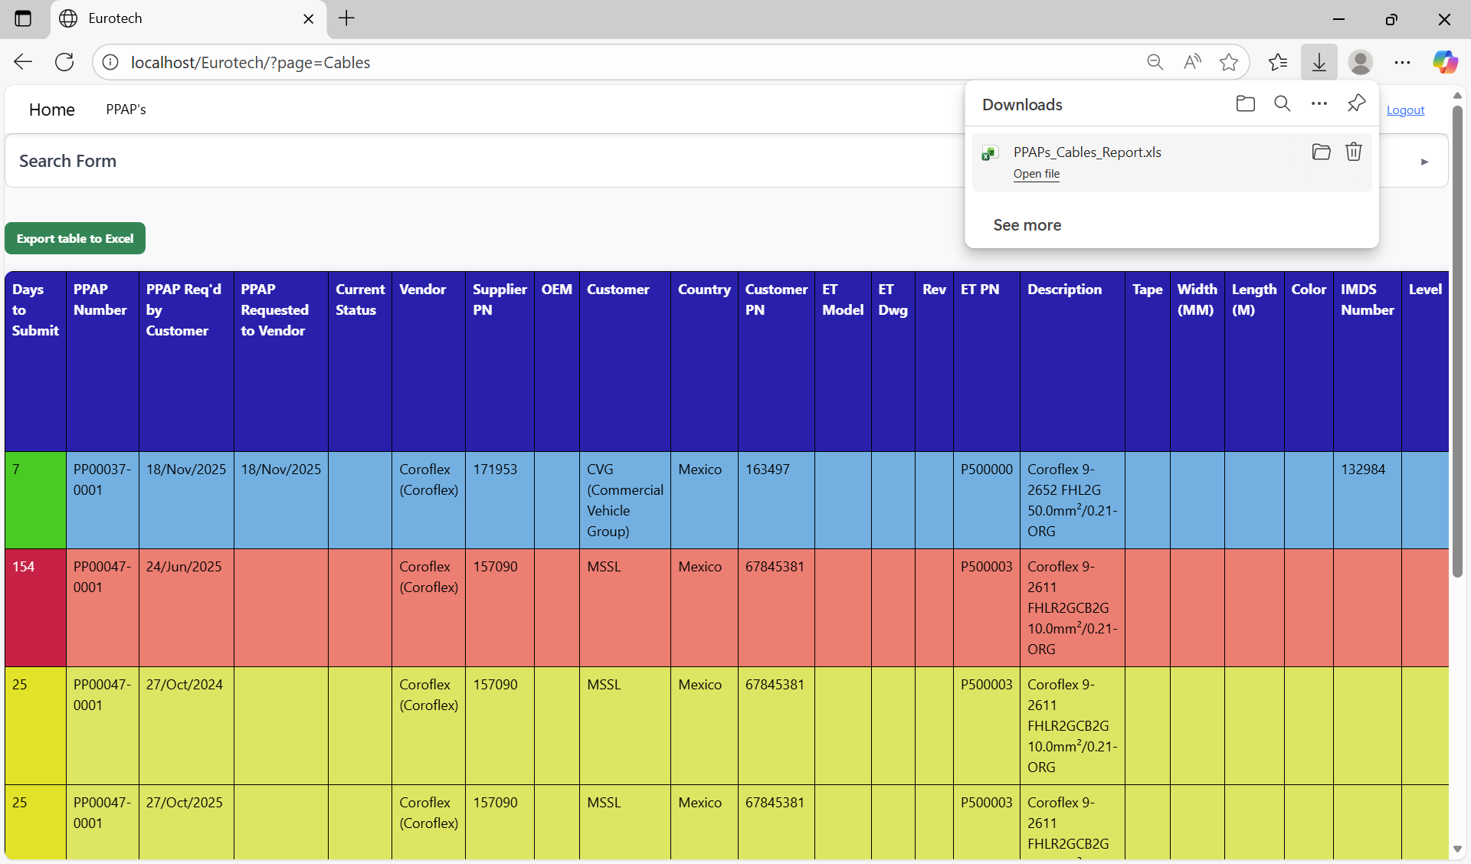

Once the download is finished, you can go to the folder it was downloaded and open the Excel document.

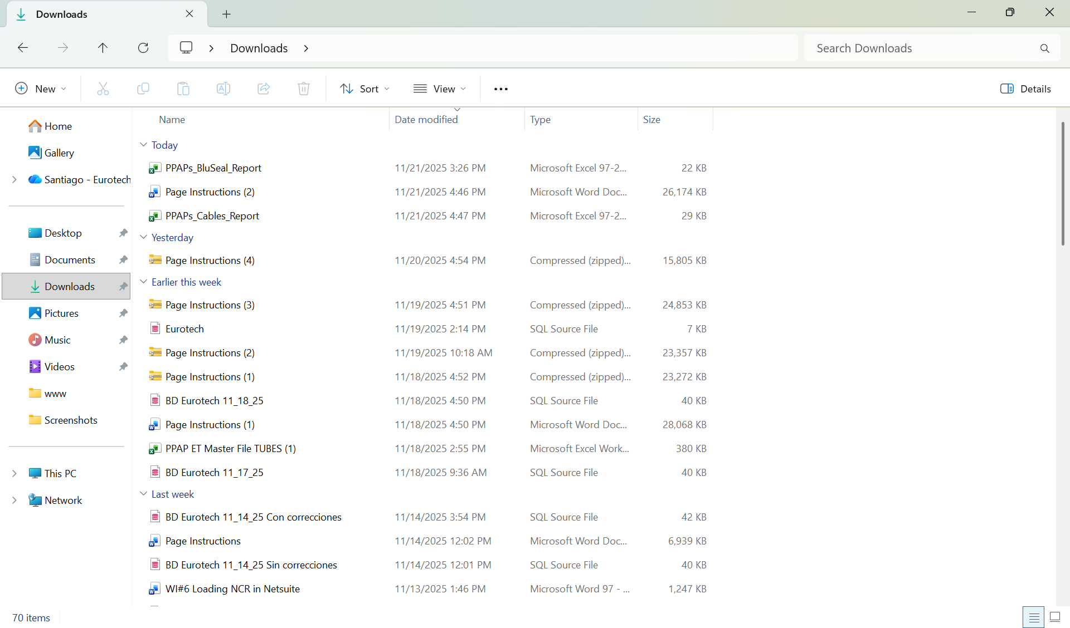

This is an example of how the document would look like:

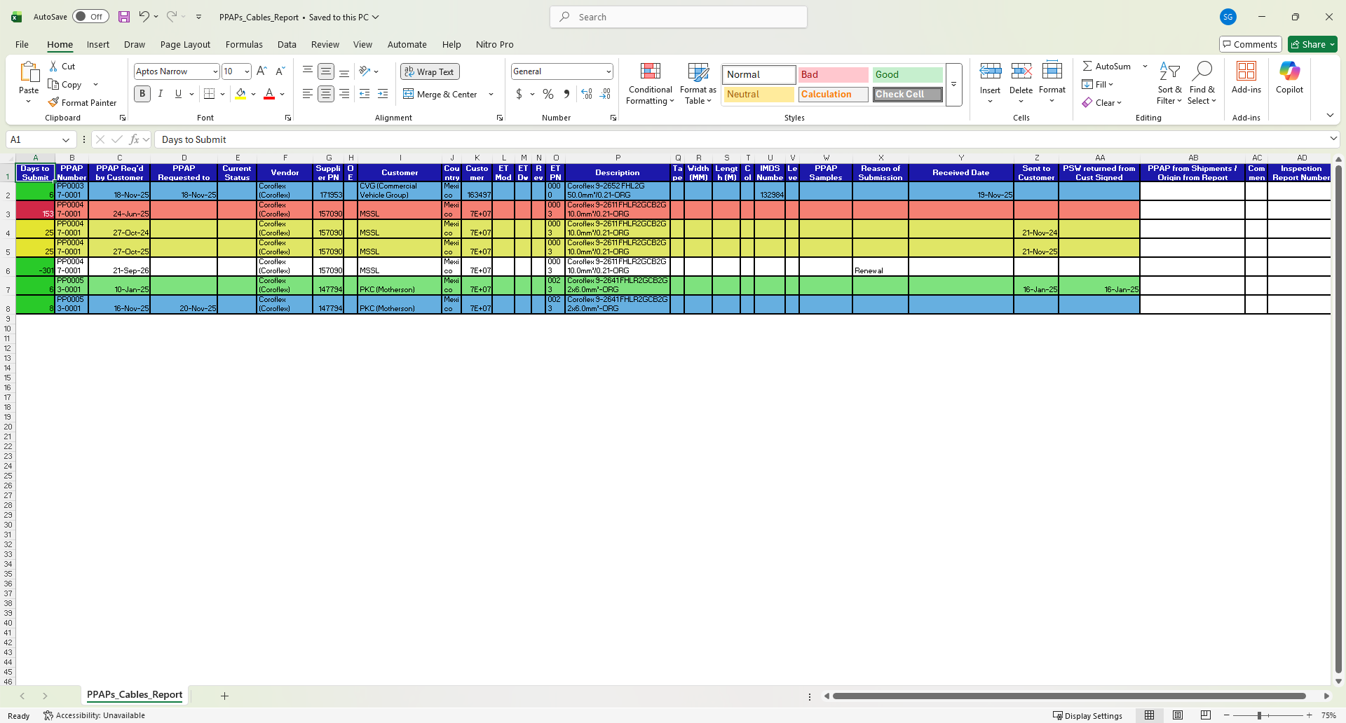

## ***4.4 Tapes Page***

### *4.4.1 How to Navigate to “Tapes” Page.*

On the navigation bar, you can navigate to the “Tapes” page.

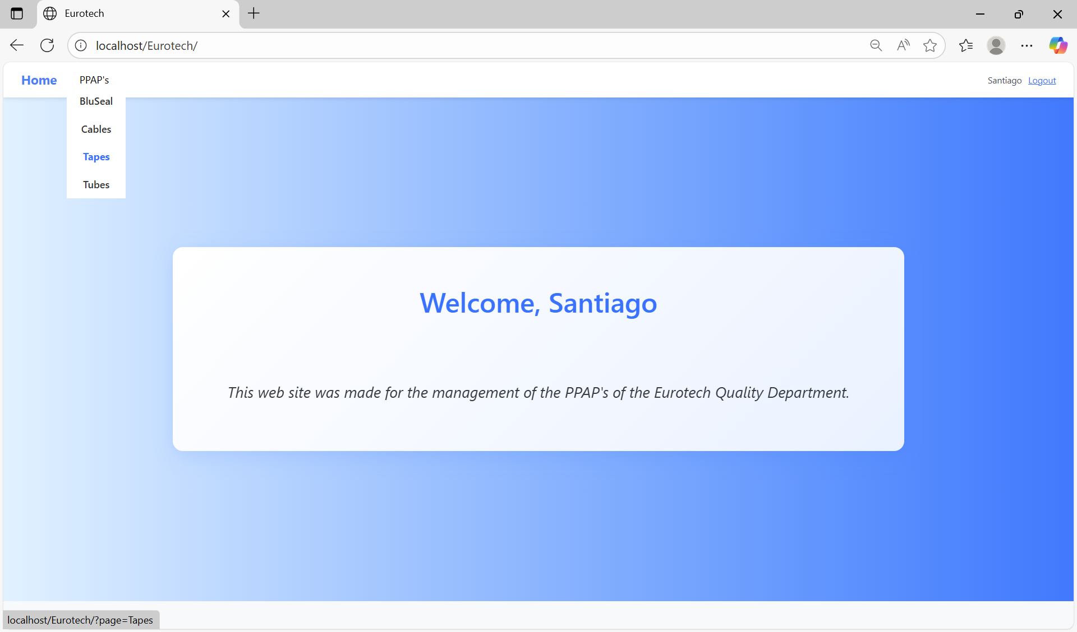

In this page you can manage the registers of all the PPAPs of Tapes.

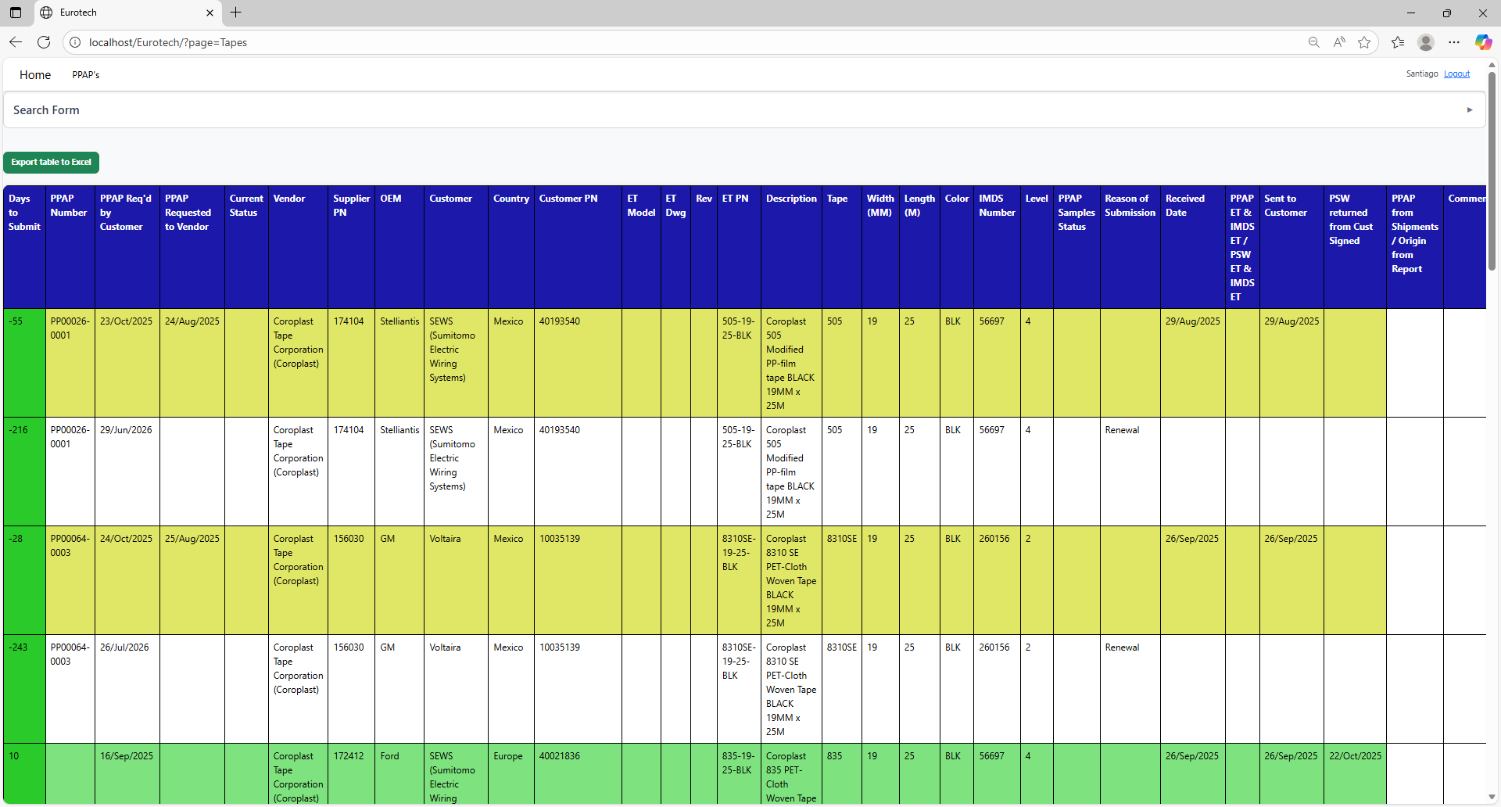

### *4.4.2 How to Search a PPAP.*

At the top of the page, it will be a dropdown “Search Form” that has all the fields of the table for querying registers.

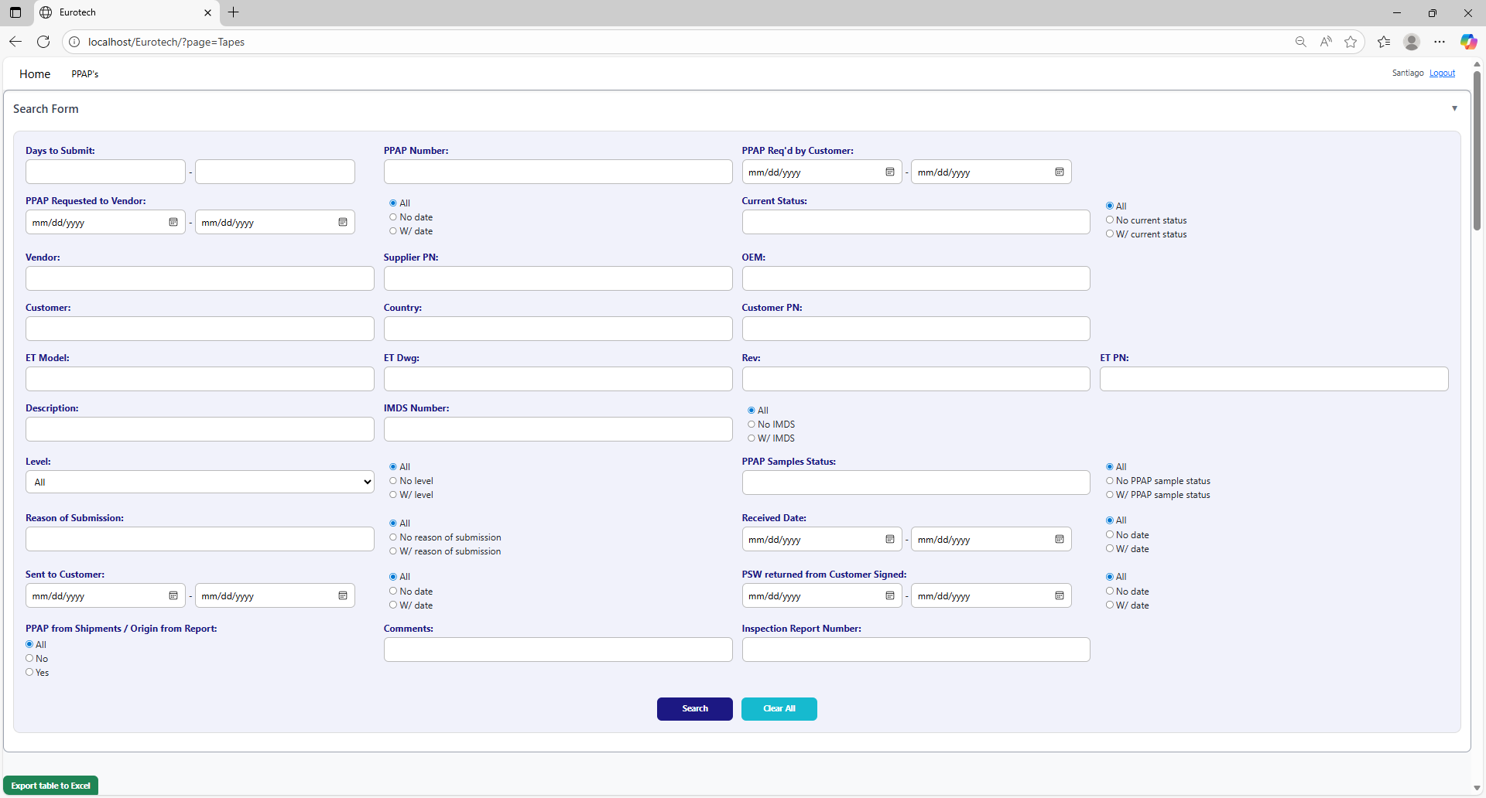

The search form allows you to perform searches by:

* Level
* PPAP Samples Status
* Reason of Submission
* Received Date
* Sent to Customer
* PSW returned from Customer Signed
* PPAP from Shipments / Origin from Report
* Comments
* Inspection Report Number
* Days to Submit
* PPAP Number
* PPAP Req’d by Customer
* PPAP Requested to Vendor
* Current Status
* Vendor
* Supplier PN
* OEM
* Customer
* Country
* Customer PN
* ET Model
* ET Dwg
* Rev
* Eurotech PN
* Description
* IMDS Number

You can search by “Days to Submit”, writing the range of days.

You can search by “PPAP Number”.

You can search by “PPAP Req’d by Customer”, writing the range of dates.



You can search registers that either have or don’t have the “Current Status” field filled in, or all the registers.

You can search by “Current Status”.

You can search registers that either have or don’t have a date on “PPAP Requested to Vendor”, or all the registers.

You can search by “PPAP Requested to Vendor”, writing the range of dates.

You can search by “OEM”.

You can search by “Vendor”.

You can search by “Supplier PN”.



You can search by “Customer PN”.

You can search by “Customer”.

You can search by “Country”.

You can search by “ET PN”.

You can search by “Rev”.

You can search by “ET Dwg”.

You can search by “ET Model”.



You can search registers that either have or don’t have the “IMDS Number” field filled in, or all the registers.

You can search by “IMDS Number”.

You can search by “Description”.

You can search by “PPAP Samples Status”.

You can search by “Level”.

You can search registers that either have or don’t have the “PPAP Samples Status” field filled in, or all the registers.

You can search registers that either have or don’t have the “Level” field filled in, or all the registers.



You can search registers that either have or don’t have a date on “Received Date”, or all the registers.

You can search by “Received Date”, writing the range of dates.

You can search registers that either have or don’t have the “Reason of Submission” field filled in, or all the registers.

You can search by “Reason of Submission”.

You can search registers that either have or don’t have a date on “PSW returned from Customer Signed”, or all the registers.

You can search registers that either have or don’t have a date on “Sent to Customer”, or all the registers.

You can search by “PSW returned from Customer Signed”, writing the range of dates.

You can search by “Sent to Customer”, writing the range of dates.



You can search by “Inspection Report Number”.

You can search by “Comments”.

You can search by “PPAP from Shipments / Origin from Report”.

You must click the “Search” button after you fill any of the fields of the “Search Form” to make the search.



This is an example of how the table would look like after a search (the meaning of the colors of the registers will be explained later).

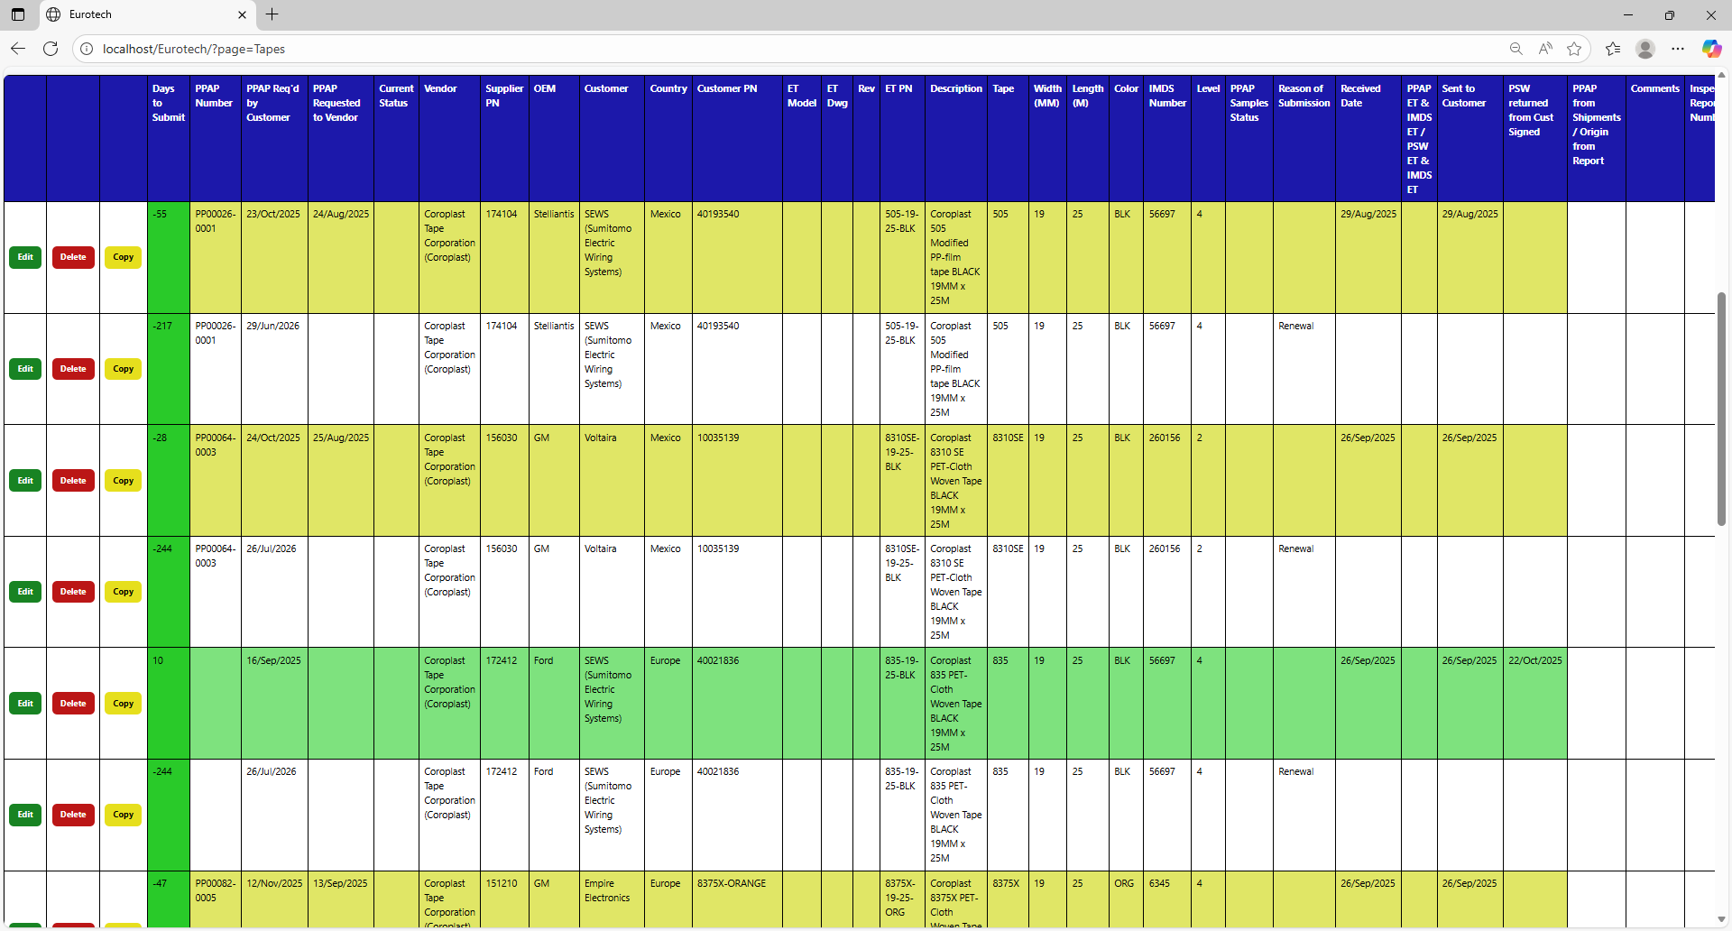

And with the “Clear All” button, you can clean the querying and see all the registers of the PPAPs.



Once you click the “Clear All” button, the fields of the “Search Form” will be empty, and in the table will be shown all the PPAPs.



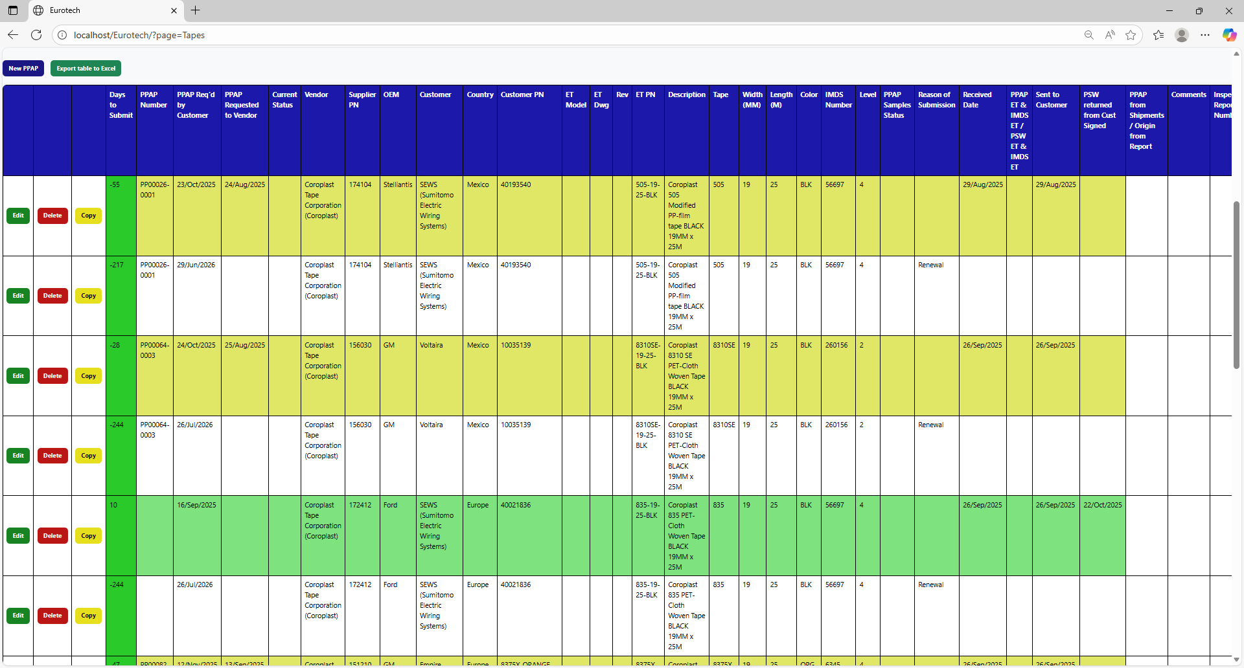

### *4.4.3 Meaning of the Colors of the Registers.*

1.- In the “Days to Submit” column there will be:

* Registers with green field indicate that the difference between the “PPAP Req’d by Customer” date and the “Sent to Customer” date is less than 19 days (if there is no “Sent to Customer” date yet, it is compared with the current date).

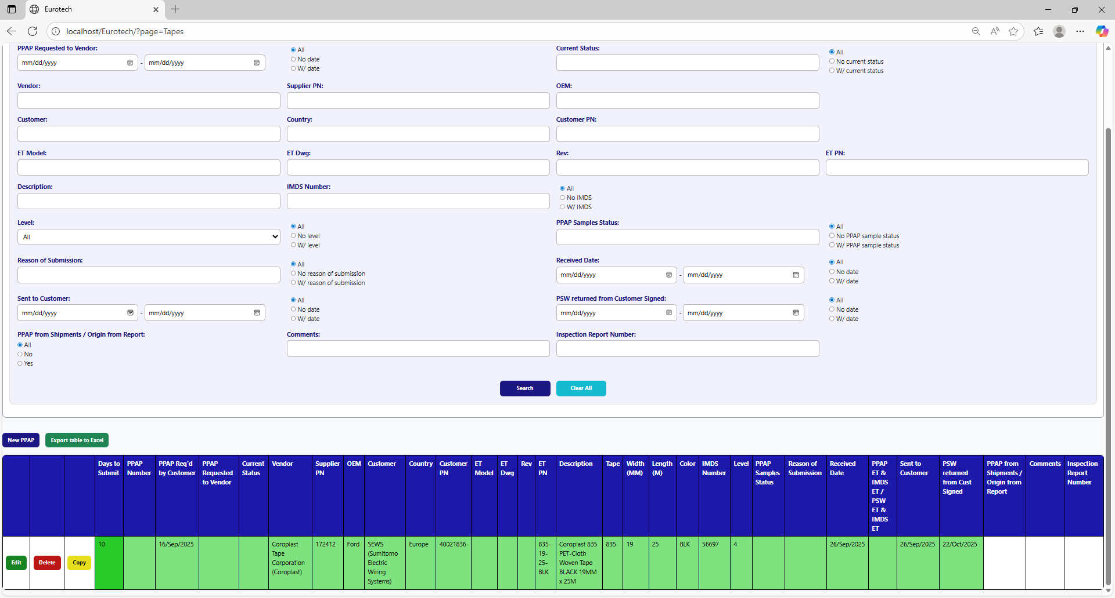

* Registers with yellow field indicate that the difference between the “PPAP Req’d by Customer” date and the “Sent to Customer” date is between 19 and 29 days (if there is no “Sent to Customer” date yet, it is compared with the current date).

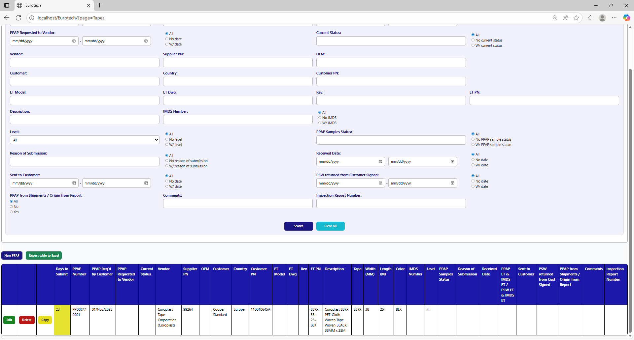

* Registers with red field indicate that the difference between the “PPAP Req’d by Customer” date and the “Sent to Customer” date is greater than 29 days (if there is no “Sent to Customer” date yet, it is compared with the current date).

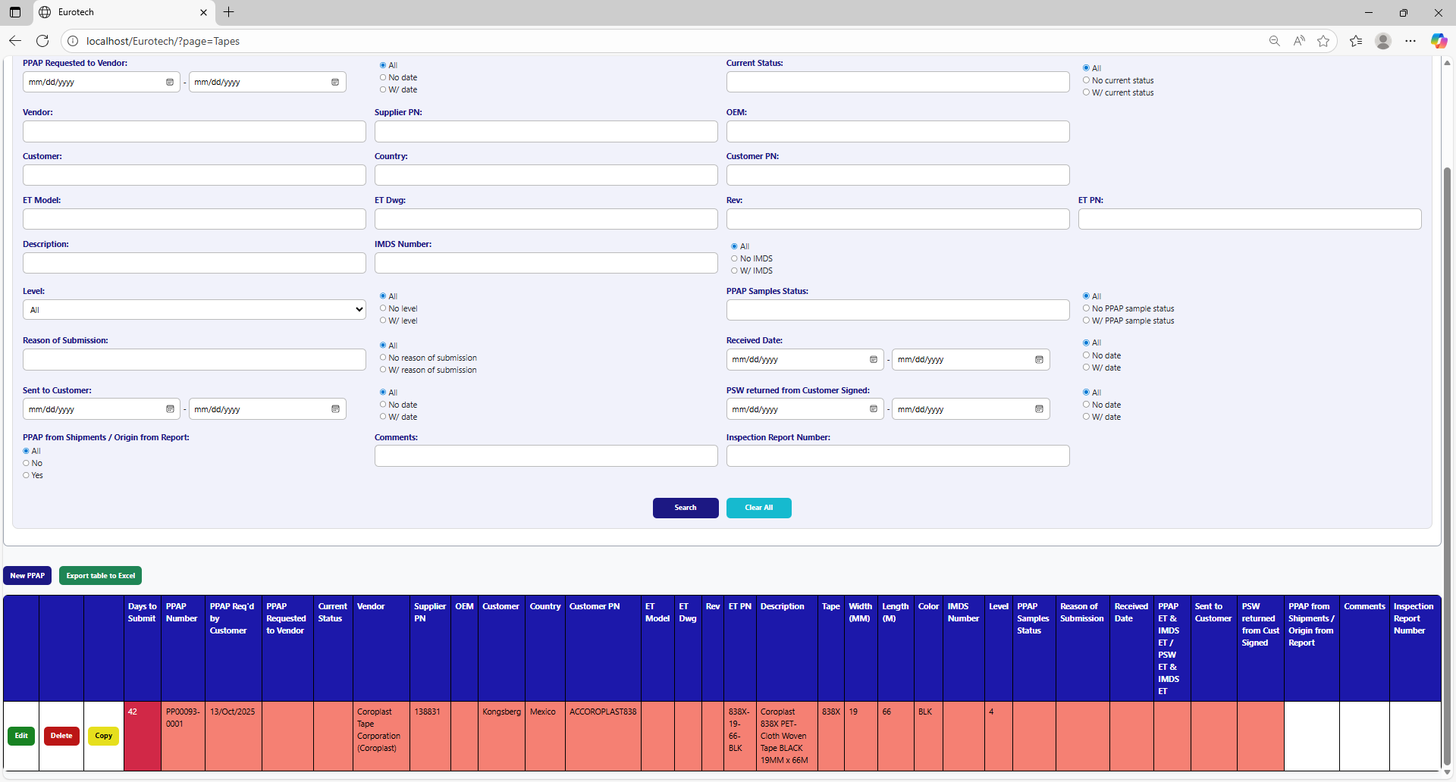

2.- In the rest of the columns of the registers will be:

* Registers with white background indicate that the PPAP has been requested by the customer, the request has not been sent to the vendor, and 30 days have not passed without the documentation being sent to the customer.

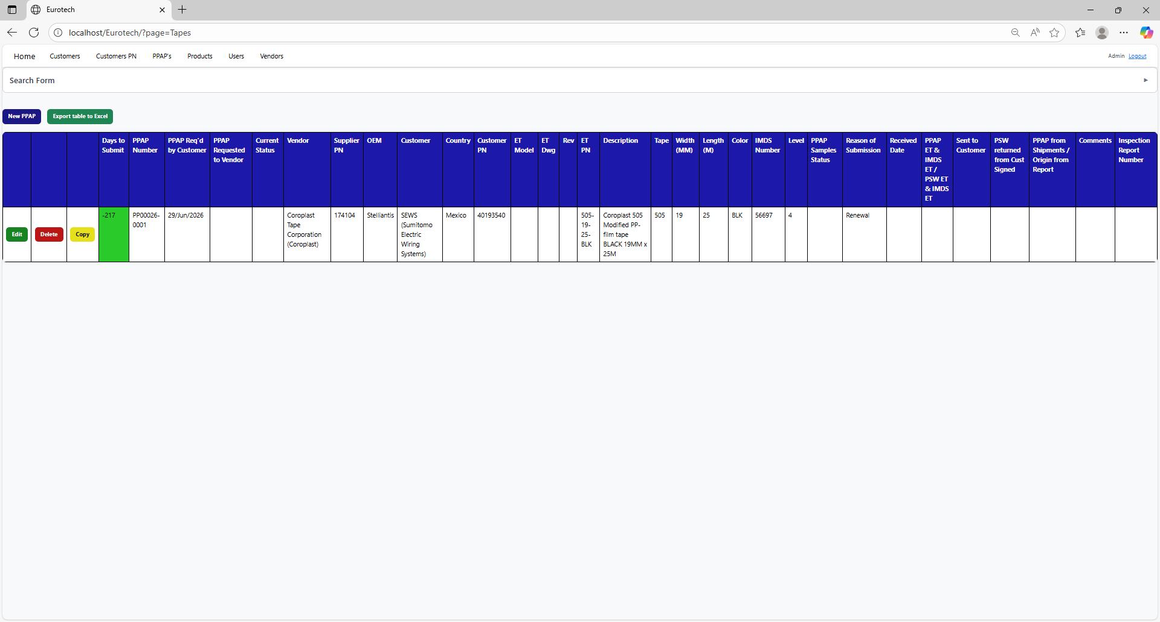

* Registers with blue background indicate that the PPAP has been requested by the customer, the request has been sent to the vendor, and 30 days have not passed without the documentation being sent to the customer.

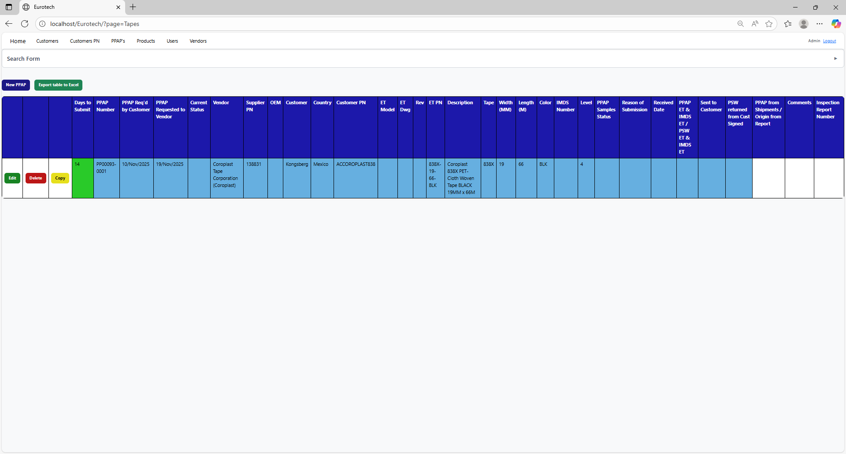

* Registers with red background indicate that the PPAP has been requested by the customer, and the 30-day limit has passed without the documentation being sent to the customer.

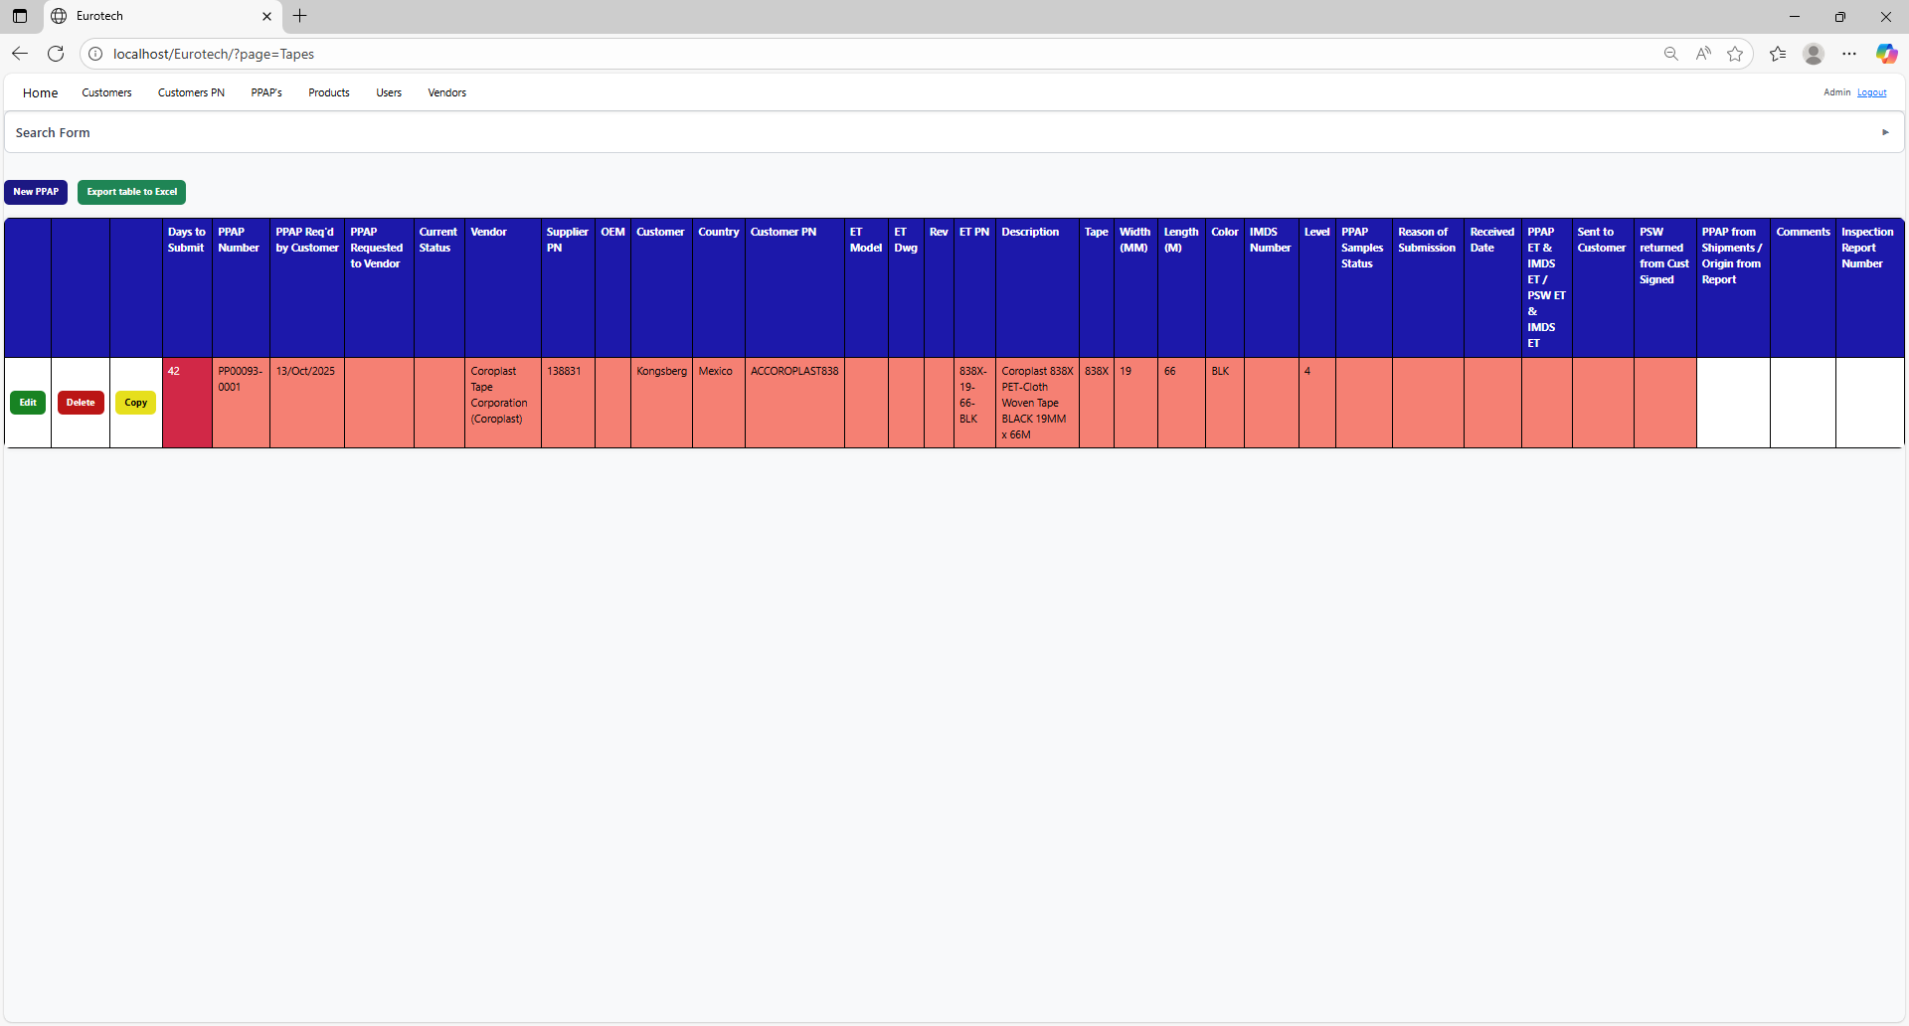

* Registers with yellow background indicate that the PPAP has been sent to the customer, and the PSW has not been returned signed by the customer.

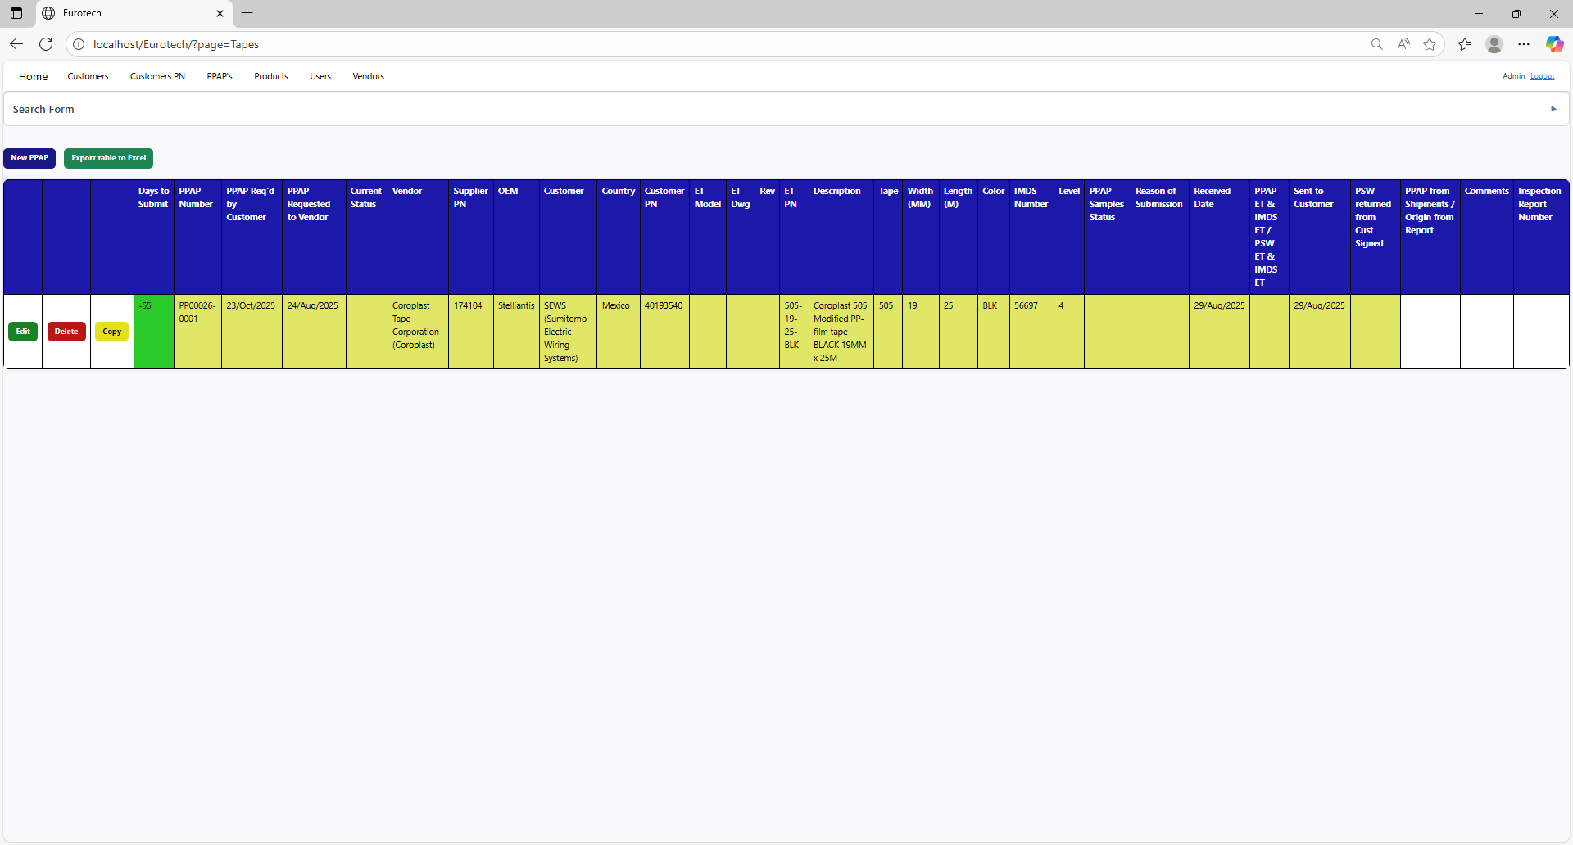

* Registers with green background indicate that the PSW has been returned signed by the customer.

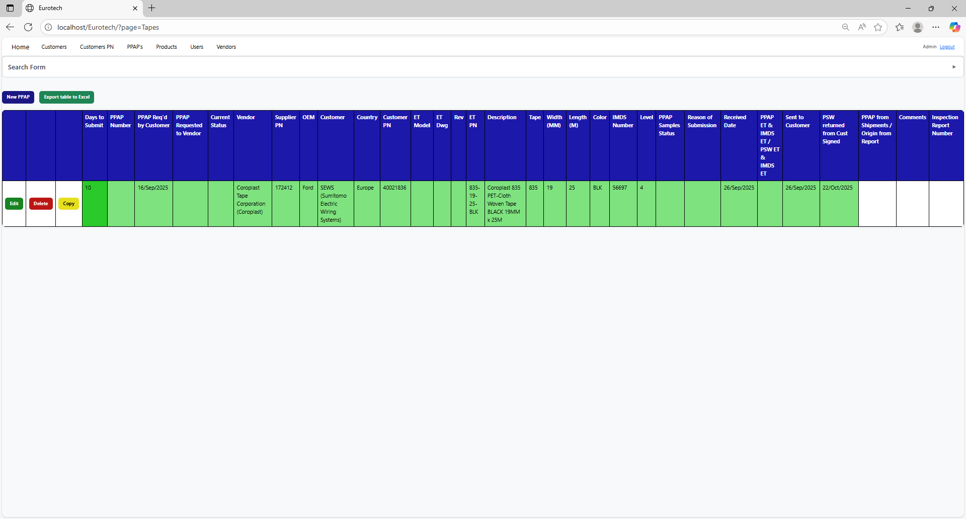

### *4.4.4 How to Export the Information of the Table to an Excel Document.*

To export the table to an Excel document, you must click the “Export table to Excel” button.



Once you click the “Export table to Excel” button, it will start to download the Excel document with the name “PPAPs_Tapes_Report.xls”.

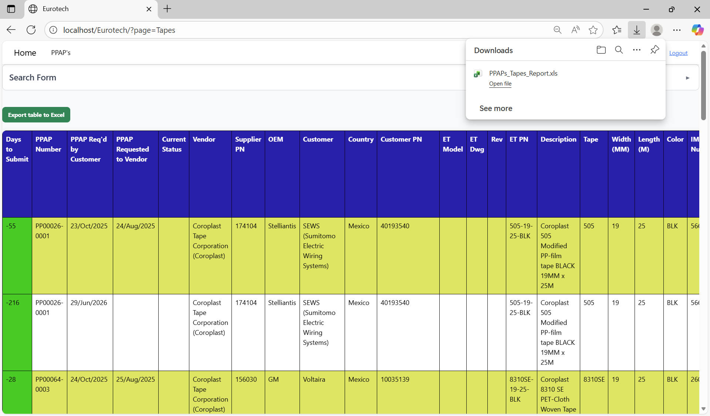

Once the download is finished, you can go to the folder it was downloaded and open the Excel document.

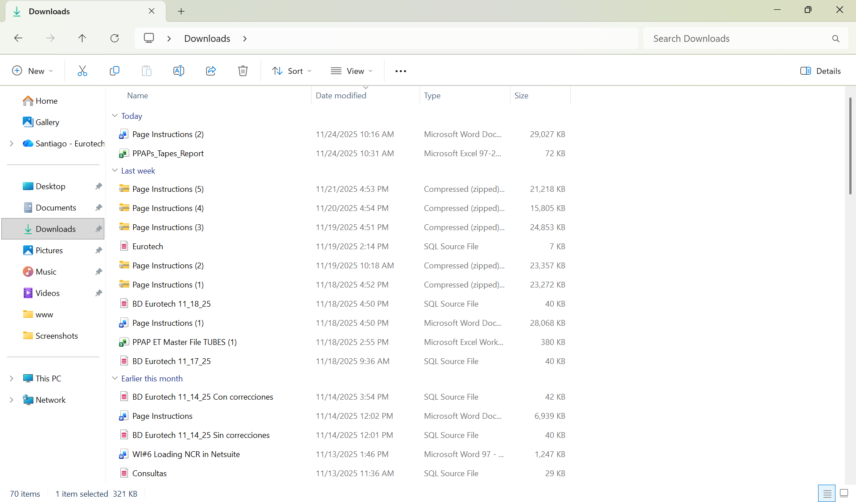

This is an example of how the document would look like:

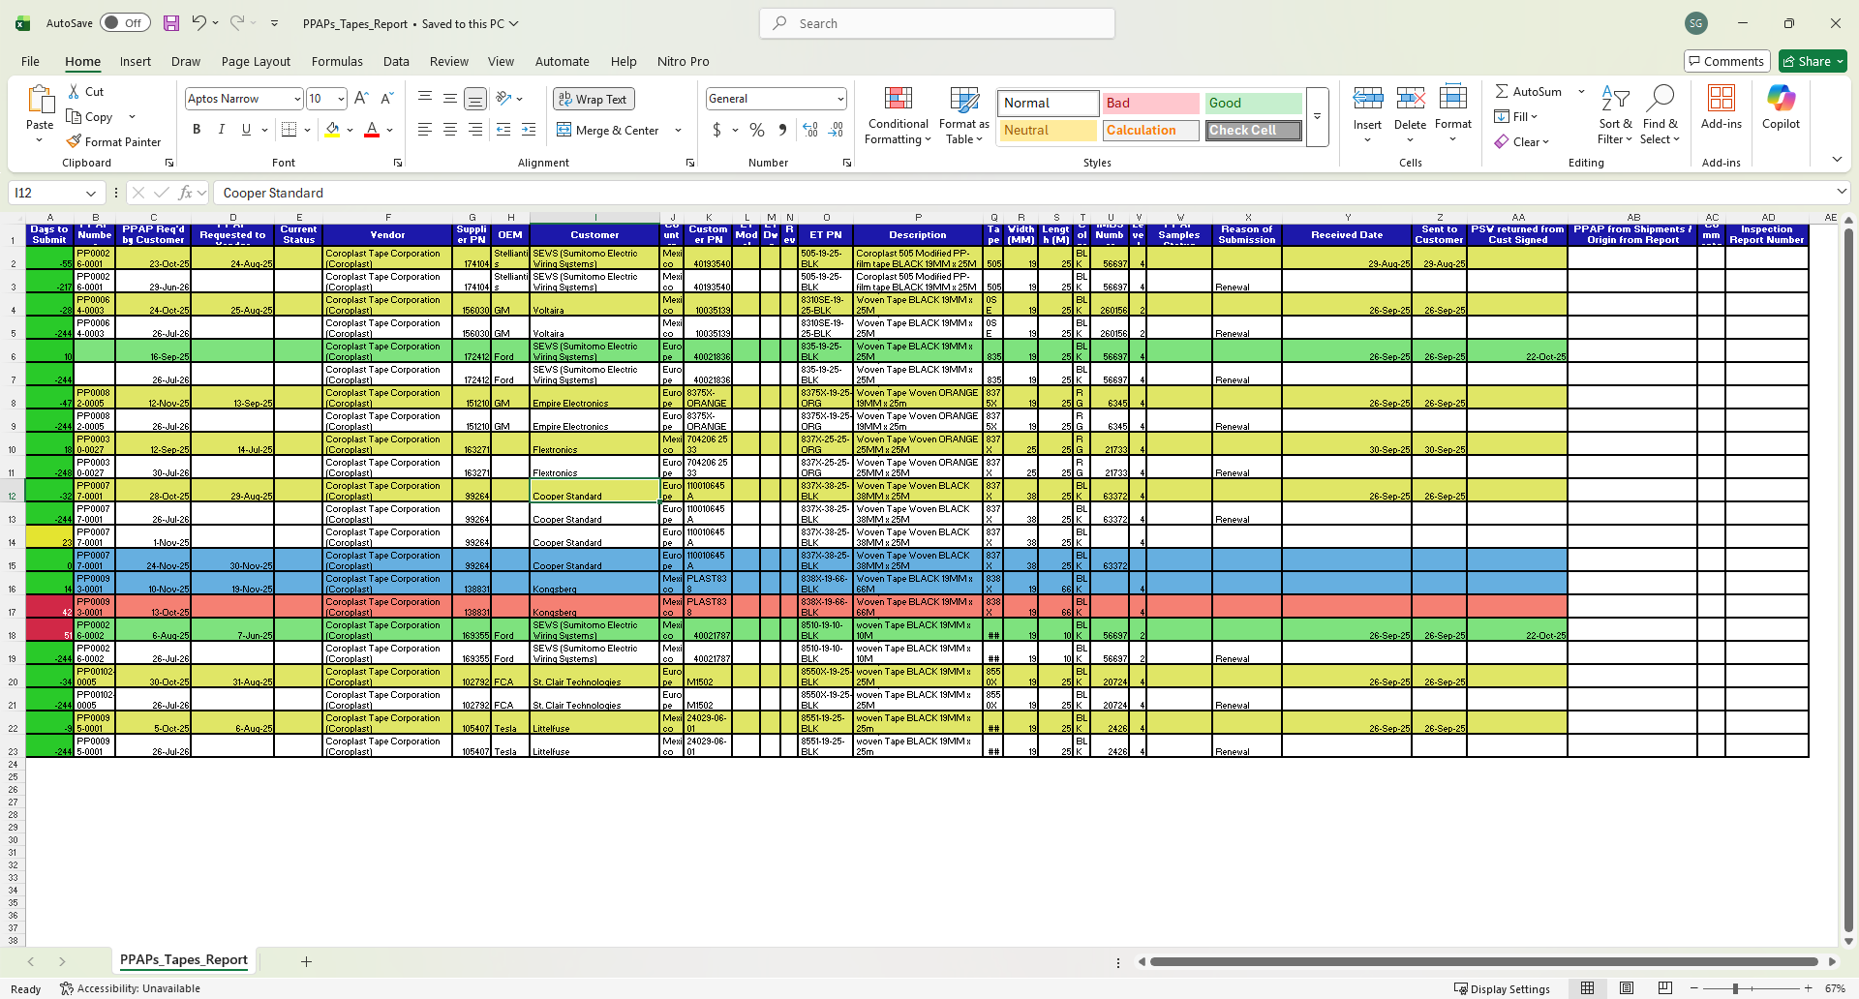

## ***4.5 Tubes Page***

### *4.5.1 How to Navigate to “Tubes” Page.*

On the navigation bar, you can navigate to the “Tubes” page.

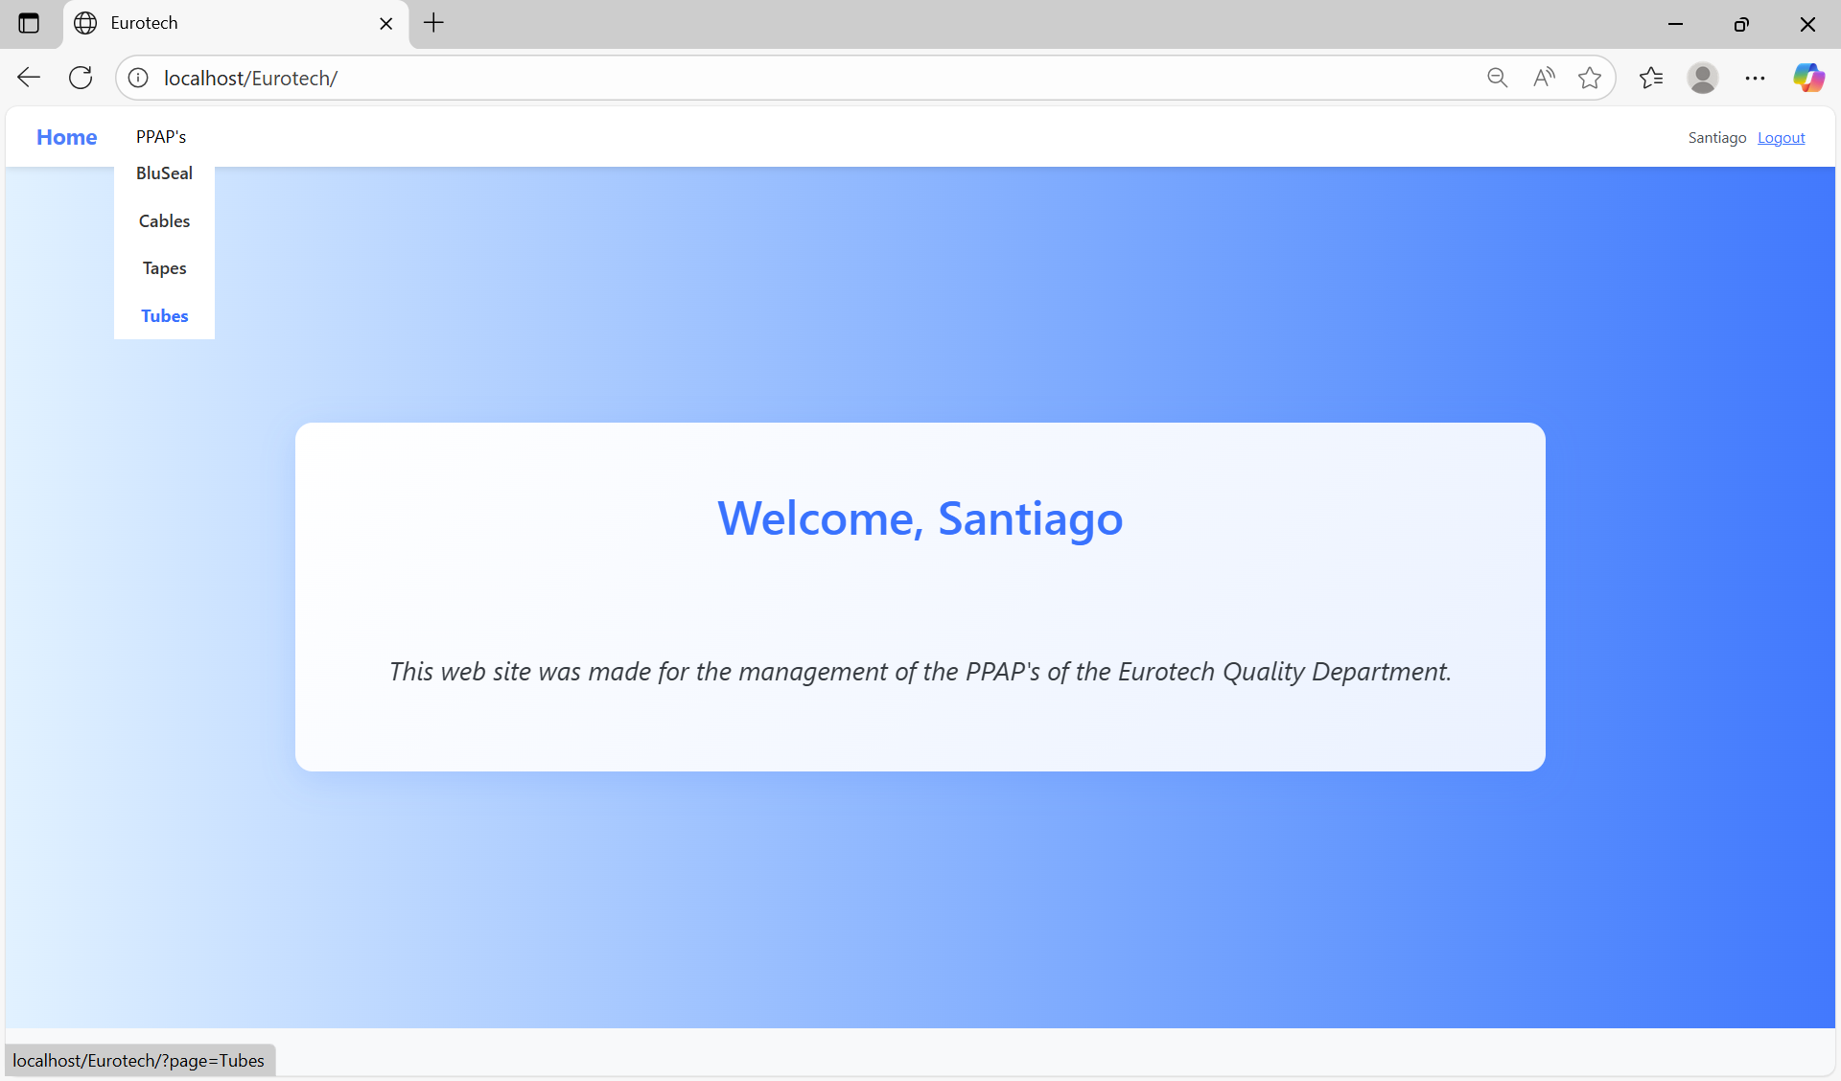

In this page you can manage the registers of all the PPAPs of Tubes.

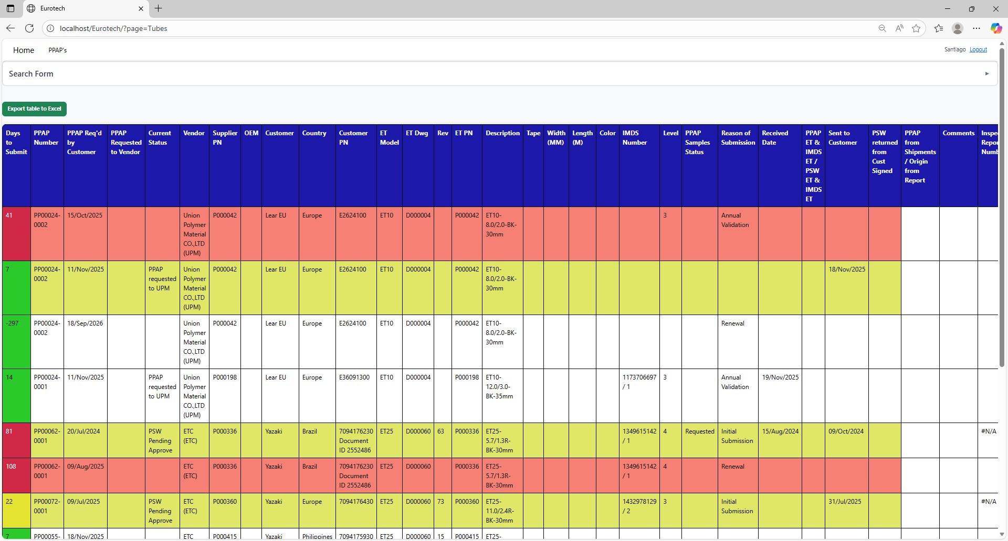

### *4.5.2 How to Search a PPAP.*

At the top of the page, it will be a dropdown “Search Form” that has all the fields of the table for querying registers.

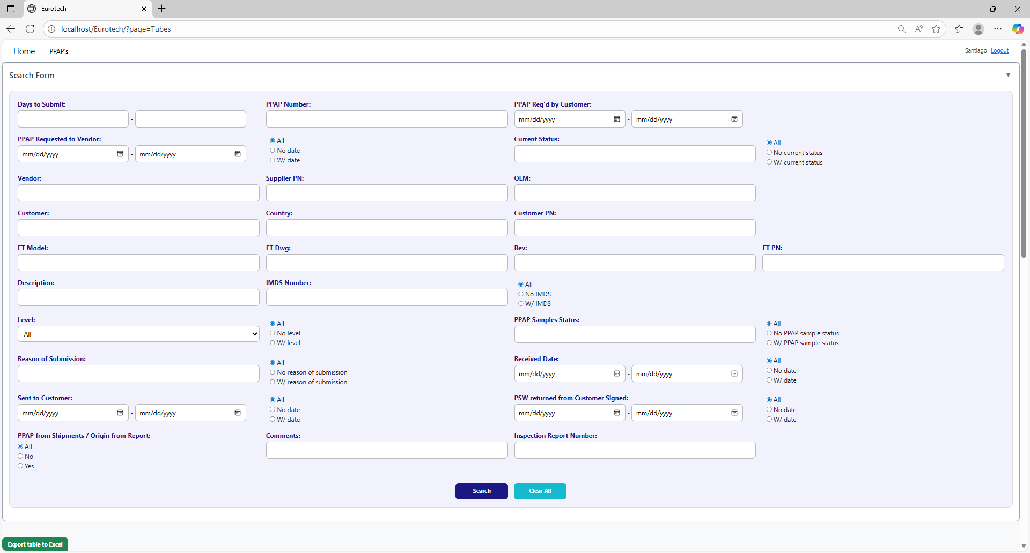

The search form allows you to perform searches by:

* Level
* PPAP Samples Status
* Reason of Submission
* Received Date
* Sent to Customer
* PSW returned from Customer Signed
* PPAP from Shipments / Origin from Report
* Comments
* Inspection Report Number
* Days to Submit
* PPAP Number
* PPAP Req’d by Customer
* PPAP Requested to Vendor
* Current Status
* Vendor
* Supplier PN
* OEM
* Customer
* Country
* Customer PN
* ET Model
* ET Dwg
* Rev
* Eurotech PN
* Description
* IMDS Number

You can search by “Days to Submit”, writing the range of days.

You can search by “PPAP Number”.

You can search by “PPAP Req’d by Customer”, writing the range of dates.



You can search registers that either have or don’t have the “Current Status” field filled in, or all the registers.

You can search by “Current Status”.

You can search registers that either have or don’t have a date on “PPAP Requested to Vendor”, or all the registers.

You can search by “PPAP Requested to Vendor”, writing the range of dates.

You can search by “OEM”.

You can search by “Vendor”.

You can search by “Supplier PN”.



You can search by “Customer PN”.

You can search by “Customer”.

You can search by “Country”.

You can search by “ET PN”.

You can search by “Rev”.

You can search by “ET Dwg”.

You can search by “ET Model”.



You can search registers that either have or don’t have the “IMDS Number” field filled in, or all the registers.

You can search by “IMDS Number”.

You can search by “Description”.

You can search by “PPAP Samples Status”.

You can search by “Level”.

You can search registers that either have or don’t have the “PPAP Samples Status” field filled in, or all the registers.

You can search registers that either have or don’t have the “Level” field filled in, or all the registers.



You can search registers that either have or don’t have a date on “Received Date”, or all the registers.

You can search by “Received Date”, writing the range of dates.

You can search registers that either have or don’t have the “Reason of Submission” field filled in, or all the registers.

You can search by “Reason of Submission”.

You can search registers that either have or don’t have a date on “PSW returned from Customer Signed”, or all the registers.

You can search registers that either have or don’t have a date on “Sent to Customer”, or all the registers.

You can search by “PSW returned from Customer Signed”, writing the range of dates.

You can search by “Sent to Customer”, writing the range of dates.



You can search by “Inspection Report Number”.

You can search by “Comments”.

You can search by “PPAP from Shipments / Origin from Report”.

You must click the “Search” button after you fill any of the fields of the “Search Form” to make the search.



This is an example of how the table would look like after a search (the meaning of the colors of the registers will be explained later).

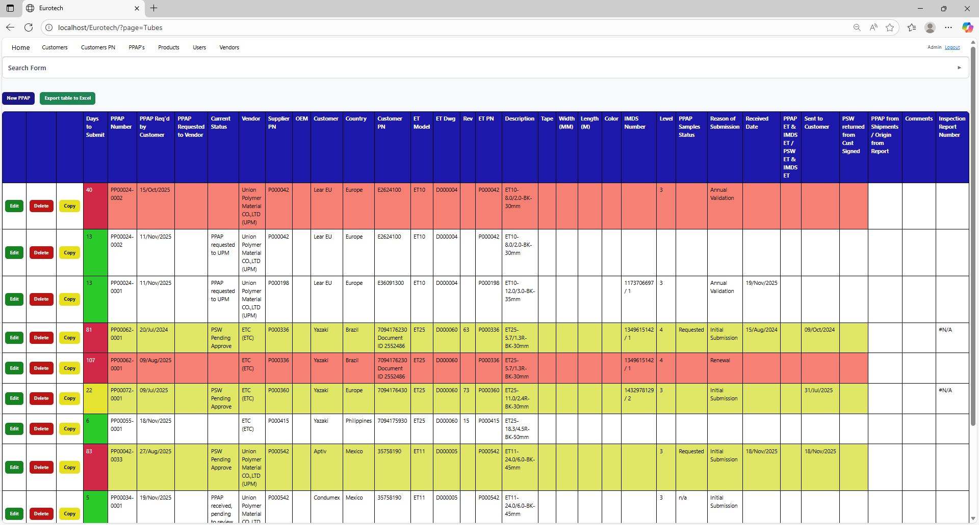

And with the “Clear All” button, you can clean the querying and see all the registers of the PPAPs.



Once you click the “Clear All” button, the fields of the “Search Form” will be empty, and in the table will be shown all the PPAPs.





### *4.5.3 Meaning of the Colors of the Registers.*

1.- In the “Days to Submit” column there will be:

* Registers with green field indicate that the difference between the “PPAP Req’d by Customer” date and the “Sent to Customer” date is less than 19 days (if there is no “Sent to Customer” date yet, it is compared with the current date).

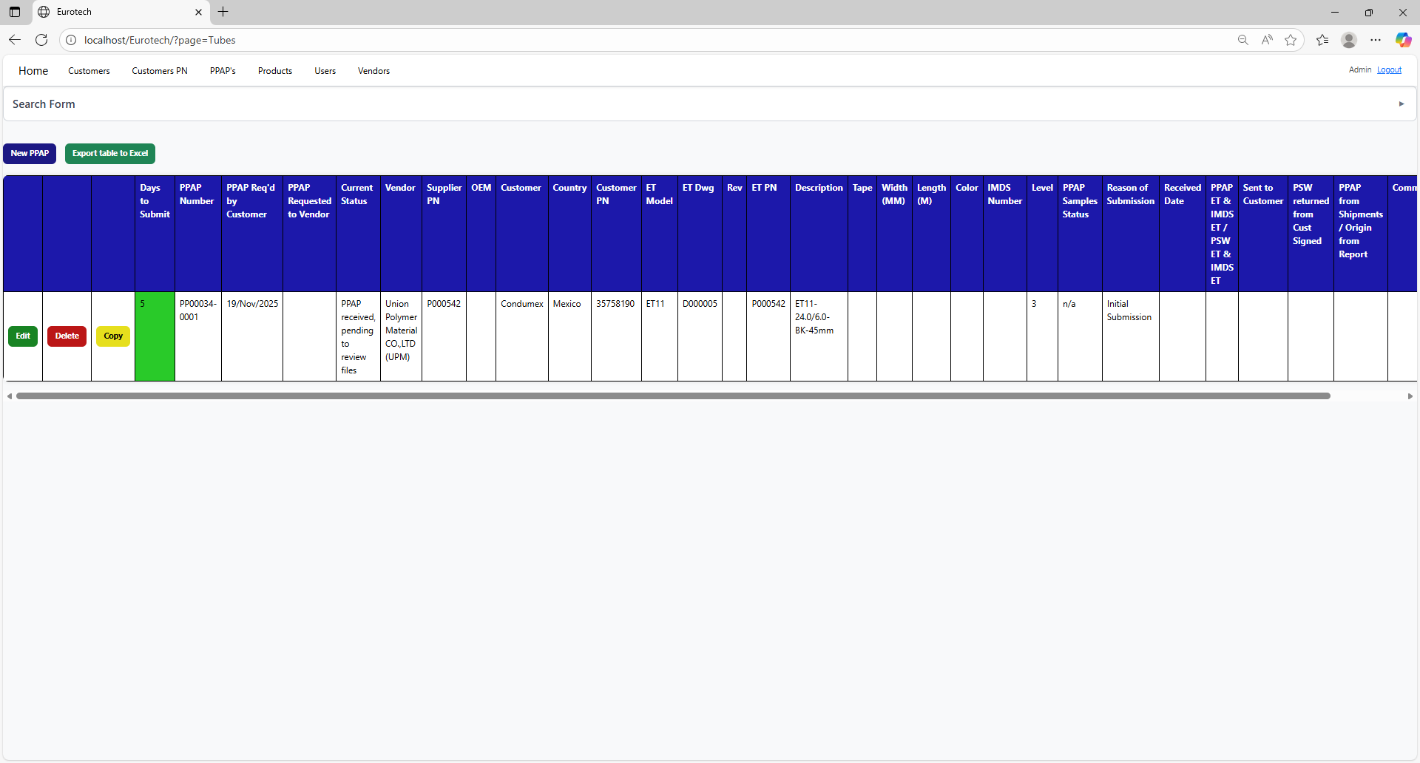

* Registers with yellow field indicate that the difference between the “PPAP Req’d by Customer” date and the “Sent to Customer” date is between 19 and 29 days (if there is no “Sent to Customer” date yet, it is compared with the current date).

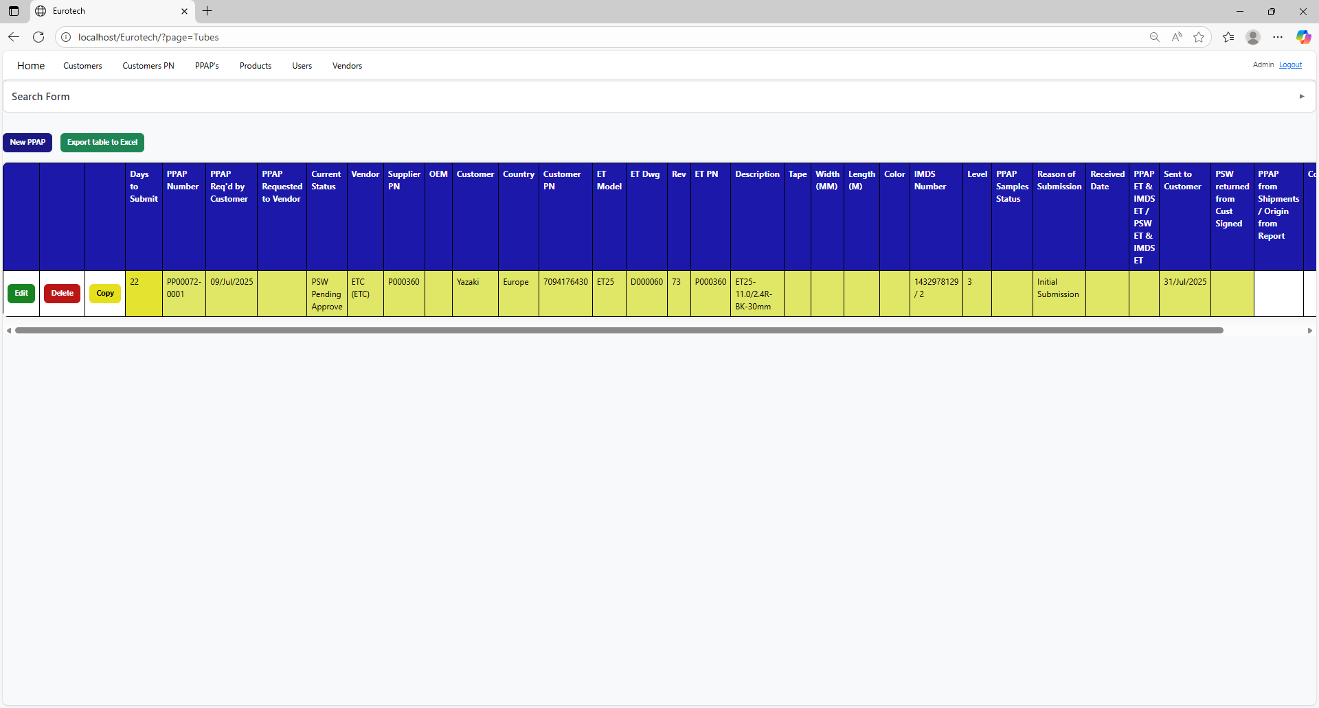

* Registers with red field indicate that the difference between the “PPAP Req’d by Customer” date and the “Sent to Customer” date is greater than 29 days (if there is no “Sent to Customer” date yet, it is compared with the current date).

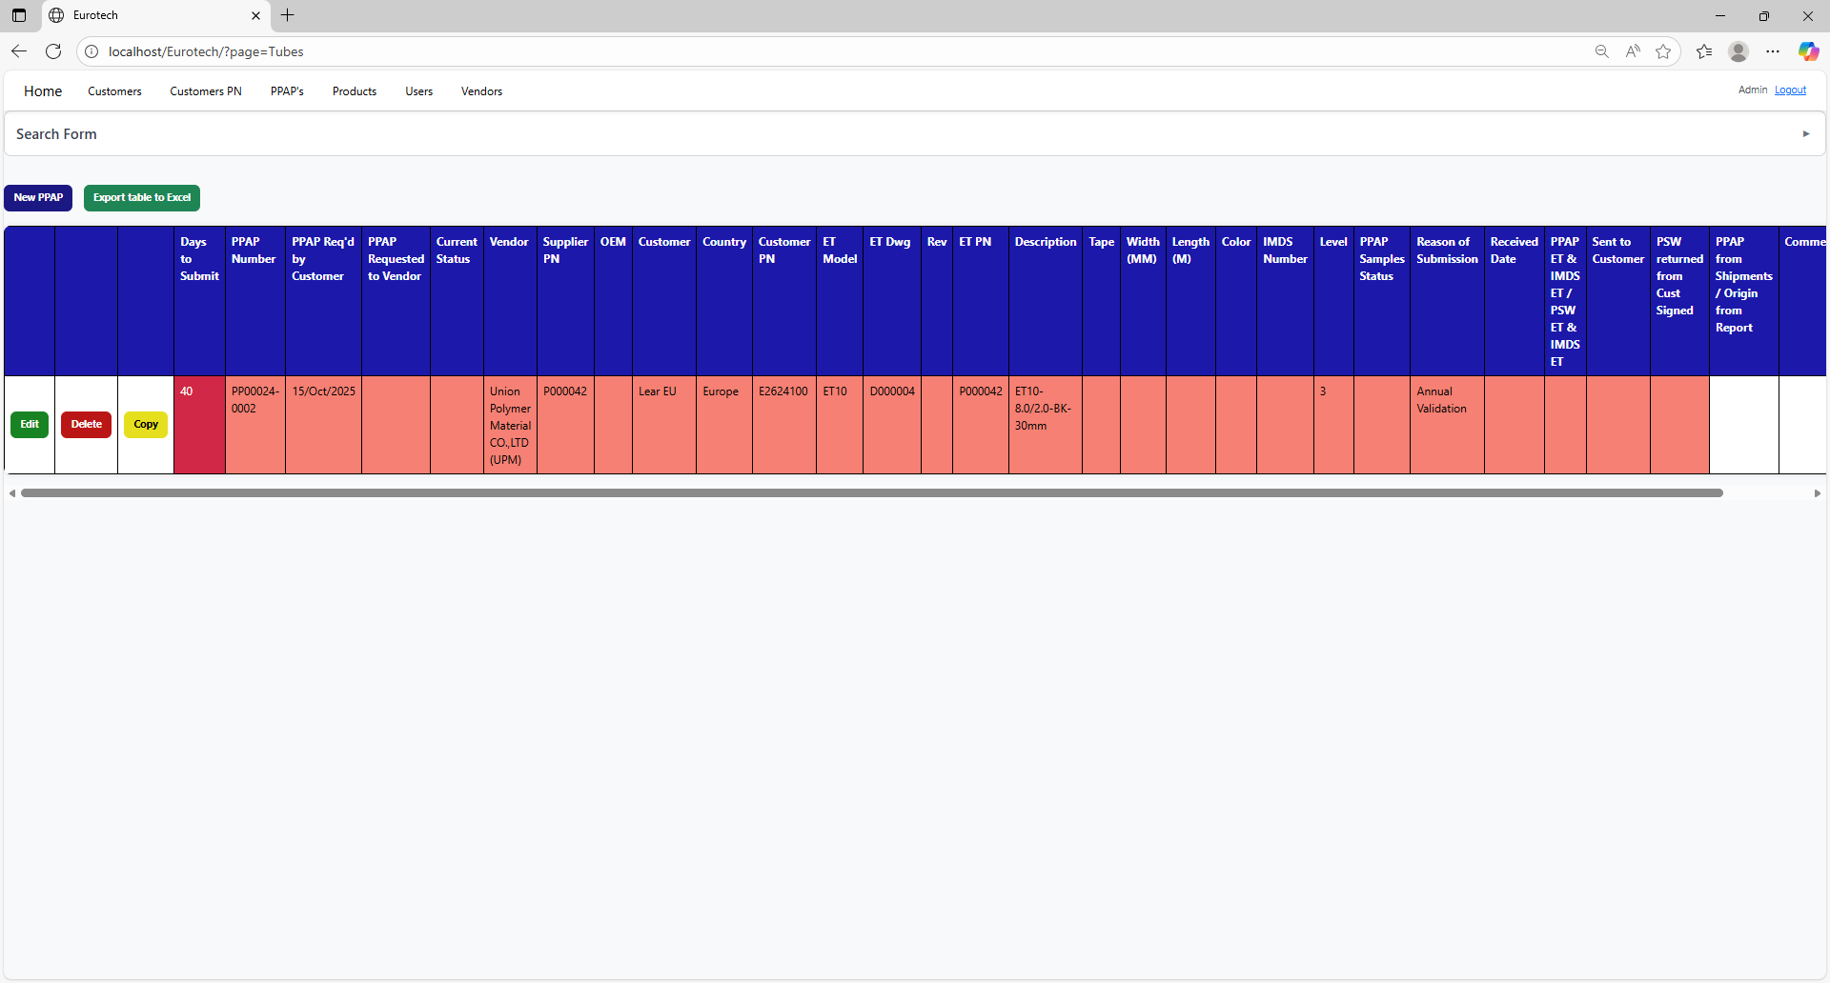

2.- In the rest of the columns of the registers will be:

* Registers with white background indicate that the PPAP has been requested by the customer, the request has not been sent to the vendor, and 30 days have not passed without the documentation being sent to the customer.



* Registers with blue background indicate that the PPAP has been requested by the customer, the request has been sent to the vendor, and 30 days have not passed without the documentation being sent to the customer.

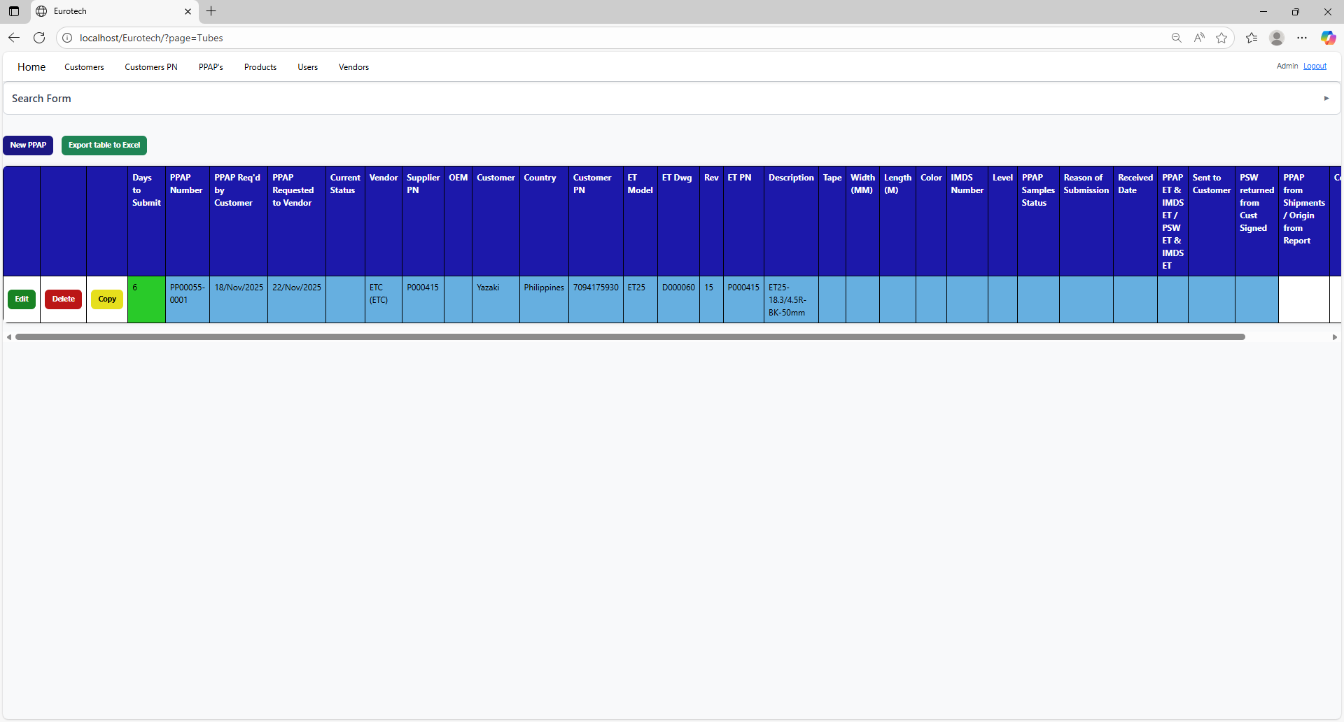

* Registers with red background indicate that the PPAP has been requested by the customer, and the 30-day limit has passed without the documentation being sent to the customer.



* Registers with yellow background indicate that the PPAP has been sent to the customer, and the PSW has not been returned signed by the customer.

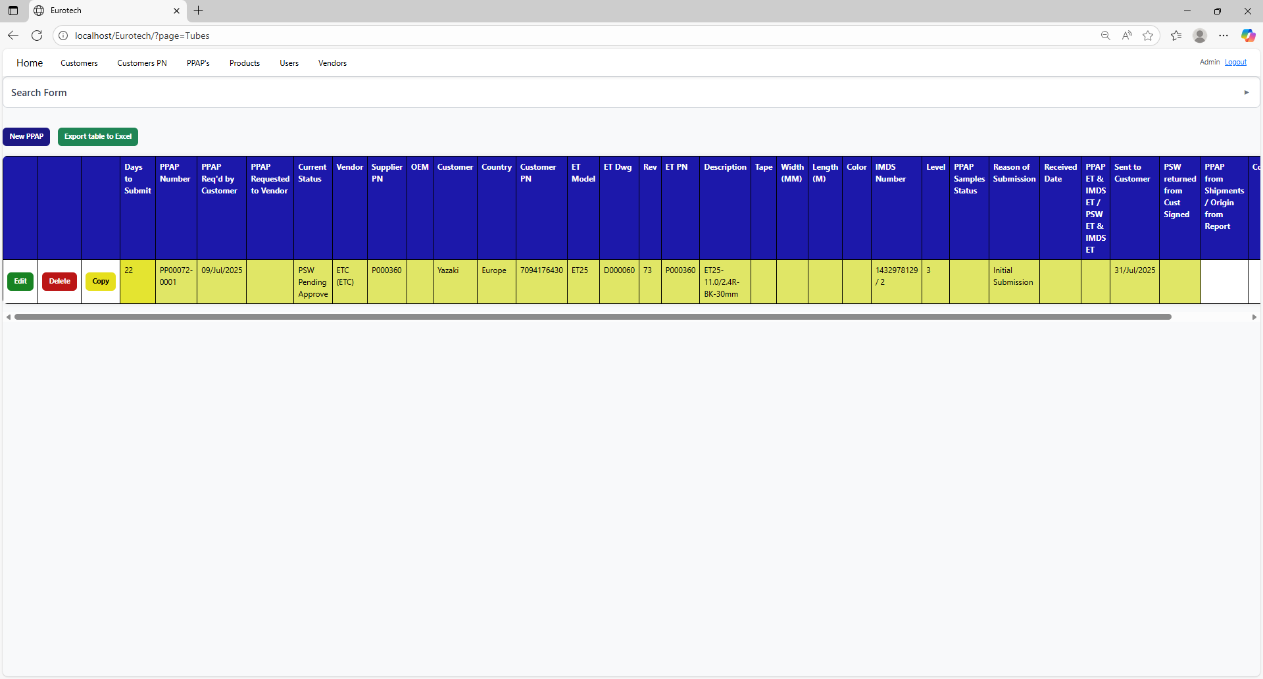

* Registers with green background indicate that the PSW has been returned signed by the customer.

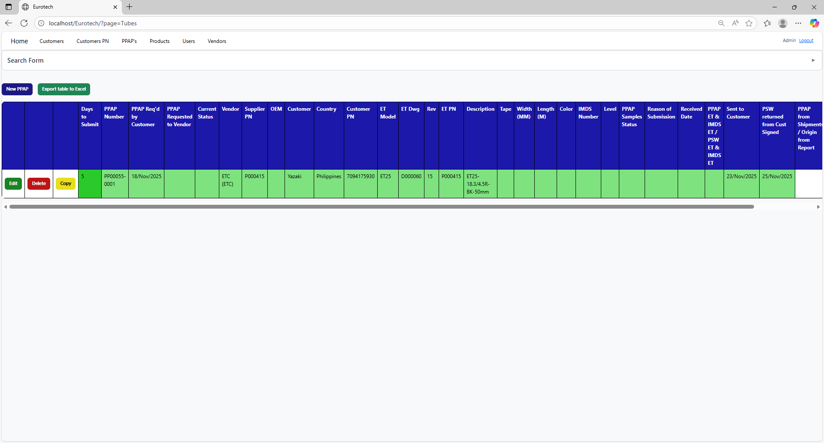

### *4.5.4 How to Export the Information of the Table to an Excel Document.*

To export the table to an Excel document, you must click the “Export table to Excel” button.



Once you click the “Export table to Excel” button, it will start to download the Excel document with the name “PPAPs_Tubes_Report.xls”.

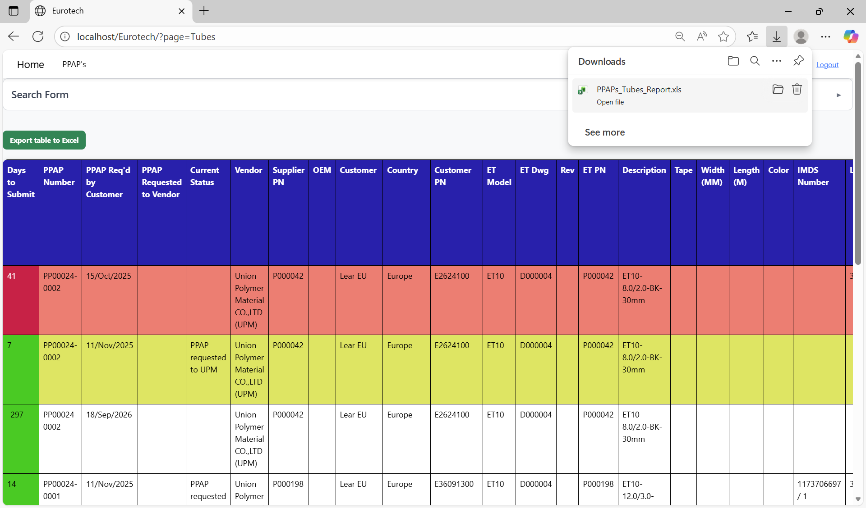

Once the download is finished, you can go to the folder it was downloaded and open the Excel document.

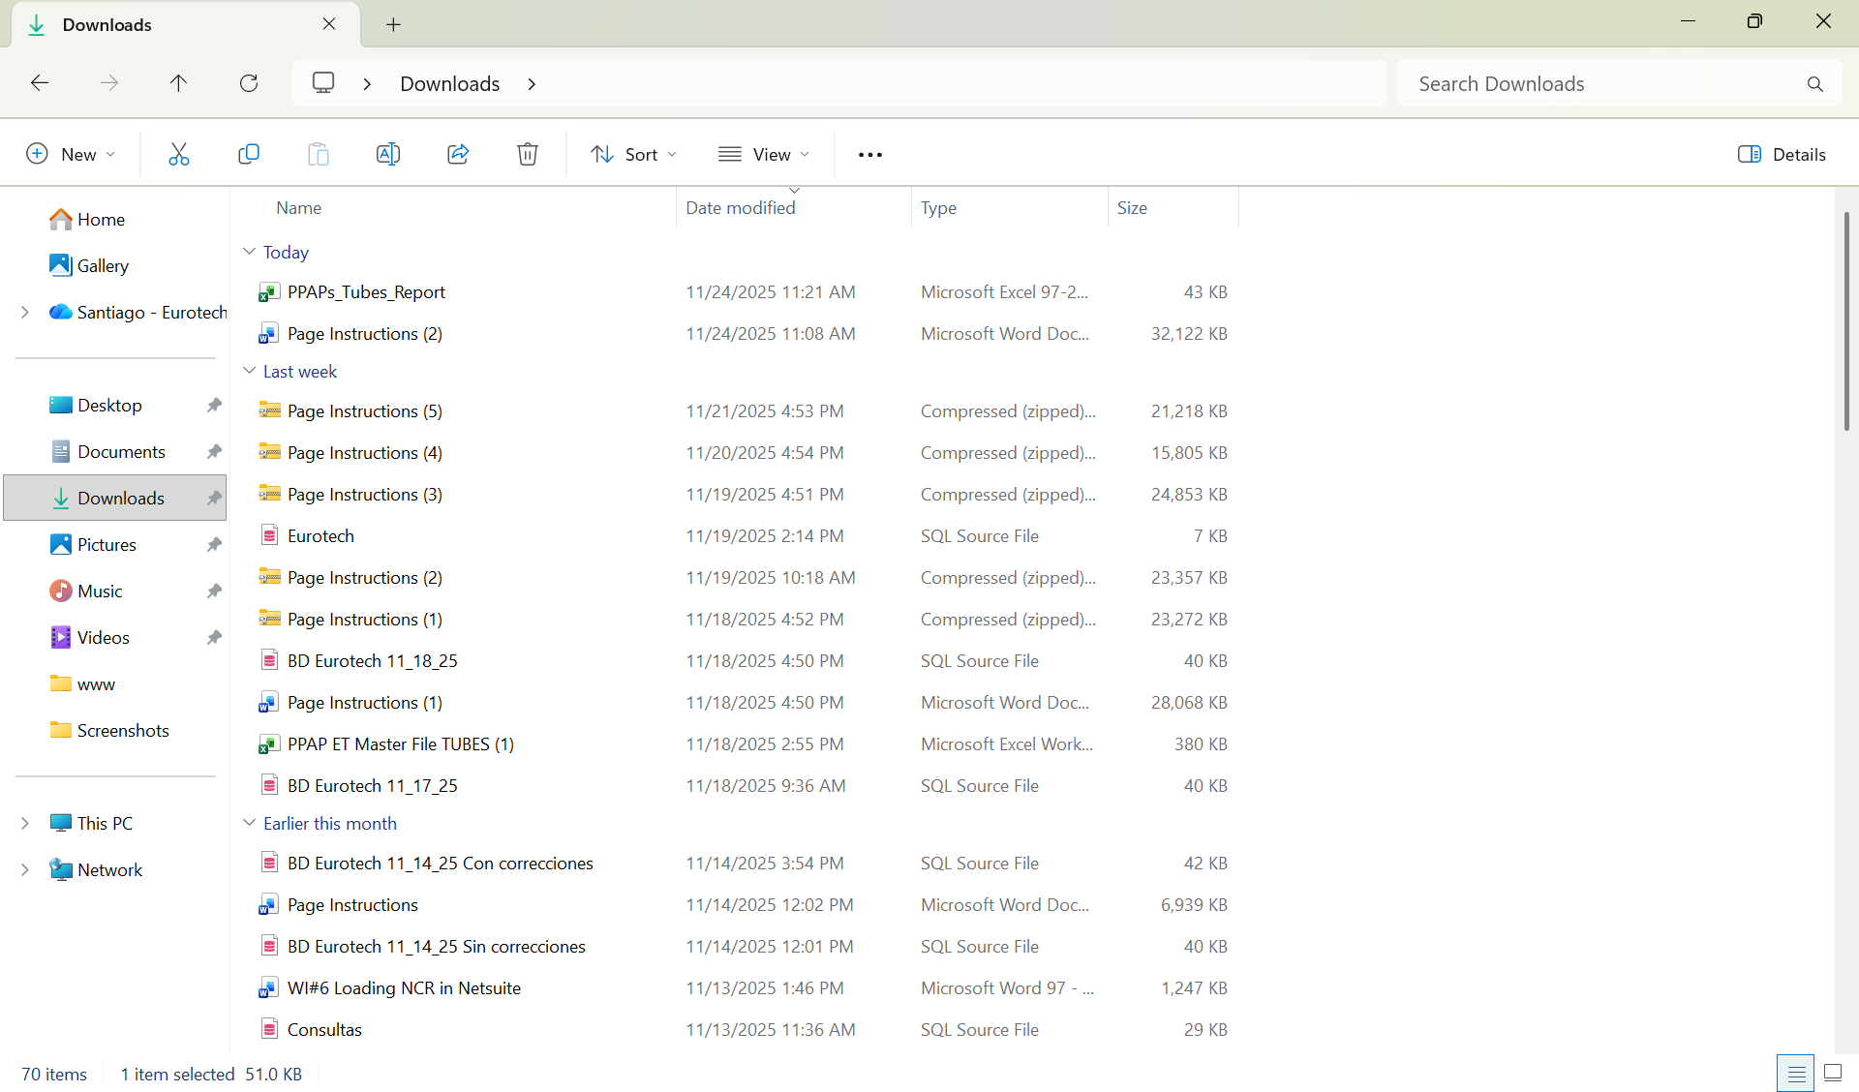

This is an example of how the document would look like:

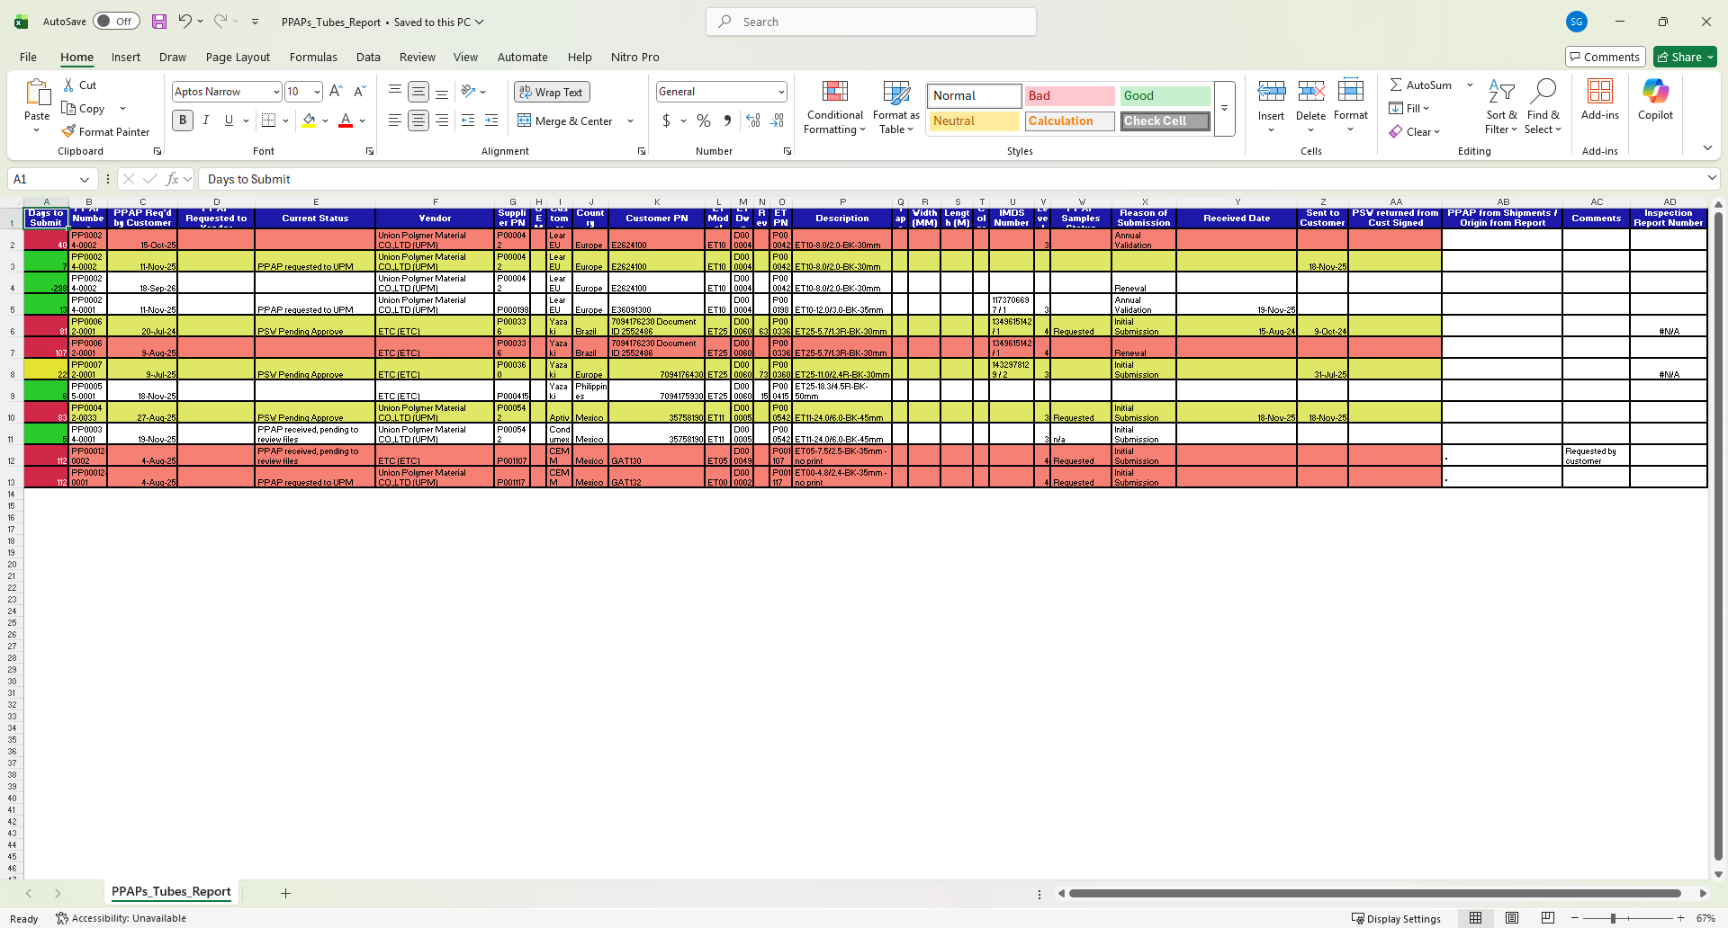

## **4.6 Log out.**

### *4.6.1 How to log out from the web site.*

If you want to log out from the page, you must click the “Logout” button that is at the top right corner of the page, next to the user’s name.

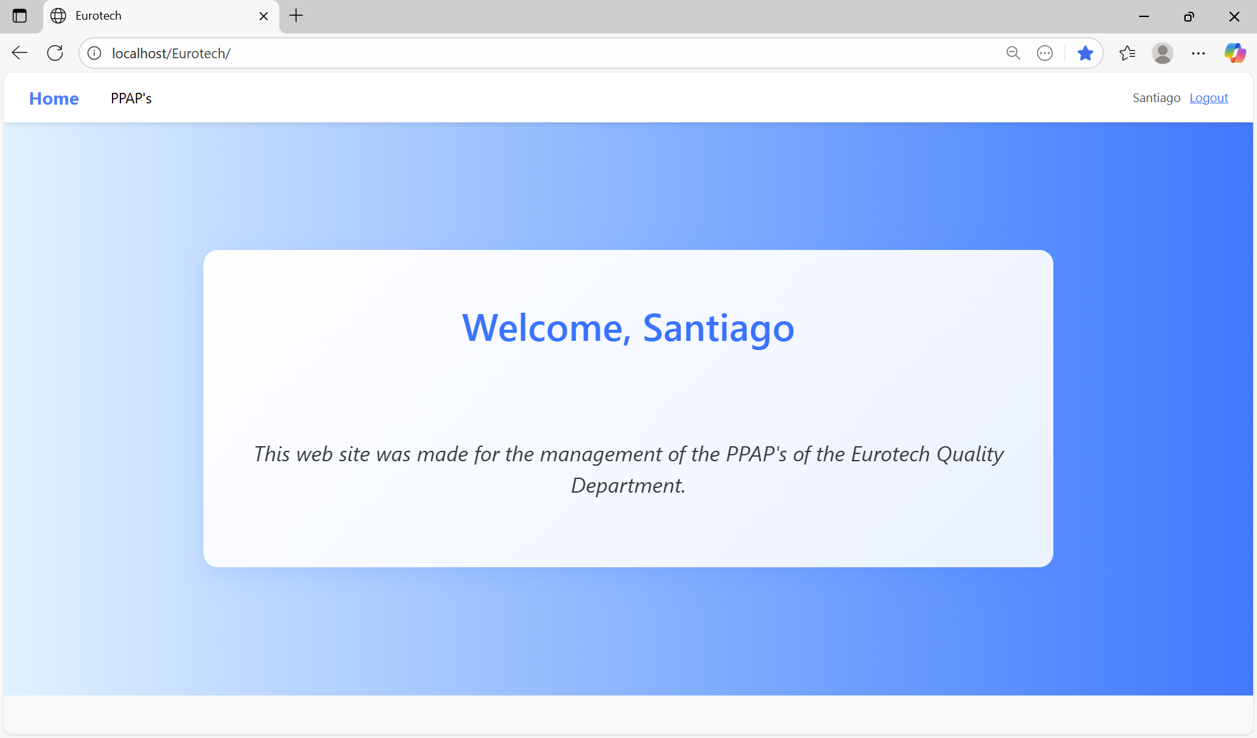

Once you click the “Logout” button, it will close the session of your user, and it will show you the “Login” page.